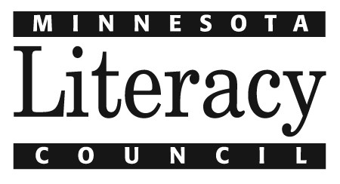

Steps for Becoming a Volunteer Teacher

The following is a list of steps that new volunteer teachers usually go through as part of the application, orientation, and training process. In some cases you might not complete these steps in the suggested order. If you have questions or concerns about any step in the process please discuss it with the learning center coordinator:

Coordinator Name, phone and email

- Complete and return a volunteer application
- Observe several classes at the learning center
- Meet with the coordinator to discuss experience and possible placement
- Complete pre-service training (3 options)

  - 12-hour training at the Minnesota Literacy Council
(http://www.themlc.org/trainingregistration.html for a description and schedule)

  - TEFL or equivalent certificate

  - Current Minnesota teaching license
- Receive classroom curriculum and lesson planning resources
- Team teach with a volunteer or staff member (during the first week in the classroom)
- Teach with observation and feedback from a staff member (during the second week in the classroom)

