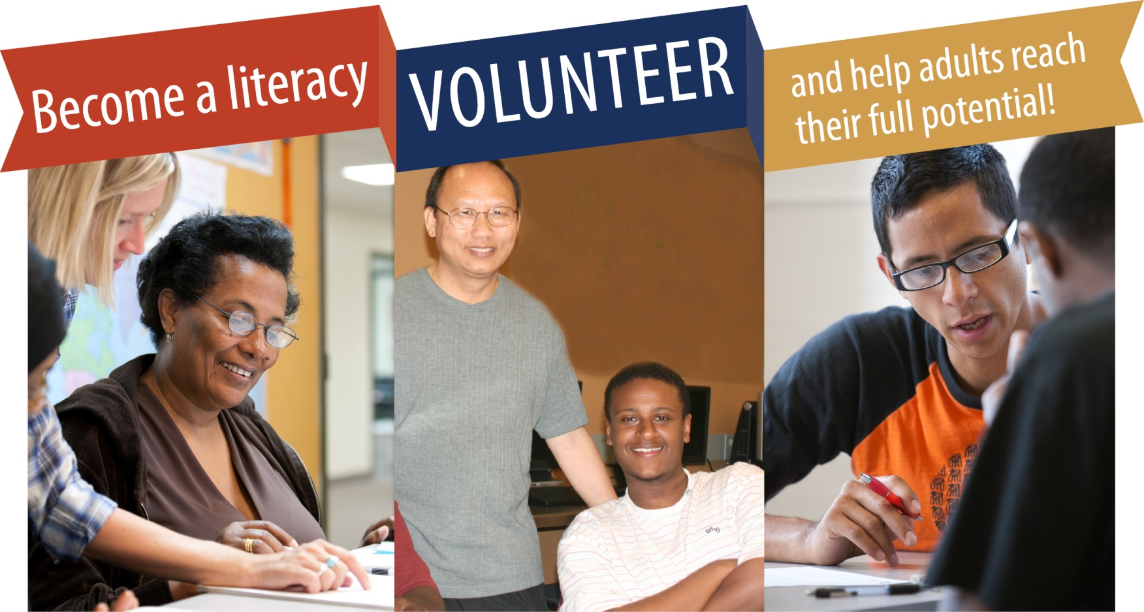



*Supported by the Minnesota Literacy Council*

**mnliteracy.org/volunteer**



* Dependable, prompt and patient
* Respectful of differences
* Strong communicators with excellent interpersonal skills
* Trained through a pre-service workshop
* Committed to 1-3 hours weekly for six months *(preferred)*



Volunteer as a tutor, teacher or program support assistant in one of the following areas:

* English (ESL)
* GED
* Citizenship
* Reading and writing
* Computer or employment skills
* Math





**Literacy Program Name Here**

**PHONE:** (651)555-5555 **EMAIL:** email@yourdomain.org

**ADDRESS:** 2222 Street Name, City, MN 55111

**WEBSITE:** yourdomain.org