Understanding the Somali People: History, Culture and Migration to Minnesota Presented by CAIR-MN
As you complete this reflection form, you will need access to the video and the slides. See the Special Topics section of the Webinar Materials page to access the slides. Use the timestamps listed below to help you note the moments in the video where you may wish to pause to give yourself time to respond to the questions.
- CAIR MN and Jaylani Hussein (timestamp 0:00-10:00)
  - What is one thing about Jaylani’s family background that stood out to you?
Click or tap here to enter text.
  - What are two parts of CAIR’s work and mission that might be most important to learners you work with?
Click or tap here to enter text.
- Cultural artifacts (timestamp 10:00-25:40)
  - For each item Jaylani displays, type your guess and then the correct answer:
Picture, Somali word | Your guess | Correct answer
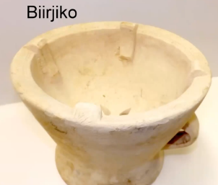 | Click or tap here to enter text. | Click or tap here to enter text.
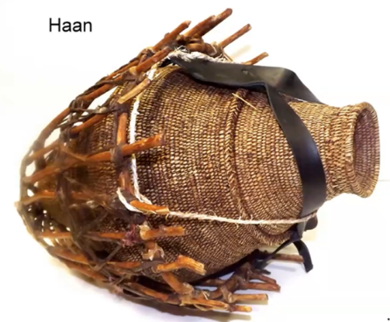 | Click or tap here to enter text. | Click or tap here to enter text.
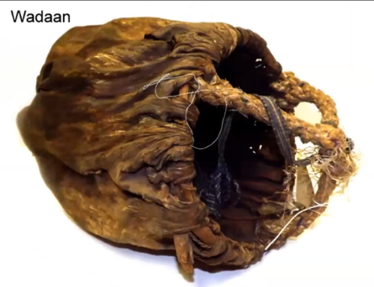 | Click or tap here to enter text. | Click or tap here to enter text.
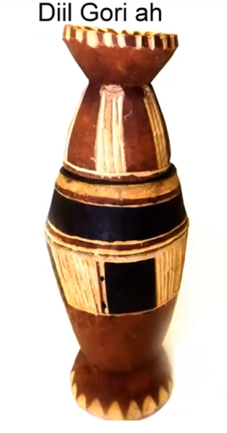 | Click or tap here to enter text. | Click or tap here to enter text.
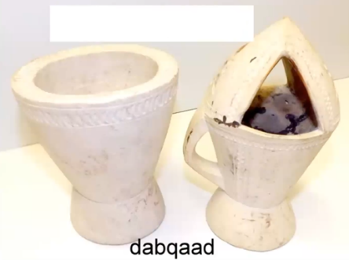 | Click or tap here to enter text. | Click or tap here to enter text.
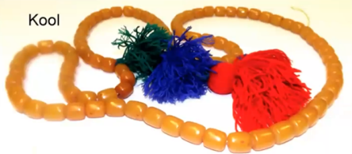 | Click or tap here to enter text. | Click or tap here to enter text.
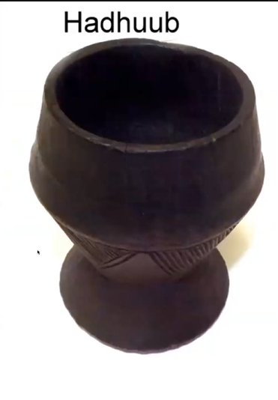 | Click or tap here to enter text. | Click or tap here to enter text.
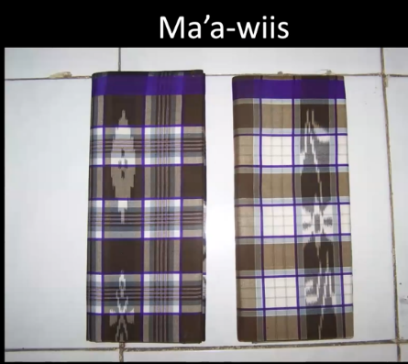 | Click or tap here to enter text. | Click or tap here to enter text.
  - After hearing about these items and Jaylani’s discussion afterwards, what two items are of particular importance in Somali culture?
Click or tap here to enter text.

  - What stood out to you about frankincense as you watched the video about it?
Click or tap here to enter text.
- Somali history: geographic location, trade advantages, influence from Far East (timestamp 25:40-32:40)
What are two surprising or interesting things you learned in this section about Somali history?
Click or tap here to enter text.
- Somali Food (timestamp 32:40-35:12)
What foods from other nations are you reminded of when you watch the video about Somali food? What other nations does the narrator mention?
Click or tap here to enter text.

- Geography (timestamp 35:12-40:38)
What are two surprising or interesting things you learned in this section about geography?
Click or tap here to enter text.
- Language and Oral Tradition (timestamp 40:38-47:10)
How might you apply what Jaylni says in this section about language and oral tradition to your teaching and tutoring with Somali learners? Or, how might you behave differently, given this knowledge? List at least three ideas.
Click or tap here to enter text.

- Colonization and Independence (timestamp 47:10-53:39)
What is one surprising or interesting thing you noted in the videos about the colonization (insert original video link) and independence of Somalia?
Click or tap here to enter text.

- Civil War and Migration (timestamp 53:39-56:50)
What’s one thing you’ll remember about this section on the civil war and migration?
Click or tap here to enter text.

- Somalis in Minnesota (timestamp 56:50-1:07:00)
According to the news clip, why have Somalis come to and stayed in Minnesota?
Click or tap here to enter text.
What is one stat that struck you from the ones Jaylani shared about Somalis in Minnesota?
Click or tap here to enter text.
How might the fact that 80% of Somalis in Minnesota are living at or near poverty affect their ability to reach their adult education goals? What do you think?
Click or tap here to enter text.

- Education and the Importance of Teachers (timestamp 1:07:00-1:12:37)
How will you apply what you learned about Somalis, education and the importance of teachers to your teaching and tutoring context?
Click or tap here to enter text.

- Mental health (timestamp 1:12:37-1:14:30)
How will you apply what you learned about Somalis and mental health to your teaching and tutoring context?
Click or tap here to enter text.

- Cross cultural gaps (timestamp 1:14:30-1:21:45)
What was something new you learned in this section about cross cultural gaps?
Click or tap here to enter text.

- Q & A (timestamp 1:21:45-end)
It is optional to watch the question and answer part of the video. If you do watch it, write your biggest takeaway below.
Click or tap here to enter text.
Submission Instructions
To receive credit for this training, email your completed reflection form to:
  - Literacy Minnesota Tutor Training Coordinator Meghan Boyle: mboyle@literacymn.org, and
  - Your coordinator at the literacy program where you volunteer
And fill out the evaluation form for this training: https://www.surveymonkey.com/r/TY3TFJM
Thank you!

