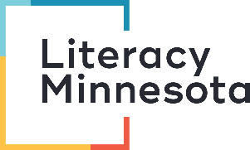
Teaching Citizenship Remotely
Reflection Form

Overall Reflection: What are your top three take-aways from the webinar?
1. Click here to enter text.
2. Click here to enter text.
3. Click here to enter text.

Small Talk: How will you teach small talk? What are 1-2 activities you can do with your learners?
Click here to enter text.

100 Questions: How will you teach the 100 questions? What are 1-2 activities you can do with your learners?
Click here to enter text.

Yes/No Questions: How will you teach the yes/no questions? What are 1-2 activities you can do with your learners?
Click here to enter text.

Reading/Writing: How will you teach the reading and writing portions of the interview? What are 1-2 activities you can do with your learners?
Click here to enter text.

Resources from Open Door: Look at the resources (videos and review activities on Jessica’s citizenship website. What are two resources that you will use?
https://sites.google.com/view/citizenshipopendoor/home
1. Click here to enter text.
2. Click here to enter text.

Citizenship Instructional Support Kit: Download the Citizenship Instructional Support Kit from Literacy Minnesota. What are two activities that you will use in your teaching?
https://www.literacymn.org/citizenship-esl-instructional-support-kit
1. Click here to enter text.
2. Click here to enter text.

Submission Instructions
To receive credit for this training, email your completed reflection form to:
- Literacy Minnesota Tutor Training Coordinator Meghan Boyle: mboyle@literacymn.org, and
- Your coordinator at the literacy program where you volunteer
And fill out the evaluation form for this training: https://www.surveymonkey.com/r/7DZD8J7
Thank you!

