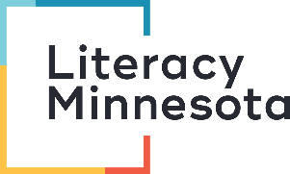
Facilitating Positive Learner Experiences 101
Reflection Form

1. Routines
What are other examples of routines that you could use in a remote lesson?
Click here to enter text.

2. Build Schema
What are three additional ways that you could activate and build schema during a remote lesson?
- Click here to enter text.
2.Click here to enter text.
3.Click here to enter text.

3. Repeated Reading and Whole-Part-Whole Instruction
What are other “part” activities that you could do to practice the language in the story?
Mon - Discussion Questions, Sound of the Week
Tue - Correct the Sentences
Wed - Fill in the Blanks, 9-Square
Thur - Dictation
Click here to enter text.

4. Teacher Talk
What are three ways that you can reduce your teacher talk during remote lessons?
- Click here to enter text.
2.Click here to enter text.
3.Click here to enter text.

5. Demonstrate Knowledge
What are two additional ways that you can have learners demonstrate knowledge during remote lessons?
- Click here to enter text.
2.Click here to enter text.

6. Extend Activities
Brainstorm activities to extend the noun and verb slides. What else can learners do (think reading, writing, listening and speaking)?
Click here to enter text.

Submission Instructions
To receive credit for this training, email your completed reflection form to:
- Literacy Minnesota Tutor Training Coordinator Meghan Boyle: mboyle@literacymn.org, and
- Your coordinator at the literacy program where you volunteer
And fill out the evaluation form for this training: https://www.surveymonkey.com/r/SPN3QXL

Thank you!

