Spring Tutoring Refresher
APRIL 18, 2020

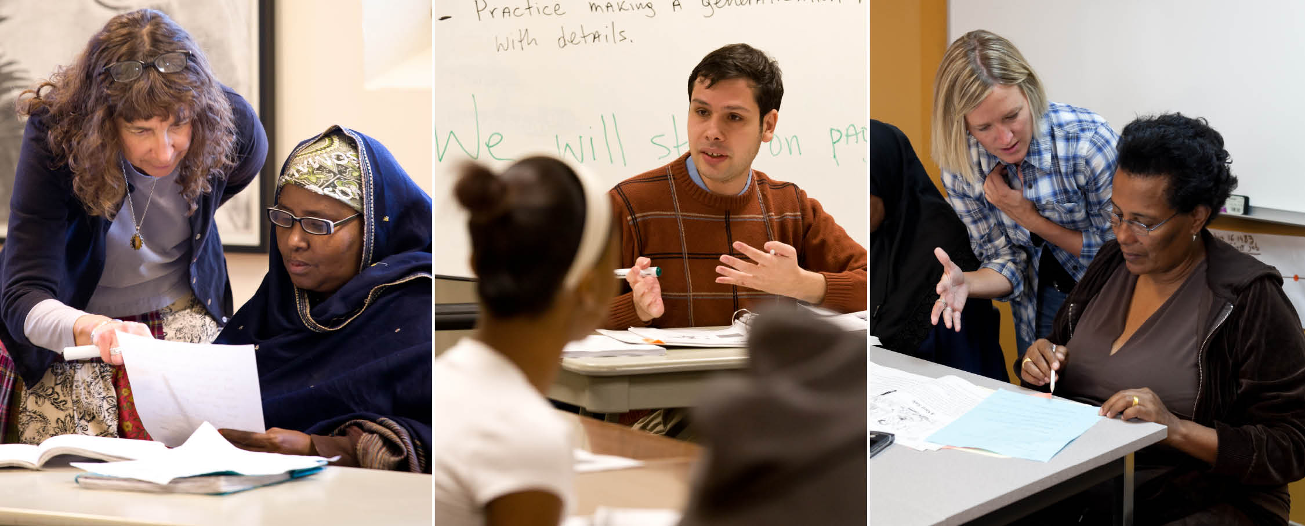

Join more than 100 tutors and teachers to share experiences and pick up new tutoring ideas.
THE CONFERENCE:
This free mini-conference will feature a variety of 50-minute sessions designed to give you practical ideas and activities. The will be sessions appropriate for one-to-one tutors, classroom assistants and small group leaders.
THE SCHEDULE:
8:30 - 9 Registration, bagels and fruit, and mingle
9 - 9:50 Concurrent sessions
10 - 10:50 Concurrent sessions
11 - 11:50 Concurrent sessions
THE LOCATION:
Literacy Minnesota – Open Door Learning Center Lake Street
2700 East Lake Street (second floor)
Minneapolis, Minnesota 55406
REGISTRATION:
For more information or to register online, go to www.literacymn.org. You can also register by completing the form below and giving it to your center’s coordinator.
_ _ _ _ _ _ _ _ _ _ _ _ _ _ _ _ _ _ _ _ _ _ _ _ _ _ _ _ _ _ _ _ _ _ _ _ _ _ _ _ _ _ _ _ _ _ _ _ _ _ _ _
2020 SPRING TUTORING REFRESHER REGISTRATION
Name __________________________________________________________________________
Email Address _______________________________________________________________________
Tutoring Program ______________________________________________________________________

2020 Spring Tutoring Refresher Sessions (subject to change)

9-9:50
ESL Instructional Support Kits—Come Take a Look!
Meghan Boyle
Five ESL Instructional Support Kits addressing the following topics are available for download on the Literacy Minnesota website: Phonics and Phonemic Awareness, Speaking and Listening, Pronunciation, Citizenship and Reading. See them in their ready-to-use format and think about how to use them in your teaching context. Come take a look at these valuable teaching resources that will make your life easier!
Getting Miles Out of a Mingle
Mya Shaftel
This session focuses on three fun and engaging mingle (conversation) activities. Emphasis is on listening and pronunciation, creating authentic contexts, and developing finger dexterity and fine-motor skills. These low-prep, easy-to-use activities are suitable for all levels of adult ESL.
Activities for Building Reading Fluency
Rob Podlasek
Limited reading fluency often holds students back from comprehending what they are reading. Learn about the key aspects of reading fluency (accuracy, rate, prosody) and practice a variety of strategies you can use to help learners build this important literacy skill.
Northstar Digital Literacy and Me – How Can I Use Northstar to Increase My Own and My Learners’ Digital Skills?
Theresa Sladek
What is Northstar? What’s this I hear about new curricula? How can I teach digital literacy when I don’t feel I know enough? Come join our session on an overview of what Northstar can offer volunteer teachers, tutors and coordinators. We will highlight the new features released in February, and discuss how Northstar assessments, curricula and online learning can be used in conjunction with one another in the ESL and ABE classroom and how Northstar can be used for our own personal development.
Introduction to Microaggressions Wendy Roberts, Yixiu Chen
“Where are you really from?” “Stop acting like a girl.” “Everyone can succeed if they just work hard enough.” Microaggressions are verbal and nonverbal slights and insults, whether intentional or unintentional, that remind marginalized people they are outsiders. In this session, we will learn how to identify microaggressions and practice responding to microaggressions that we may experience in our lives.
10-10:50
Let Me Ask You a Question: Giving Feedback that Learners Remember Andrea Echelberger
Giving effective feedback is more than providing the right answer. In this interactive workshop, learn how to be the question-asker instead of the answer-giver to encourage independent learning and help feedback to stick.
Effective Phonics Tutoring with Adults
Burgen Young
Phonics instruction is a very effective approach for teaching new readers. In this workshop we’ll list and define the skills beginning readers need to practice learning to decode English. The presenter will demonstrate practice activities for each skills and share phonics resources for tutors.
Dealing with Details
Rob Podlasek
Details are key to comprehension. Come learn some great ways to help students at all levels begin to recognize and evaluate different types of details.
DON'T PANIC: It's Just a Computer. Answers to Common Computer Lab Questions
Jason Brazier
Looking to volunteer but terrified you will be asked to help out in a computer lab? Fear not! Helping in a computer lab is fun, rewarding and doesn’t require you to be a computer expert. This session will guide you through some of the most common problems and give you confidence in your own computer abilities.
Accessible ABE with Universal Design for Learning
Andy Francis
Come learn how Universal Design for Learning (UDL) can minimize barriers and maximize learning opportunities for all students. You will leave this session with a basic understanding of the five principles of UDL, why they are important to Adult Basic Education and concrete methods and activities to implement in your classroom. Some topics include: creating a welcoming environment, providing clear expectations and exploring multiple instructional methods.

11-11:50
Embrace the Stress! Word Stress Activities for ESL Classes
Andrea Echelberger
Want to give learners’ intelligibility a boost? Correctly using English word stress helps language learners to be more easily understood when they communicate. Come learn five activities to improve word stress production for beginning-to-advanced level classes.
Understanding and Teaching Modal Verbs
Susan Wetenkamp-Brandt
Why should you come to this session? Can you choose between all the great sessions this morning? If you want to understand a bit more about how words like should and can work, and how to teach them to adult English learners, then you might not find a better session on the schedule!
Reading Between the Lines: 5 Activities for Teaching Inferences Rob Podlasek
Help students use the information on the page and the knowledge in their heads to answer inferential questions.
Engaging Refugees and Immigrants through the Frame of Cultural Humility
Yixiu Chen, Ebyan Abdulle
What defines my culture? What defines their culture? Cultural humility challenges the narrative that culture is static and that any one individual can possibly master another’s. Rather, it promotes culture as an ever-evolving, fluid and non-linear force. Learning to have cultural humility is dynamic and requires a lifelong process of self-reflection. This presentation will focus on unpacking the concept of cultural humility and posits ways to engage with adult refugee students in the classroom using this framework.
Incorporating Digital Literacy into ESL Classes Using the Northstar Curriculum
Theresa Sladek, Laurie Patton
The digital literacy gap in the U.S. is such that 24% of the population does not have basic digital literacy skills – such as using a mouse, searching the internet or using email. These skills are increasingly important in getting a job, entering higher education and functioning efficiently in society. We will look at Northstar curricula created for ESL learners and how it can be incorporated into ESL lessons to begin to bridge the digital literacy gap and help learners gain and practice these skills imperative to living in a digital age.

