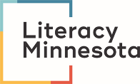
Virtual Lesson Plan Template
Date:
Objective
By the end of this lesson, learner/s will be able to…
Main Text
(reading text, conversation questions, picture, etc.)
Key Language
(vocabulary, phrases, grammar, concept, etc.)

Routine Warm Up
Activity 1 | I Do It:  We Do It:  You Do It:
Activity 2 | I Do It:  We Do It:  You Do It:
Activity 3 | I Do It:  We Do It:  You Do It:
Wrap-Up

Review for next lesson:

