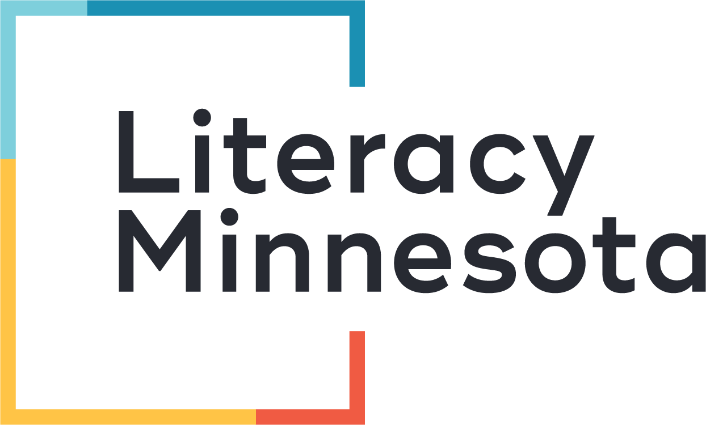
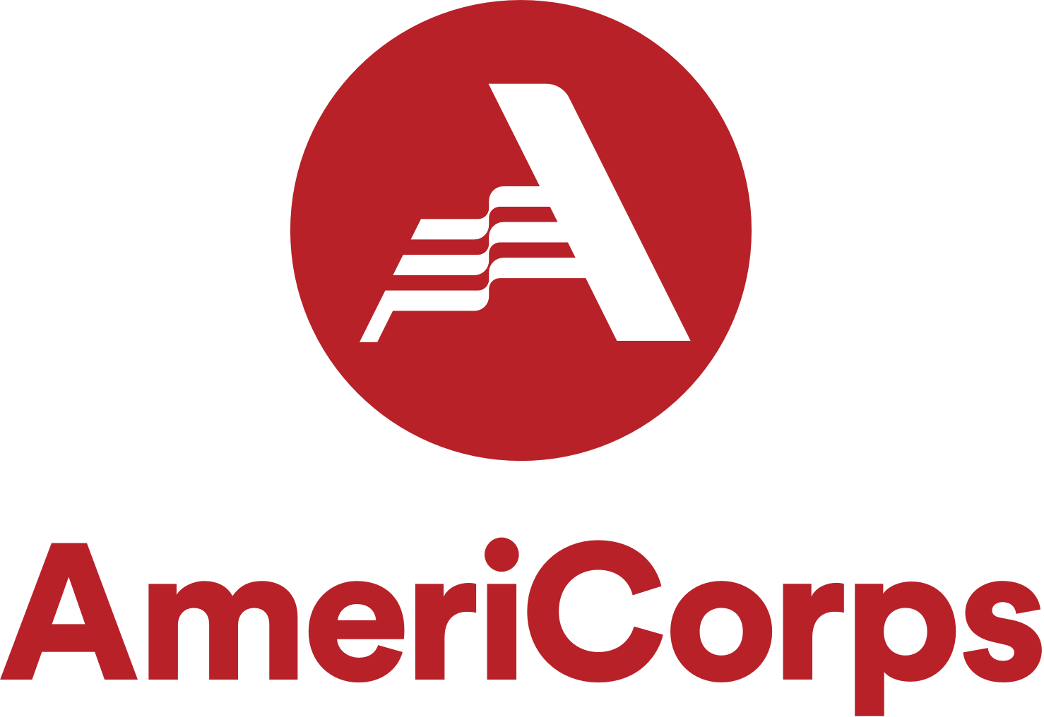
Literacy Leadership
AmeriCorps VISTA Host Site
Request for Proposals 2023-24

OVERVIEW

Literacy Minnesota seeks proposals from organizations anywhere in the United States interested in hosting one or more full-time AmeriCorps VISTA members with our Literacy Leadership VISTA program in the 2023-24 program year. A Literacy Leadership VISTA enables your organization to turn a dream project into a reality, and to launch, expand or improve literacy or digital literacy programs and services for low-income individuals and communities. Our program includes two tracks or cohorts: Literacy for All (building capacity for literacy for children, youth, adults or families) and Digital Literacy (building digital equity for youth or adults).

Rather than provide short-term direct services, AmeriCorps VISTA members work behind the scenes to put infrastructure in place that will last beyond their service. AmeriCorps VISTAs develop program content; build community partnerships; improve volunteer recruitment, training and management systems; conduct program evaluation and data collection/analysis; and help secure resources to ensure long-term sustainability of literacy and digital literacy programs and services.

At the same time, AmeriCorps VISTA members build their own leadership, explore career paths, pay for college and become lifelong advocates for the communities they serve due to the power of their experience. It is a unique opportunity to invest in, coach and mentor emerging leaders in the education and nonprofit fields.

As a host site, you provide the vision, project plan, day-to-day management of the project and on-site supervision of the AmeriCorps VISTA. Literacy Minnesota provides training and technical assistance to you and the AmeriCorps VISTA at all stages of the project, and manages the AmeriCorps VISTA member’s living allowance and benefits.

An AmeriCorps VISTA member serves full-time for 12 months, with the option to serve for multiple years. A typical AmeriCorps VISTA project is renewed annually for 3-5 years.

We invite your organization to participate in this annual competitive selection process.

CONTACT

Jesse Chang
National Service Program Director
jchang@literacymn.org
651-251-9069
www.literacymn.org/americorps-vista

LITERACY MINNESOTA’S NATIONAL SERVICE PROGRAMS

Literacy Minnesota currently operates two AmeriCorps VISTA programs: Literacy Leadership and Summer Reads. Literacy Leadership includes two tracks, where members serve full-time for one year: Literacy for All (with a heavy focus on culturally responsive literacy education) and Digital Literacy. Literacy Leadership is national in scale, meaning organizations located anywhere in the United States are eligible to apply and host VISTAs. Summer Reads is a summer associate VISTA program, where members serve full-time for 8 weeks over the summer in organizations throughout Minnesota to provide direct service as children’s literacy mentors (grades K-5).

Please contact Literacy Minnesota for more information about applying for AmeriCorps VISTA resources through Summer Reads.

TIMELINE*

Look for an email with dates (TBD) for the live Supervisor Workshops or links for recorded workshops.

December 2022-February 2023 Watch Info Session (required for new sites)
February 13, 2023 Deadline for proposals (submit online)
Late February 2023 Sites notified of selection
March 13, 2023 Deadline for first draft of workplan (VAD) and position description (SOL)– once approved, you may begin recruiting your VISTA member(s)
April-July 2023 Member recruitment, interviews and selection
April 2023 Site visit with Literacy Minnesota staff
April 30, 2023 Deadline for Site Agreement, Board Letter of Commitment, and initial $1,000 cost-share payment
June 30, 2023* Deadline for Literacy Leader selection
July 21, 2023 Deadline for Organizational Assessment and Literacy Leader VISTA site orientation plan
July 31, 2023* Literacy Leader first day of service and national VISTA Member Orientation (webinars/online coursework)
August 28-Sept 1, 2023* Tentative Member Early Service Training with Literacy Minnesota (webinars/online coursework)

*Alternate start dates for VISTAs include August 14 and August 28, 2023. Member selection deadlines are one month before the VISTA start date, and orientation dates differ for the later start dates.

AmeriCorps VISTA

AmeriCorps VISTA (Volunteers In Service To America) is a National Service program funded by the federal government through the AmeriCorps federal agency. Founded in 1965 as a domestic equivalent to the Peace Corps, VISTA became part of the AmeriCorps network of programs in 1993. AmeriCorps VISTA members dedicate one year (12 months) of full-time service to the community to lead anti-poverty projects, and are provided a modest living allowance and benefits including an Education Award scholarship upon completion of service.

Literacy Minnesota has received a generous grant from AmeriCorps to sponsor and support AmeriCorps VISTA members to build capacity in nonprofit and public agencies that increase literacy access and success and/or digital equity for low-income individuals and communities. For more info about AmeriCorps VISTA, please visit www.NationalService.gov. For more info about Literacy Minnesota’s AmeriCorps programs, visit www.literacymn.org/americorps-vista.

The VISTA program’s governing legislation and applicable regulations are as follows:
- Domestic Volunteer Service Act of 1973 (as amended)
- National and Community Service Act of 1990 (as amended)
- Code of Federal Regulations, Title 45, Chapter 25 Part 2556

LITERACY MINNESOTA

Literacy Minnesota began in 1972 when a group of volunteers realized if one person taught someone to read, and that person taught someone to read, they could create a movement. Today, Literacy Minnesota is recognized as a local and national leader and a driving force behind the latest developments in literacy learning. We continue to build a movement of learners, educators, literacy advocates and organizations in pursuit of a world where life-changing learning is within everyone’s reach. Our mission is to share the power of learning through education, community building and advocacy. Current programs and services:

In Minnesota
- Open Door Learning Centers - Six Twin Cities sites offering English, GED, computer, citizenship, job-readiness and other basic-skills classes for adults. Our Arlington Hills location in Saint Paul also has a preschool program for children of adult students.
- Parenting Program - Provides families with tools to break through inequitable power structures and create a more just education system.
- Adult Literacy Hotline - Online and phone referral service to adult literacy programs across Minnesota.
- Summer Reads (AmeriCorps VISTA) - Provides literacy tutors and mentors for children entering grades K-5 across Minnesota.
- Tutor Training - Pre-service and in-service workshops for literacy volunteers and educators.
- Volunteer Recruitment – Recruits and places volunteers into service organizations across Minnesota.

National
- Literacy Leadership (AmeriCorps VISTA) – Engages AmeriCorps members to design and carry out literacy initiatives for preK through adults or to build digital literacy programs and services for youth or adults in partnership with schools, public agencies, community organizations and Tribal Nations.
- Northstar Digital Literacy - Assesses digital skills through online modules and provides classroom curriculum and self-directed online learning.
- Advocacy - Mobilizes to influence policy and legislation around the literacy cause.
- Curriculum & Resources - Searchable online library of literacy curriculum and teaching tools.
- Journeys - An anthology of adult student writing with accompanying classroom resources.
- Literacy Strategies - Consulting services to help organizations launch and develop literacy programming.
- Open Door Collective - Combats poverty through literacy education, policy and research.

Visit our website for more info: www.literacymn.org.

LITERACY LEADERSHIP: OUR GOALS, OBJECTIVES and CORE PRINCIPLES

We partner with communities anywhere in the United States to collaboratively build literacy and digital equity that enables individuals and communities to move out of poverty; and we support change-makers in cultivating leadership, exploring career paths and becoming lifelong advocates for literacy and digital equity.

Our core principles:
- Anti-poverty focus: supporting community efforts to overcome poverty
- Capacity-building: strengthening and supporting efforts that focus on literacy and/or digital literacy by building infrastructure, expanding community partnerships, engaging volunteers, and securing long-term resources
- Community voice: valuing the inherent strengths and resources of the community and involving those who are most affected in the planning, development and implementation of projects
- Sustainable solutions: providing short-term resources to help organizations achieve lasting solutions to poverty
- Service: providing individuals with the opportunity to serve the community and participate in community change efforts

Literacy Minnesota provides your organization with a full-time, qualified and energetic Literacy Leadership VISTA dedicated to realizing your project's goals. By creating new programs and services, making improvements to existing programs and services or expanding the reach of programs and services, Literacy Leadership enables agencies to serve more individuals, more deeply impact causes of poverty and expand the quality and quantity of programs and services.

ELIGIBLE ORGANIZATIONS

Nonprofit organizations, government agencies, and Tribal nations located anywhere in the United States that provide – or wish to newly provide – literacy or digital literacy services to low-income individuals and communities may apply for a Literacy Leadership VISTA. With regard to nonprofit organizations, hosting AmeriCorps members is not limited to those designated by the Internal Revenue Service (IRS) specifically as 501(c)(3). Nonprofits with other IRS-designated 501(c) statuses that focus on anti-poverty outcomes are eligible to apply. Organizations that focus solely on advocacy or lobbying are not eligible.

ELIGIBLE LITERACY LEADERSHIP PROJECTS: Capacity-building

AmeriCorps VISTA members do not directly provide services to participants. They work behind the scenes on capacity-building project(s) you identify. An AmeriCorps VISTA project should not focus on maintaining existing programming or services. Projects focus instead on changes that build organizational capacity so that you can more effectively achieve your mission now and in the future.

Eligible projects in the Literacy Leadership program will build the capacity of host sites to help low-income individuals and communities improve literacy and/or digital literacy skills. Digital Literacy track projects may also work toward improving either or both of the other two components of digital equity for low-income individuals and communities: connectivity and device access.

What is capacity-building?
Capacity-building is not maintenance of your current, existing services, nor direct service to participants such as teaching or tutoring. Capacity-building is a short-term investment in the long-term strength of an organization. It involves activities to bring your organization to the next stage of operational, programmatic, financial, or organizational maturity, so that you may more effectively advance your mission. It is a continuous improvement strategy toward a sustainable and effective organization.

Capacity-building activities could include:
- Researching community needs and assets, and creating strategic plans
- Developing, designing or improving program content
- Designing or conducting program evaluation
- Identifying goals and outcomes, or improving data collection/analysis systems
- Developing and nurturing partnerships to enhance program/service delivery
- Enhancing volunteer recruitment and/or training
- Improving volunteer systems
- Implementing new marketing, outreach or fundraising strategies
- Developing content and designing infrastructure for staff training
- Building local coalitions to promote digital literacy and work together on collective solutions

LITERACY FOR ALL TRACK: Project examples and definitions

How do we define literacy?
Literacy includes reading, writing, and oral language skills. Projects in the Literacy for All track should not focus on financial or information literacy unless it is secondary and complementary to reading, writing, and oral language goals.

Our priority in 2023-24 for projects that fall under the Literacy for All track is on building culturally responsive literacy programs and services for low-income children, youth, adults or families. We will additionally support other types of projects

Why culturally responsive literacy?
According to federal education data, students of color make up 51% of the nation’s public school students. According to Minnesota Department of Education data, 47% of adult basic education students in Minnesota are English Language Learners. It is well-known that Minnesota and Wisconsin for a long time have had among the nation’s largest achievement and opportunity gaps between white students and students of color, and between students living in poverty and students who are more affluent. Despite the diversity of students’ cultures and identities, education typically reflects the dominant White, middle class, abled culture. An approach to education in which multiple expressions of diversity (race, class, gender, language, religion, ability, etc.) are recognized and regarded as assets for teaching and learning have been shown to improve academic and engagement outcomes for students of marginalized identities. Imagine a system where all students’ identities and cultures are respected and reflected in their schools and out-of-school-time programs, and where students of all cultures and identities are given choice and voice in their education.

What are some project examples?
Literacy for All VISTA projects will build the capacity of host sites to reflect and integrate the diverse cultures and identities of participants in their literacy programs and services. Projects could involve developing culturally responsive curriculum, incorporating student voice and choice in teaching and learning, increasing diversity of volunteers, increasing access for specific marginalized communities, or other activities that build cultural responsiveness in literacy programs and services.

Examples:
- Culturally Responsive Curriculum Project: Improve youth literacy outcomes and develop culturally relevant literacy tutoring programming by 1) reviewing existing tutoring materials and developing new culturally responsive curriculum; 2) with input from participants/families, developing tools and systems to measure effectiveness and impact of programming; and 3) designing training for volunteers on new programmatic systems and tools.

- Student Voice & Outreach Project: Establish an organizational culture that centers learner voices and decision making by 1) creating systems and tools to collect learner input and feedback and to identify strategies that ensure program content is responsive to participants’ needs and goals; 2) creating a toolkit and staff training for community engagement and outreach strategies to increase participation of underserved learner populations; and 3) developing community partnerships for student recruitment and processes for ongoing collaboration with partners.

- Volunteer & Learner Accessibility Project: Support inclusion of learners and volunteers with disabilities through integration of Universal Design for Learning and promoting best practices for accessibility. Research disability issues, identify programs that provide accommodations for learner and volunteer referrals, promote best practices, and train teachers and staff on strategies and resources for accommodations. Goal: to provide accessible, inclusive and equitable learning and working environments for everyone to access and get involved with literacy.

DIGITAL LITERACY TRACK: Project examples and definitions
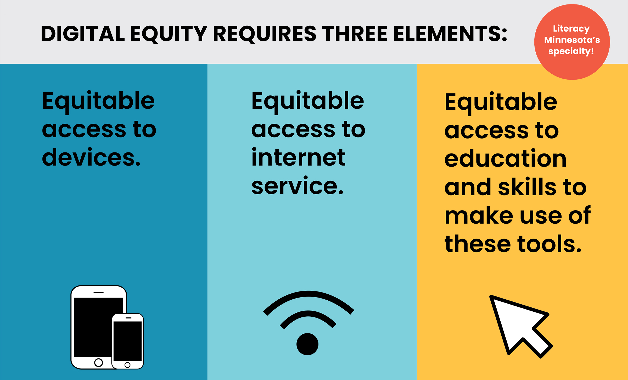
How do we define digital equity?
When we talk about digital equity, we come from a framework that digital equity involves three interrelated elements: equitable access to devices, equitable access to internet service, and equitable access to education and skills to make use of these tools.

Why digital equity?
Digital equity is a fundamental right. Without digital equity, people cannot fully participate in civic life or fully access education, employment or health care. The COVID-19 pandemic has only amplified ways that digital exclusion reinforces inequities, especially for populations marginalized because of race, language, poverty or disabilities – and given greater urgency to the need to bring collective solutions and voice to ensuring equitable access to digital skills and technology in the immediate term and as we move toward post-pandemic life.

From K-12 students lacking home access to the internet to participate in school, to newly unemployed adults whose access is limited to a mobile device for completing online job applications, the United States is at a critical juncture. We know there are a range of common barriers that compromise digital equity, not limited to poverty, geography or educational attainment. Barriers are structural and systemic, such as availability of a broadband infrastructure, as well as personal, like a lack of digital literacy materials in languages other than English.

What are some project examples?
Digital Literacy VISTA projects will build the capacity of host sites to either help low-income individuals and communities improve digital literacy skills, connectivity, and/or device access (with a primary focus on skills), or to improve the host site’s capacity to provide programs and services through virtual/distance learning delivery methods.

Examples:
- Youth virtual tutoring network project: Develop communities of practice, training and resources for youth tutoring programs in a regional tutoring network as they transition to the virtual/remote environment. Assess current challenges and needs in the field; develop and share resources (e.g., exemplars of policies, curriculum, training materials); and develop a support network for sharing information and knowledge amongst practitioners.

- Rural digital literacy project: Recruit and train digital literacy/technology volunteer tutors and navigators, develop streamlined systems for screening learners for digital access needs and for equitably distributing and training learners on computer/hotspot devices for learning, identify local partnerships for referrals, and expand languages of digital learning resources for adult learners in rural communities in three counties – where many people face multiple barriers to digital inclusion. This project will enable more learners to access services, which will as a result lead to improved employment, increased involvement with their children’s teachers, improved communication skills, and ultimately self-sufficiency that creates pathways out of poverty.

- Distance learning project: Develop a volunteer-led distance learning program at an adult learning center, in which volunteers enroll, orient, track students and develop resources for staff/volunteers to coach students throughout their distance learning participation, in order to increase intensity of instruction and provide learners additional opportunities to practice and increase their language, literacy and technology skills. Research and pilot new distance learning platforms or lab structures; develop new volunteer role, position description, recruitment strategy, and orientation/training plan; and work with fundraising staff to research and identify grant opportunities to support distance learning programming.

HOW DOES AMERICORPS VISTA AND THE LITERACY LEADERSHIP PROGRAM WORK?

Literacy Minnesota receives a grant from the AmeriCorps federal agency to manage and distribute AmeriCorps VISTA resources to eligible agencies. The host site provides the project vision, day-to-day management, progress reporting and supervision of the AmeriCorps member (Literacy Leader). Literacy Minnesota provides training, technical assistance, support and resources to the host site and Literacy Leaders through every stage of the project, and pays the AmeriCorps VISTA members’ living allowance and other benefits.

Literacy Leaders are short-term resources that serve to build the long-term sustainability of organizations and programs. Host sites are typically awarded 3-5 years of AmeriCorps VISTA resources to complete a project. Literacy Leaders cannot take the place of regular employees, and projects should be designed with a goal to ultimately eliminate the need for Literacy Leaders and maintain programming or results of projects without them.

Each year of a project is meant to build upon the previous year:
- Year 1: Literacy Leader creates project foundation, conducts research, and begins implementation process
- Year 2: Literacy Leader continues to implement project, evaluates and makes refinements from Year 1, and begins to create structure for sustainability
- Year 3: Literacy Leader focuses on sustaining the project beyond the AmeriCorps VISTA resource
- Years 4 and 5 (if needed): Literacy Leader continues to focus on sustaining the project beyond the AmeriCorps VISTA resource

Key questions to consider:
- Who would be doing this work if you had no Literacy Leader VISTA? Who will continue the work after the resource ends? Is this type of work typically done by paid staff in other similar organizations? (Literacy Leaders are intended to create something new and/or enhance existing efforts and not to deliver core organizational functions or maintain existing programs and services.)
- What will remain after your Literacy Leadership VISTA project ends? (If nothing remains but a hole in your human resources that a Literacy Leader previously filled, capacity was not built.)
- How will the work be sustained? (Creating new programs and/or systems that cannot be sustained after the Literacy Leadership VISTA resources end is counterproductive and a waste of resources and time. Sustainability planning is an essential element of Literacy Leadership VISTA project planning.)

HOST SITE RESPONSIBILITIES

Literacy Leadership VISTA supervision
Site supervisors are expected to be actively and regularly involved in the AmeriCorps VISTA member’s work. Expect that your site’s VISTA supervisor will spend an average of 10-12 hours per month on supervision and project oversight. Please take this into careful consideration when choosing a staff member for the Supervisor position. *Site supervisor involvement is the key determinant of a successful AmeriCorps VISTA member placement.*

Supervisors must make time to meet regularly with Literacy Leaders (at least once per week) to provide support, feedback, guidance, training and mentoring and to assess progress toward project goals.

Site supervisors attend multiple training workshops annually: before beginning member recruitment for the next program year, a 2-part orientation on designing annual work plans and recruiting and supervising AmeriCorps VISTA members, and a joint workshop after VISTAs begin service with the Literacy Leadership VISTAs and supervisors on communication and work styles. Additional joint trainings or conferences may be offered for VISTA supervisors, and regular (typically monthly) trainings will be required for AmeriCorps VISTA members.

Project planning
Host sites work with Literacy Minnesota to develop an annual VISTA Assignment Description (VAD) workplan. This document must be approved by the federal AmeriCorps agency.

Project management
Host sites oversee the day-to-day management of the project, including direct supervision of Literacy Leadership VISTA member(s), reporting and evaluation, and ensuring AmeriCorps VISTA members have sufficient resources and on-site support to fulfill their project responsibilities. This involves budgeting adequate staff time for direct supervision of the Literacy Leader and of the project. Host sites are also responsible for providing the necessary administrative support to design and complete the goals and objectives of the Literacy Leadership VISTA project and ensure sustainability.

AmeriCorps VISTA member recruitment and selection
Host sites recruit, interview and check references for their Literacy Leadership VISTA applicants. Literacy Minnesota will assist you in this process by providing training and technical assistance, placing your position description on the AmeriCorps online recruitment website, phone screening all applicants, and conducting general recruitment activities. The primary responsibility for filling the position, however, rests with the host site.

Literacy Leadership VISTA member training and professional development
Host sites must arrange for initial site orientation and training in the Literacy Leader’s first weeks, and ongoing training and professional development throughout the year as needed for their AmeriCorps VISTA members. Additionally, sites must ensure Literacy Leaders attend a mandatory national VISTA Member Orientation (virtual) on their first day of service, an Early Service Training orientation with Literacy Minnesota during their first month of service (virtual), and monthly in-service trainings with Literacy Minnesota (virtual). Literacy Minnesota also may provide VISTAs with optional professional development and networking events, small group professional learning and support opportunities, and individual professional development funds. Training and professional development is considered a part of the Literacy Leader’s full-time service, and is not “extra.”

Project evaluation and progress reporting
Host sites track and report data related to the project and the Literacy Leader’s activities (for example, number of individuals served, number of volunteers recruited, number of volunteers trained, amount of donations leveraged, etc.). Site supervisors (with input from AmeriCorps VISTA members) complete four formal online progress reports and an Organizational Assessment each year to share progress on project goals and impact.

Communication with Literacy Minnesota
Host sites are expected to maintain regular communication with Literacy Minnesota national service staff about the project and AmeriCorps VISTA member. Host sites should notify Literacy Minnesota immediately regarding changes to the project workplan; any issues that arise with member performance; unscheduled termination of an AmeriCorps VISTA member or unscheduled changes of status and conditions of an AmeriCorps VISTA member such as arrest, hospitalization, or unapproved absences; or anything else impacting the completion of the Literacy Leadership project.

Financial & in-kind match
Host sites are expected to provide a financial and in-kind match toward the costs of hosting an AmeriCorps VISTA member.

Direct support to Literacy Leadership AmeriCorps VISTA member:
- Adequate work space and supplies:
  - A comfortable and welcoming work environment
  - Reasonable office space
  - Access to building and workspace (e.g., keycard)
  - Materials and supplies necessary to perform assigned duties
  - Use of a work computer, phone/phone number, and email comparable to that of paid staff
- Service-related travel reimbursement
  - Mileage reimbursement (or reimbursement for public transit costs) for project-related travel, at rates and using processes as used for host site’s employees
- Reimbursement for project-related supplies and materials
  - Reimbursement for out-of-pocket expenses (with documentation/receipts) for supplies and materials needed to perform assigned duties

Host sites also pay a financial cost-share match to Literacy Minnesota. The cost-share rate is currently $6,000, effective as of 10/2/21. This amounts to about 35% the annual base living allowance rate for the majority of VISTAs in the majority of states, or approximately 15% of the total annual cost per AmeriCorps VISTA member, including all member benefits and training. See below for example living allowance rates by state. Please note that the cost-share rate may increase due to future increases to the federal living allowance rates.

This includes a non-refundable $1,000 initial payment before the AmeriCorps VISTA member begins service. The remainder is to be paid after the AmeriCorps VISTA member starts service. Literacy Minnesota will work with host sites on payment plans to pay in installments rather than in a single payment, if preferred. AmeriCorps VISTA members may help host sites with fundraising, including toward the cost-share match, as part of their service responsibilities.

Sample Annual Living Allowance Rates by State (effective August 14, 2022):
Living allowance rates vary nationwide from about $17,000-$30,000 annual (pre-tax), depending on the poverty rate in the county of service. Some example annual living allowance rates by state (ask Literacy Minnesota for rates for additional locations):

State/County | Annual VISTA living allowance 2023-24 (effective 10/1/21)
All counties:  Minnesota  Wisconsin  Pennsylvania  Delaware  Louisiana  Mississippi  Most counties:  Illinois  Rhode Island | $17,600
New Jersey | $17,600-$24,119 (depending on county – highest rate in Hudson County)
New York  Washington | $17,600-$26,798 (depending on county – highest rates in New York City, NY; King and Snohomish Counties, WA)
Hawaii | $18,177-$26,798 (depending on county)
Texas | $17,600

OPTIONAL: Additional benefits and support for Literacy Leadership VISTAs as able
Additionally, host sites are not required but strongly encouraged to provide additional supports and benefits to Literacy Leaders whenever feasible. Host sites that are able often have an increased ability to recruit and retain high-quality AmeriCorps VISTA members. By doing so, they help to create pathways for more people from a wider range of identities and backgrounds to participate in AmeriCorps VISTA service (beyond those who have pre-existing sufficient financial safety nets) and enable more members to successfully complete a term of service.

As you envision your Literacy Leadership VISTA project, consider the multitude of ways in which you could support your AmeriCorps VISTA member in successfully completing their service and having an even greater impact on your project and community. Examples include: emergency funds, housing assistance, food or grocery cards, phone or internet reimbursement, formal career coaching, public transit passes or gas cards.

Please discuss in advance with Literacy Minnesota staff any additional benefits you intend to provide in order to ensure they follow AmeriCorps regulations and policies.

AMERICORPS VISTA MEMBER BENEFITS

AmeriCorps VISTA members receive a living allowance (related to the poverty level of the county in which the host site is located – see chart below for sample living allowance rate ranges), a $7,900 healthcare allowance, relocation allowance (if eligible), childcare allowance (if eligible), federal student loan deferment/forbearance, 10 personal and 10 medical leave days, workers’ compensation, access to emergency funds (if eligible), and choice of an education award scholarship ($6,395) or end-of-year cash stipend ($1,803) in exchange for one year (12 months, 365 days) of full-time service. These benefits are provided by AmeriCorps and managed by a combination of Literacy Minnesota and the federal AmeriCorps agency.

Literacy Minnesota additionally provides monthly training and networking, individual professional development funds, $750 per year in housing assistance funds, an Employee Assistance Program, individualized technical assistance, and peer mentoring from a VISTA Leader.

AmeriCorps VISTA members serve full-time (about 40 hours per week) with their host sites, typically weekday business hours, and should be available for evening and weekend project needs as needed. AmeriCorps VISTA members must request approval to hold another part-time job or attend school part-time while in service.

SELECTION CRITERIA

Category | Weight | Details
Organizational Capacity:  - Organization information  - Contact information  - Participation in National Service Programs  - Organization description  - Project management and supervision | 30% | - Organization’s mission and current programming fit with the proposed project  - Organization is capable of providing the necessary level of support for a successful project and successful AmeriCorps VISTA member  - Narrative demonstrates the organization has the capacity and will be prepared to provide an appropriate work environment  - Narrative demonstrates that the organization has a plan for providing ample supervision and support for both the AmeriCorps VISTA and the project as a whole  - Staff member is identified to directly supervise the AmeriCorps VISTA and manage the project, will be able to dedicate 10-15 hours a month to project management/supervision and is qualified and prepared to provide adequate supervision and support  - Narrative demonstrates organization has a plan for project management and on-site supervision and support that will provide an attractive service opportunity for an AmeriCorps VISTA
Project Concept:  - Summary of request  - Need statement  - Project vision  - Community involvement  - Goal statement  - Capacity-building focus  - Capacity-building results  - Capacity-building activities  - Programming interventions | 70% | - Project supports Literacy Minnesota and AmeriCorps VISTA missions and goals, specifically as they relate to digital literacy/literacy and the elimination of poverty  - Project concept is innovative and forward-thinking with a compelling vision  - Target population has significant digital literacy/literacy needs and indicators of poverty  - Narrative demonstrates the need for AmeriCorps VISTA resources to expand capacity to serve target population  - Project concept has been well thought-out and has clearly defined goals, objectives and strategies  - Narrative demonstrates an ambitious but manageable plan for utilizing a full-time Literacy Leadership VISTA to build the host site’s capacity to be more effective and/or expand services  - Narrative demonstrates a realistic plan to make the project sustainable within 3-5 years  - Narrative demonstrates a plan for community involvement that will give the target community a role to play in decision-making and long-term sustainability of the project  - Project involves appropriate capacity-building activities (not direct service, not replacing a staff role, sustainable)

APPLICATION PROCESS

Proposals for Literacy Leadership projects through Literacy Minnesota must be submitted through an online application by 11:59pm on February 13, 2023.

Sign up for the Info Session, which will include an application link: https://www.tfaforms.com/5008031

Selected host sites are then required to create a detailed work plan for the project (VISTA Assignment Description, or VAD) and position description for member recruitment purposes (Service Opportunity) – first draft due March 13, 2023 (templates/instructions provided) – and participate in two supervisor training webinars before recruiting their Literacy Leadership VISTA member. Dates of trainings TBD.

Please contact the Literacy Minnesota national service staff with any questions about this application, requests for technical assistance or for feedback on project ideas.

Jesse Chang
National Service Program Director
jchang@literacymn.org
651-251-9069
www.literacymn.org/americorps-vista

