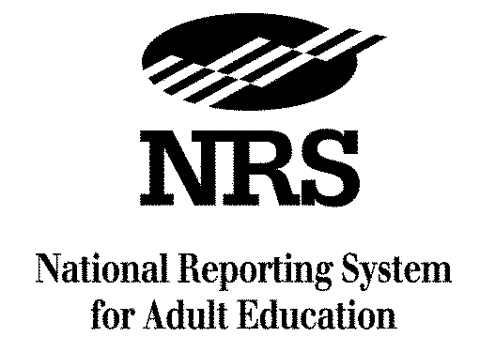
A Project of the U.S. Department of Education

Changes to NRS Guidelines
For Distance Education Learners

1. See the section beginning on p. 22 on “State Responsibilities for Measuring Educational Gain”:

Assessment of Students in Distance Education

Students in distance education should be posttested after the same amount of instructional time as other students, according to the state’s approved NRS assessment policy. States that choose to develop proxy contact hours using one of the approved models will use the proxy contact hours to measure the posttest time for distance education students. For example, if the state’s assessment policy requires posttesting after 80 contact hours, programs must posttest distance education students after 80 proxy contact hours, as determined by the state model.

States that choose not to collect and report proxy contact hours must develop procedures for determining the appropriate time for posttesting students in distance education and may use one of the proxy contact hour models or another appropriate method, as long as the posttesting time is after the same amount of instructional time as other students. The state will describe the methodology it employed for determining posttest time and procedures for posttesting distance education students in its state assessment policy.

Programs must administer all pre- and post- assessments used to measure educational gain of distance education students for NRS reporting in person, at a proctored program site within the state that meets NRS assessment policy. Assessments not conducted through face-to-face interaction with a trained test administrator in a secure setting are not allowed for NRS reporting.

2. See p. 45, under “Student Participation Measure #1: Contact Hours”:

Measuring Contact Hours for Learners in Distance Education

Students in distance education (defined below under Student Participation Measure #2) must have at least 12 hours of contact with the program before they can be counted for federal reporting purposes. Contact hours for distance learners can be a combination of actual contact and contact through telephone, video, teleconference or online communication, where student and program staff can interact and through which learner identity is verifiable.

Optional Reporting of Proxy Contact Hours

States may, but are not required, to report proxy hours of time students spent on distance learning activities. States providing distance education that want to measure and report proxy contact hours for these students must develop a state distance education policy that describes the following.
- The curricula that local programs can use to provide distance education;
- The model or models used to assign proxy contact hours for each type of curriculum. States must develop proxy contact hours using one of the following models.
- Clock Time Model, which assigns contact hours based on the elapsed time that a learner is connected to, or engaged in an online or stand alone software program that tracks time.
  - Teacher Verification Model, which assigns a fixed number of hours of credit for each assignment based on teacher determination of the extent to which a learner engaged in, or completed, the assignment.
  - Learner Mastery Model, which assigns a fixed number of hours of credit based on the learner passing a test on the content of each lesson. Learners work with the curriculum and materials and when they feel they have mastered the material, take a test. A high percentage of correct answers (typically 70%-80%) earns the credit hours attached to the material.
- The proxy contact hours assigned for completing requirements for each type of curriculum used (teacher verification model) or the proxy contact hours assigned for completion of units of material comprising the curriculum (learner mastery model). The state must use the proxy contact hour model appropriate for the distance education curricula. The state may use the clock time model with curricula that track time student spends interacting with instructional material and disconnects after a preset period of inactivity; and must describe the procedures the state used to develop proxy contact hours.

\

3. See p. 47), under “Student Participation Measure #2: Program Enrollment Type”:

- Distance Education—Formal learning activity where students and instructors are separated by geography, time or both for the majority of the instructional period. Distance learning materials are delivered through a variety of media including, but not limited to, print, audio recording, videotape, broadcasts, computer software, web-based programs and other online technology. Teachers support distance learners through communication via mail, telephone, e-mail or online technologies and software.
Note: For participants who receive both distance education and traditional classroom instruction during a program year (such as through a blended distance-classroom approach or concurrent enrollment in both types of instruction), the state must have a policy, consistent with the NRS definition, that defines how local programs are to classify the student. For NRS reporting, states can count a student only once, as either a distance education student or traditional classroom learner.
4. See p. 76, under “Federal Reporting Tables”:

NRS Reporting for Students in Distance Education

States will report all required NRS data elements on distance education students in all NRS tables, according to current requirements. States electing to develop proxy contact hours for students in distance education will report both proxy and actual contact hours in Table 4.

States must report data on students in distance education separately in Table 4c, identical to NRS Table 4, and in Table 5a, identical to Table 5. Only students in distance education are to be reported in these new tables table and all contact hours (proxy and actual) are to be reported in Table 4c.

Two newFederal Reporting Tables have been added:

Table 4c and 5a.

See Project Ideal (2005), Working Paper No. 2 Measuring Contact Hours and Learner Progress in Distance Education Programs, Institute for Social Research, University of Michigan, for further information on the use and development of these models.

