Enrolling in MN IDEAL Courses
The IDEAL Consortium, a project of the EdTech Center at World Education, Inc., is working to develop effective online education programs for adult learners, raising the quality of blended and distance online learning across the United States through new educational technology innovations and collaborative research and practice. Here’s how you make an account and enroll in your course!
To enroll in IDEAL online courses: Go to https://elearning.worlded.org/login
- Click Create new account
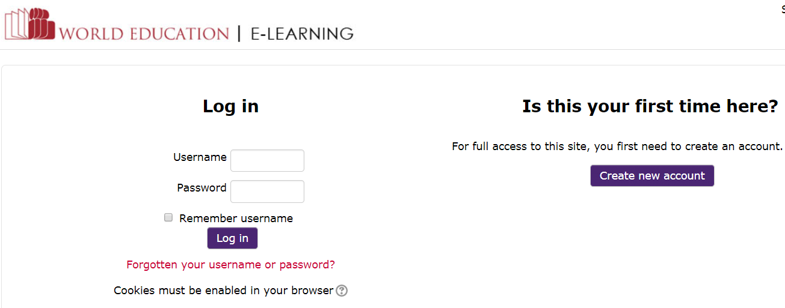

- Fill out the form and the CAPTCHA, click Create my new account
(or sign in if you already have a WorldEd E-Learning account)
- Go to your email, open the email from World Ed, and click on the blue link to confirm your account.
- Once you are signed in, click on Site Home in the upper left navigation panel, then scroll down to click IDEAL Consortium, then Minnesota.

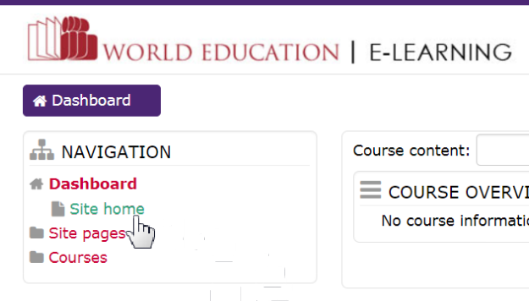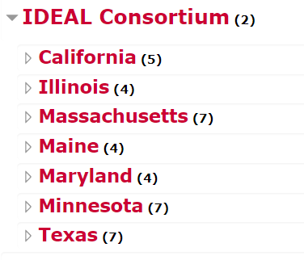

- Scroll down a bit, then click on any of these: MN Introduction to Blended Learning; MN Introduction to Mobile Learning, or MN Open Educational Resources
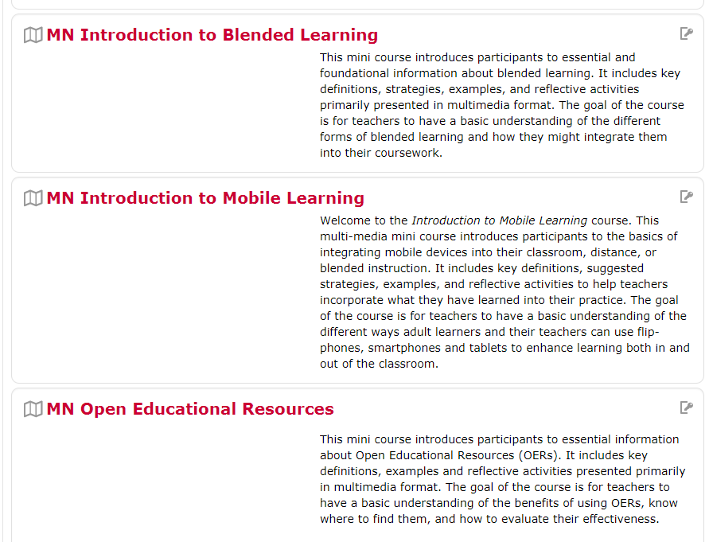

- Enter the enrollment key for MN in the box: MNIDEAL then click the blue Enroll Me button.
- You’re done! You’re now enrolled in your course.

