What is this?
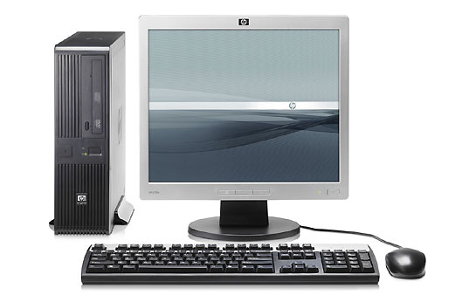
A. laptop computer
B. CPU
C. desktop computer
D. internet

What is this?
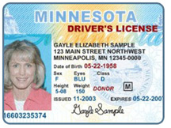
A. social security card
B. green card
C. driver's license
D. ID card

What place is this?
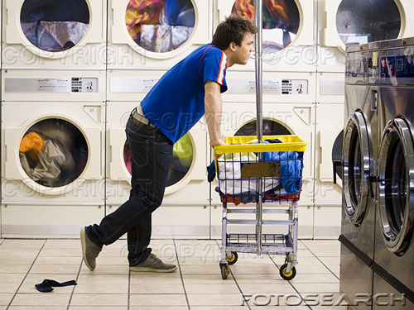
A. laundry
B. laundromat
C. wash your clothes
D. laundry detergent
What can you do here?
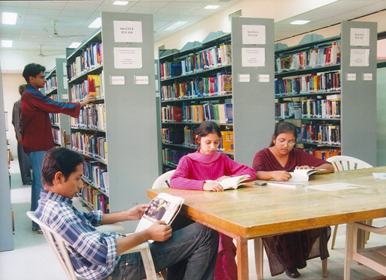
A. check out a book
B. get money
C. get a driver's license
D. get a job

Which one is a date?
A. March
B. Tuesday
C. 12/6/78
D. 245 8768

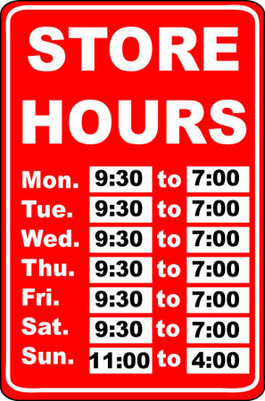
What time does the store open on Monday?
A. 7:00
B. 4:00
C. 11:00
D. 9:30

What time does the store close on Sunday?
A. 7:00
B. 4:00
C. 11:00
D. 9:30
Housekeeper needed.
Ramada Inn is hiring a p/t and f/t housekeeper.
Must be able to work weekends. Day and evening shifts available. Apply in person in the office.
635 W. 7th St. St. Paul, MN 55102
Please bring two forms of ID.

What job is available? ____________________________________
Where is the job? ____________________________________
How do you apply for this job? ____________________________________
Where is the office? ____________________________________
What do you need to bring? ____________________________________
Is the job full time or part time? ____________________________________
How many jobs are available?
____________________________________

Yesterday was my day off. I was very busy. I went grocery shopping at Cub Foods. I went to the post office to mail some letters and to buy stamps. I went to the bank to deposit my paycheck and get some cash. I had to write a lot of checks to pay the bills. I paid the cell phone bill, the electric bill, the credit card bill and the rent! I also cleaned my bathroom and the kitchen because they were dirty and messy. I ate an apple for lunch. My children came home after school. I made pasta, salad and bread for dinner. We talked about their day. My daughter had a good day at school. She drew a picture for me. My son had a bad day at school. Sometimes he doesn’t understand and he gets angry. I usually help him with his homework at night. I read a couple books to the kids before they went to bed. Then I took a shower and went to bed. I was tired!

Where did she go grocery shopping?
____________________________________
What bills did she have to pay?
____________________________________
What did she clean?
____________________________________
What did she make for dinner?
____________________________________
Who had a bad day at school?
____________________________________
Do you think she is a good mom?
Why or why not?
________________________________________________________________________

