Affordable Connectivity Program (ACP)

SECTION 1: PROGRAM INFORMATION
Purpose of the Program: The Affordable Connectivity Program (ACP) provides a discount of up to $30 per month toward internet services for eligible households. Household on qualifying Tribal lands can receive up to $75 per month. ACP is administered by the Universal Service Administrative Company (USAC) with oversight from the Federal Communications Commission (FCC). The funds will go directly to the broadband service provider that the qualified household applies with.
$100 Off
Device
$75 Off
Per Month
On Tribal Land

$30 Off
Per Month

List of providers participating in ACP:
Affordable Connectivity Program Providers | Federal Communications Commission (fcc.gov)

Contact Information:
ACP Support Center at (877) 384-2575

SECTION 2: ELIGIBILITY REQUIREMENTS
Basic Eligibility: Households with incomes at or below 200% of the Federal Poverty Guidelines or if a member of the household meets at least one of the following criteria:
- Participates in certain assistance programs, such as SNAP, Medicaid, Federal Public Housing Assistance, SSI, WIC, or Lifeline;
- Participates in Tribal specific programs, such as Bureau of Indian Affairs General Assistance, Tribal TANF, or Food Distribution Program on Indian Reservations;
- Participates in the National School Lunch Program or the School Breakfast Program, including through the USDA Community Eligibility Provision;
- Received a Federal Pell Grant during the current award year; or
- Meets the eligibility criteria for a participating provider's existing low-income internet program.

SECTION 3: APPLICATION PROCESS
Where to sign up for the Affordable Connectivity Program?
Households can enroll through an approved provider or by visiting ACPBenefits.org. Eligible households must both apply for the program and contact a participating provider to select a service plan.
Online Application
English Application Form PDF
Spanish Application Form PDF
What information is required for filling out the application?
The following information and documents are required for the application:
PERSONAL INFORMATION
❏ Name
❏ Phone Number
❏ Date of Birth
❏ Email Address
❏ Identity Verification
- Last 4 digits of Social Security Number (Social Security Number is not required to participate in ACP but using a Social Security Number will process your application the fastest.)
- Tribal ID Number
- Driver’s License, Military ID, Passport, Taxpayer Identification Number or other Government ID
❏ Home Address
❏ Mailing Address (If different from Home Address)
❏ Proof of participation in a government assistance program
OR
❏ Copy of Proof of Income

HOUSEHOLD INFORMATION - The following information is required if applicant wants to qualify through a child or dependent in the household.
❏ Name
❏ Social Security Number (SSN) * Non-Citizens see note below
❏ Date of Birth
❏ Identity Verification
- Last 4 digits of Social Security Number (Social Security Number is not required to participate in ACP but using a Social Security Number will process your application the fastest.)
- Tribal ID Number
- Driver’s License, Military ID, Passport, Taxpayer Identification Number or other Government ID

❏ Copy of proof of participation in a government assistance program
OR
❏ Copy of Proof of Income

If the applicant applies using the online application, the applicant must upload a copy of their identity verification if NOT using their Social Security Number. File must be less than 10 MB and the following type: jpg, jpeg, png, pdf or gif.

Mail your application to:
ACP Support Center
PO Box 7081
London, KY 40742

Additional information on application process can be found here.
How to provide additional information or documentation on eligibility can be found here.

SECTION 4: EXPECTATIONS (WHAT WILL HAPPEN?)
What is the timeline for ACP approval?
- Applications are processed as quickly as possible, and you have a right to receive a response within a reasonable time of submitting all information.
- Online applications using a Social Security Number may receive quicker notification of status.
- Any missing information in your application may delay services.
- You will receive a letter when your application is completed. If you provided an email address on the application then you will receive updated via email.

Once approved, what to do next?
- After an applicant is approved for ACP, then the applicant will need to select a provider and sign up for service. See list for participating program providers.
- When signing up for service, the provider may ask questions to verify ACP approval. Once the household is signed up with services, the discount will go directly to the provider to apply to the account.

SECTION 5: ADDITIONAL RESOURCES
Affordable Connectivity Program | Federal Communications Commission (fcc.gov)
Affordable Connectivity Program Consumer FAQ | Federal Communications Commission (fcc.gov)
FCC ACP Fact Sheet
National Digital Inclusion Alliance Community FAQ
ACP Consumer Outreach Toolkit | Federal Communications Commission (fcc.gov)
Need Help with an Affordable Connectivity Program (ACP) complaint? – FCC Complaints

SCREENSHOTS
How to Apply
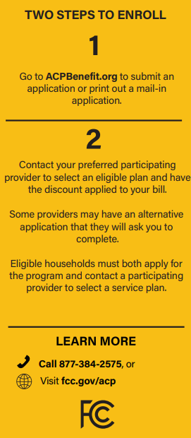
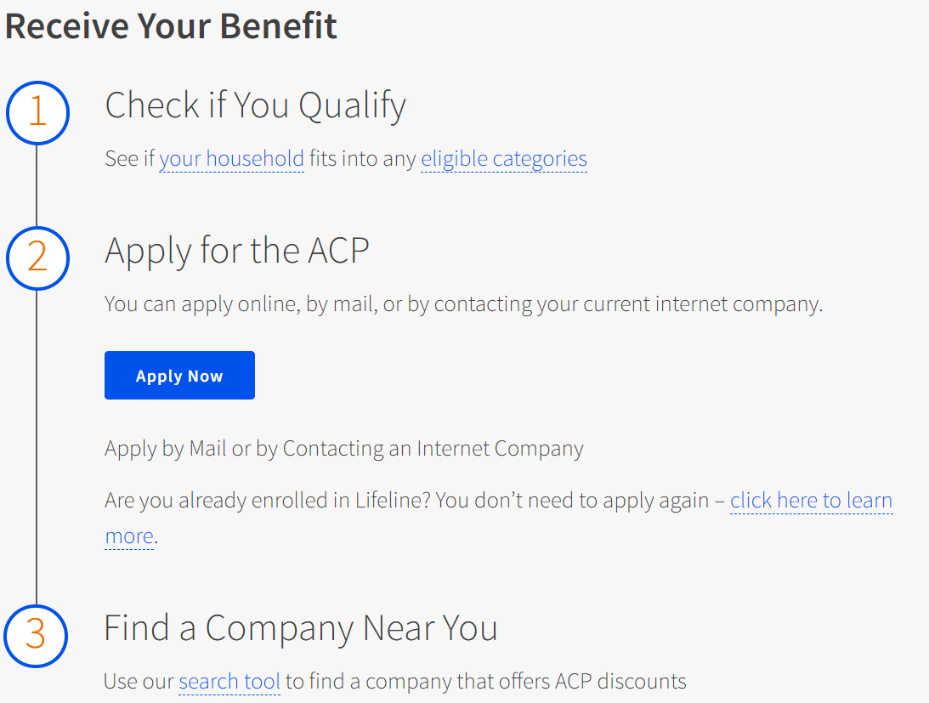

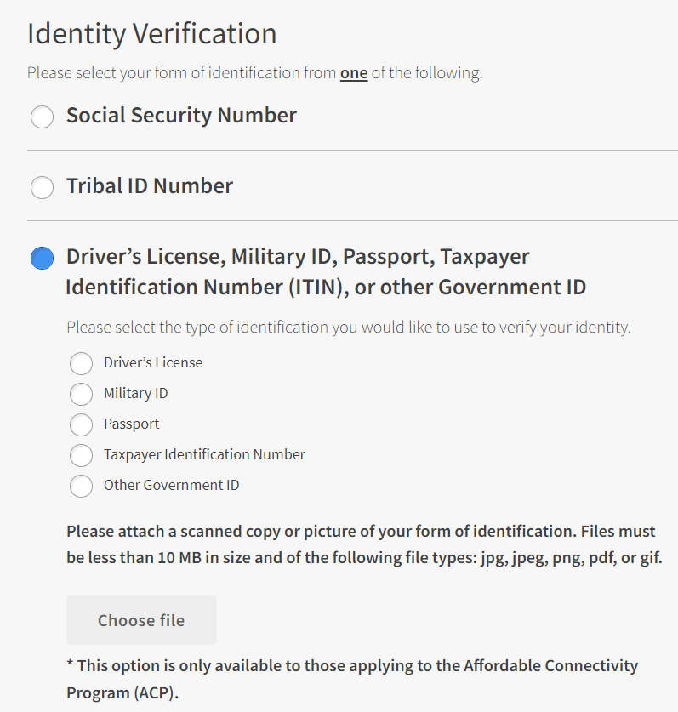
Upload Identity Verification document for online application

