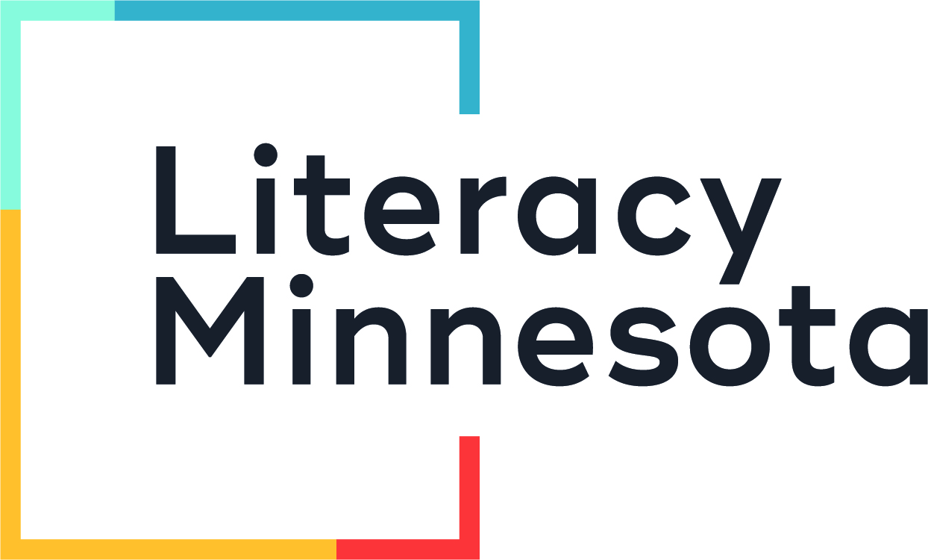
Request for Volunteer Recognition
Certificates

Certificates are available free of charge for volunteers in the Literacy Minnesota network of adult literacy volunteer programs. They are customized to be awarded to volunteers contributing any number of hours.

This form is to be completed by a volunteer coordinator or program staff. Please email your completed form to Rob at rpodlasek@literacymn.org.

Please allow three weeks for delivery.

Program Name:
Volunteer Coordinator Name:
Phone:
Email:
Mailing Address:

Volunteer Name: (Please list each name exactly as you would like it to appear on each certificate.) | Number of Hours:

