How to Be a Digital Navigator in 5,687.2 Steps
Goal:
- Follow the eight components of digital navigation to provide navigation support to programs and learners.
What is Digital Navigation?
Digital Navigation is providing assistance with digital literacy skills, access to devices and ongoing digital support.
Eight Components of Digital Navigation
The eight components of digital navigation were identified by Literacy Minnesota for what is beneficial to have in providing digital navigation/navigation. This handbook will go step by step on each component and share how to provide this assistance and any resources that would be helpful in providing this service.
- Assessing Student and Program Needs
- Accessing Devices
- Accessing Internet
- Configuring Devices and Software
- Providing Initial Training on Software and Devices
- Providing Ongoing Training on Software and Devices
- Providing Tech Support
- Providing Wrap-Around Navigation

What is a Digital Navigator?
A digital navigator is someone who provides digital literacy training to a learner. This can be assisting with accessing a device or providing digital literacy skill training on devices and software.

Do I Have to Have Advanced Training to be a Digital Navigator?
You do not need to have specific training or a specific degree to be a digital navigator. A little basic computer knowledge and the attitude to learn on the go will be more than helpful.

Component #1: Assess Student and Program Needs
Assessing Program Needs.
In order to be able to provide digital literacy training and resources to a learner, the program must first know what their program already provides. Assessing what your program provides in terms of digital navigation is important when knowing how to assist learners. Below is a program assessment following the eight components of digital navigation which can help a program decide where they already have support or need a specific digital navigatior. This form can be found in the digital navigation tool kit folder.

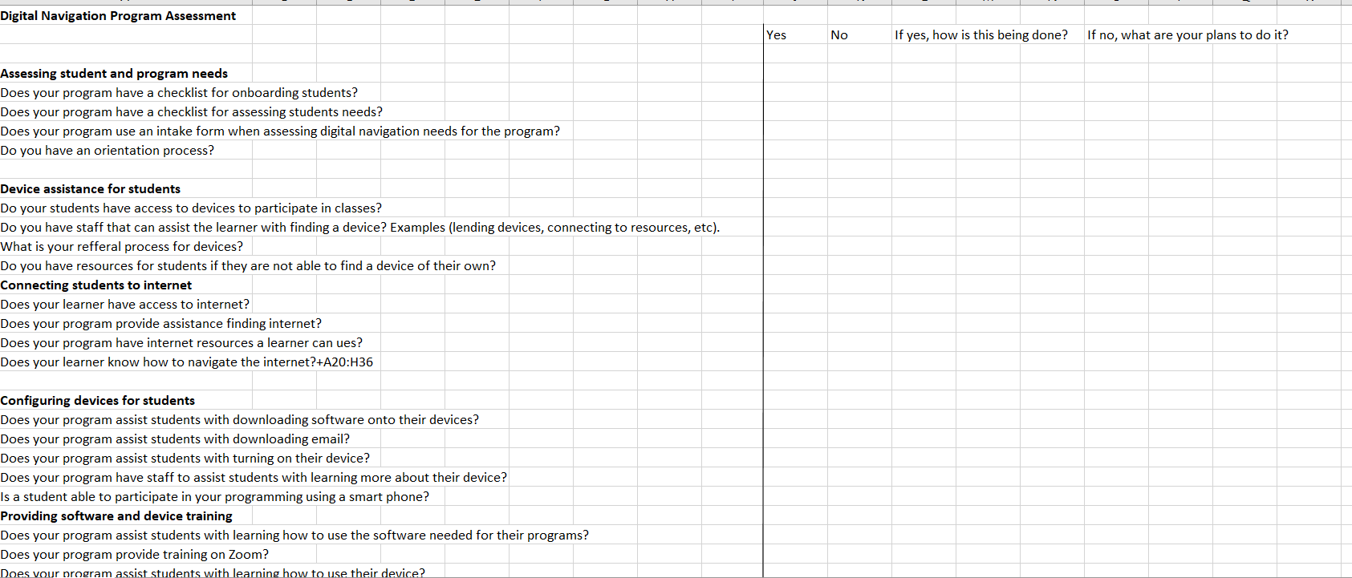

Once you have gathered this assessment, you will have a better understanding of what further digital navigation support a program needs. The full version of this can be found in the digital navigator training tool kit. Please feel free to share out the assessment as needed.

Assessing Student Needs
Assessing a student’s needs upon intake is essential to know what assistance and tools a student will need to participate in programing. As a digital navigator you can assist in this process by using one of the intake examples below. The first intake questions were created by staff at the Open Door Learning Center.

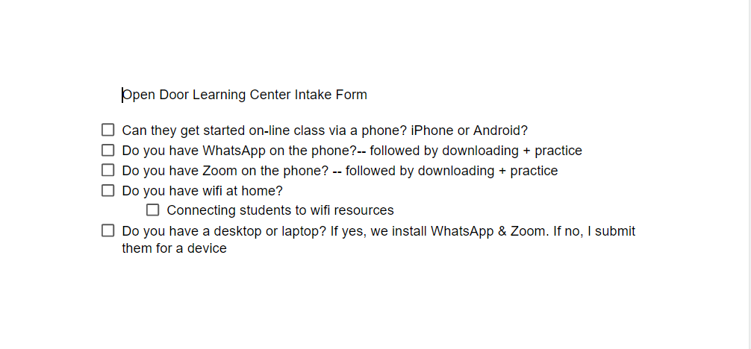

Below you will find another example of assessing student needs that was created by Literacy Minnesota. This form is based on the eight components of digital navigation and assessing a student’s needs according to each component. 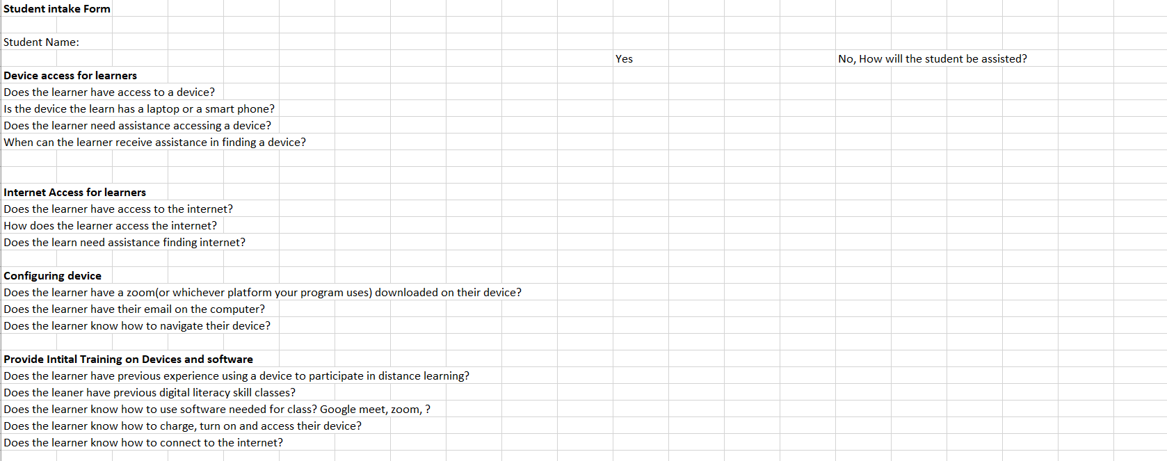

Northwest Services COOP created an excellent student technology needs survey for their program. This survey is longer than the two previous examples but gathers a lot of beneficial information that a program will want to use to assist their student.

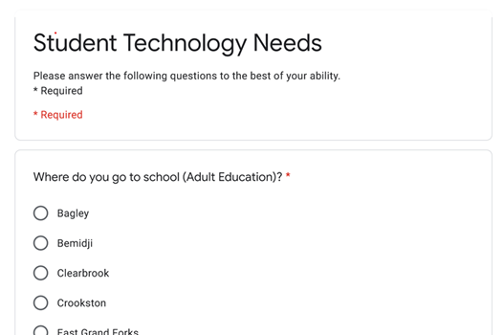

Component #2: Access to Devices

Device access is an important step towards digital equity. As a digital navigator you will need to know a few resources that you can use to help learners secure a device. There are a few different ways learners can access devices some of which are; borrowing a device from their program, receiving a device for free after attending a certain amount of classes or purchasing one through an organization. It is good practice to familiarize yourself with the programs device policies before you move on to assisting a learner with purchasing a device. Listed below are a few great organizations within Minnesota that offer reduced or no cost at al devices.
- PCs for People
- Tech Discounts
- Free Geek Twin Cities

Component #3: Access to Internet
Along with access to devices, having access to the internet is important in working towards closing the digital divide. For some learners internet might not be as high of a need but for the learners that are in need of internet assistance, it is important to know of a few resources for affordable internet. Listed below are the names of a few local internet providers. A full list of these resources can be found in the resource list in the digital navigator tool kit.
- PC’s for People Hotspots
- Borrow the Internet from the St Paul Public Library
- Internet deals at a variety of internet providers.

Component #4: Configuring Devices and Software
The next component in digital navigation is configuring devices and software for the learner. This could be assisting the learner with upgrading the software on the device or downloading software that is needed to attend class. Listed below are a few other ways a digital navigator could provide navigation with configuring devices and software.
- Configure Hotspots/Wi-Fi- Show learner how to connect their device to a hotspot and to accessible Wi-Fi.
- Update Systems Software: Update the computer software so it is up to date with the current year and will be able to function well.
- Download Program Software: Download software that is needed to participate in programming.
- Bookmark Relevant Pages: Show the learner how to bookmark pages needed for class and outside of class.

Component #5: Initial Training for Learners
As a digital navigator there are many different ways to provide initial training for learners. Providing initial training on devices should all be centered on what the device will be used for in programming and in the learner’s day-to-day life. It would be good to refer back to component #1 to get a better understanding of what the students digital literacy skills are. Initial training can mean ensuring the learner is comfortable with the beginning computer skills such as turning on the computer, charging the computer or connecting to internet. Other important resources for initial training for learners can be found in the digital navigation resource tool kit.

Component #6: Ongoing Digital Navigation
Ongoing digital navigation can provided in different ways. A few examples of providing ongoing digital navigation could be checking in with the learner about their device, providing on the spot technology support, or connecting the learner to ongoing digital literacy classes.
Some examples of providing ongoing digital literacy learning are:
  - Northstar Digital Literacy Curriculum
  - Digital Literacy Classes
  - Digital Push-in Classes
  - One-to-One Tutoring
  - On Demand Support

Component #7: Navigating Tech Support
Navigating tech support can be stressful and having the tools to communicate what is going on can make all the difference. As a digital navigator you may provide a base line of in house tech support such as software assistance or helping figure out what may be causing an issue. Some things to keep in mind when providing in house tech support are:
- Is it a tech issue or is it user error?
- Naming the problem?
- How can client communicate the issue to tech support vendor?
Some common tech issues digital navigators come into contact with are:
- Unable to connect to Wi-Fi- If this is the case, try restarting the computer or doing a hard restart of the internet/device. Every internet device is different so you may need to look in the user manual or google it.
- Forgetting Password-You might have to reset this with an email or phone associated with the account.
If the tech issue is something that you as a digital navigator cannot provide assistance with, then you might have to connect the learner to a staff or person that specifically works as tech support. It is also helpful for the learner to know how to communicate with tech support and practice how to do so with them. Here are a few key phrases that will be helpful for a learner to know when communicating with tech support:
- “Hi, my name is ____________.”
- “I received a laptop from the ____________ program.”
- “The identification number for the laptop is _______.”
- “I have been working with a navigator and we think the problem is _____________.”
“What do I need to do to get this fixed?
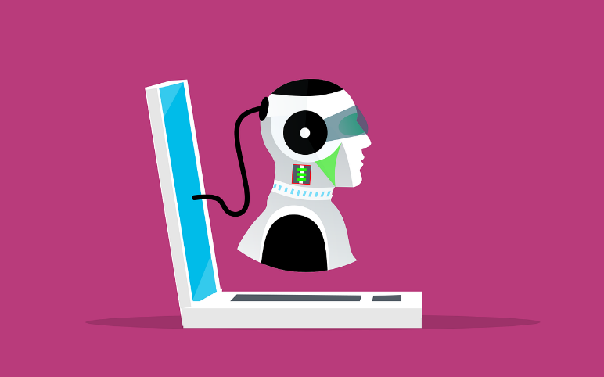
Component #8: Wrap-around Navigation
Wrap-around navigation means providing access to resources for learners outside of the classroom. These resources can be related to job searching, housing assistance, food assistance, child care and other needs. Ways for you as a digital navigator to provide wrap-around navigation is to first familiarize yourself with some resources. You can find more resources in your resource handbook list in your digital navigator tool kit. Here are a few resources that may be helpful in providing wrap-around navigation:
- Minneapolis/Saint Paul Handbook of the Streets- The book of all books of social services resources in the twin cities. You can purchase one online in the link in your resource handbook or pick up one at a local library.
- Career Force MN- Offers resources on searching for careers to food assistance.
- MN ABE Hotline- Can connect you to resources you need by giving them a call.

Time to start!
Enjoy your time as a digital navigator and any resources and tools you may need can be found in the digital navigator tool kit.

