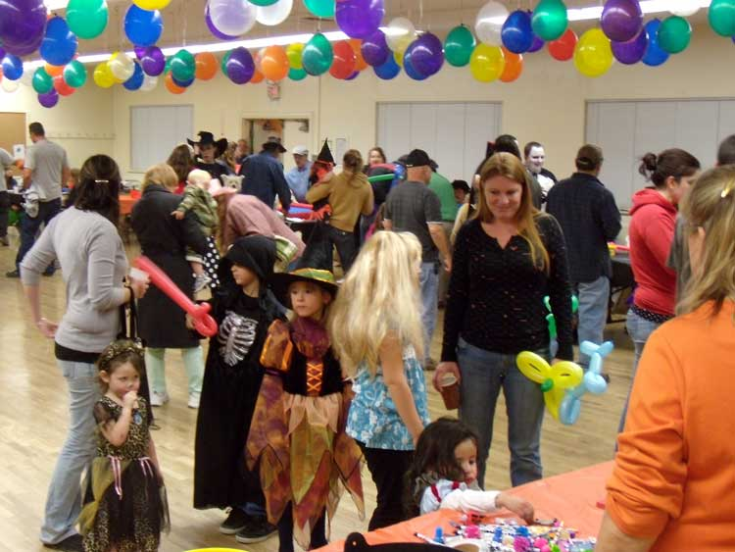
Halloween
Halloween is a holiday.
Halloween is October 31.
It is a day and night for fun and costumes.
Children love this holiday.
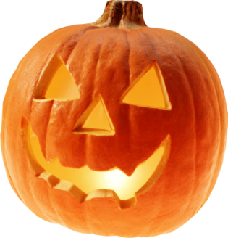
Many adults like this holiday too.

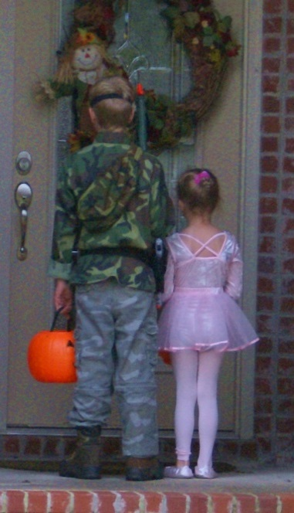
Some people make jack-o’-lanterns.
Children may wear costumes to school.

At night children go to homes in their neighborhood.
They knock on the door.
The neighbor opens the door.
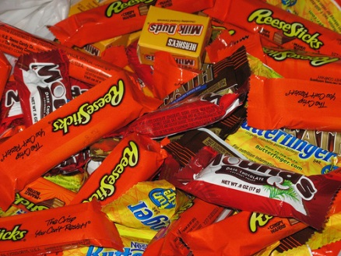
The children say, “Trick or treat!”
The neighbor gives the children candy.

Help children stay safe on Halloween.
Young children need to go out with an adult.
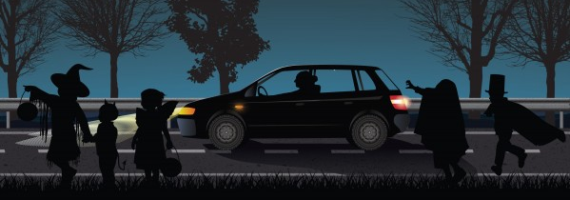
They need to carry a light.
If you are driving, be careful!
Lots of children will be out in the streets.
- Find the word costume. Look at the children in the pictures. What is a costume?

- The text says children love Halloween. Look at the text. Look at the pictures. Why do children love Halloween?

- Look at the text. What do children do for Halloween?

- Look at the text. What do adults do for Halloween?

- Look at the text again. How do people stay safe for Halloween?

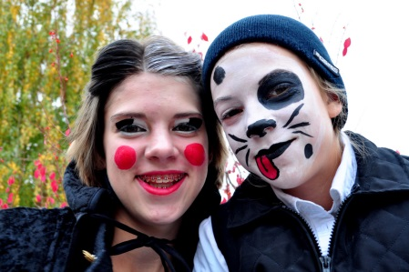
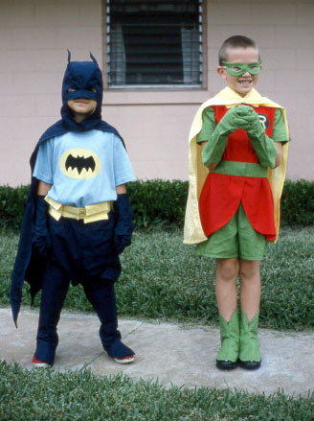
- Find the word costume. Look at all the pictures. Circle the costumes.
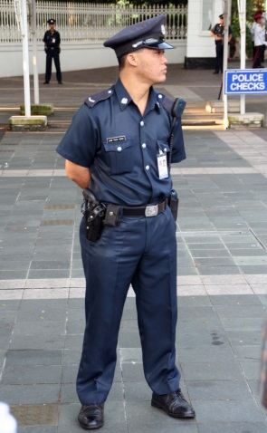

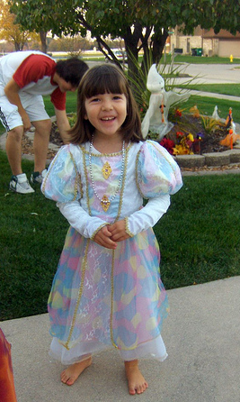
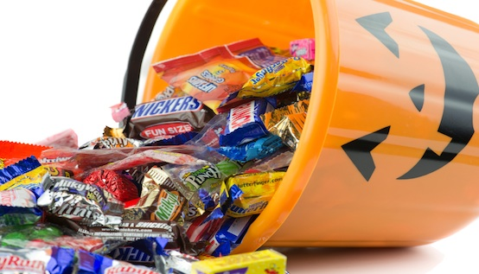
- The text says children love Halloween. Look at the text. Look at the pictures. Circle why children love Halloween.

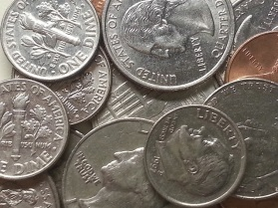

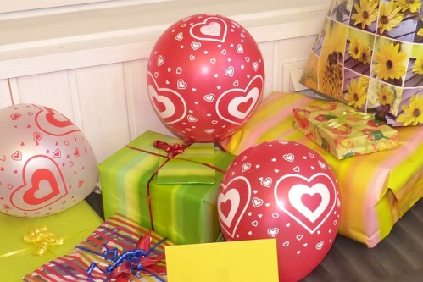
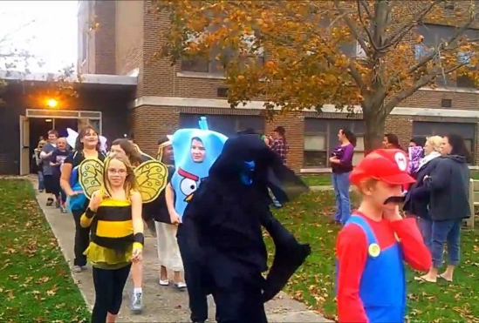
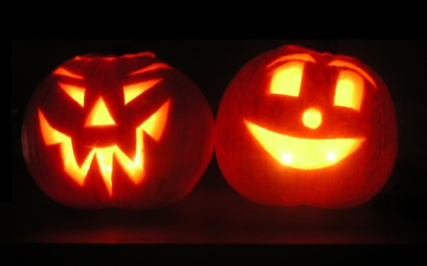

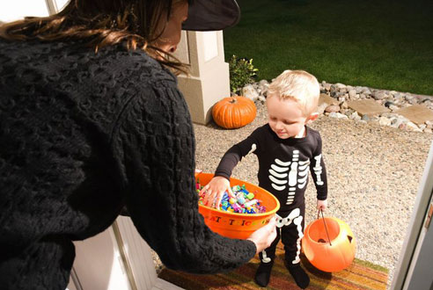
- Look at the text. Circle what children do for Halloween.

- Look at the text. Circle what adults do for Halloween.
