Microsoft Word Day 9

Objectives Learners will be able to… | Materials
Computer skill: change the space between lines  Literacy skill: follow steps to revise a partners Cover Letter  Literacy Skill: offer constructive criticism | Make Student Copies  - Microsoft Word: Exercise 9 (Tab 20)  Props, Technology or Other Resources  - Computers  - Projectors  - USB
Lesson Plan |  | Vocabulary
Warm up for today’s Lesson: 15 minutes  Description: As students come into class, have them work on their cover letters.  Materials/Prep:  Activity 1: What is Constructive Criticism? 30 minutes  Description: explain ways to give helpful criticism, do not take more than 30 minutes on this  Materials/Prep: copies of Microsoft Word Exercise 9: Constructive Criticism  Activity 2: Revising 30 Minutes  Description: learners will pair up and revise a partners cover letter  Materials/Prep:  Activity 3: Line Spacing 10 Minutes  Description: briefly go over how to change the amount of space that appears between lines and explain desired spacing for Cover Letters  Materials/Prep:  Activity 4: Editing  Description: briefly go over how to change the amount of space that appears between lines and explain desired spacing for Cover Letters  Materials/Prep: |  | - Revise  - Constructive Criticism  - Line spacing  - Sandwich method  - Edit

For today, if there are many students who still have a lot of typing to do on their cover letters, go ahead and take this time to let them try to wrap up their letters. The priority for today is that students finish as much of their cover letters as possible. The revisions can be done by the teacher Day 10 or 11. Helpful documents include:
- Cover Letter Format from Day 7
- Good Cover Letter Examples from Day 8

If students work on their cover letters for most of the class, go ahead and skip Activity 1 and move on to Activity 2. Do NOT skip activity 3; it is going to be on the assessment students take Day 11.

Teacher Directions: Activity 1: Constructive Criticism
-Microsoft Word Exercise 9: Constructive Criticism
Step 1: Context
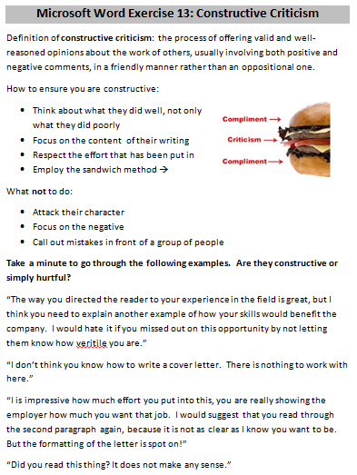
Explain that with the revising step, as we learned Day 8, often includes asking someone else to look over your work
Why important? When you bring in another pair of eyes they might catch things that you will not
Explain that an important part of working with a partner is being able to trust them to help you, but not make you feel dumb or insecure
Before we pair off, we are going to discuss ways to revise and offer suggestions for changes in a constructive way rather than a demeaning way

Step 2: What is Constructive Criticism?
Ask if anyone has heard the phrase “constructive criticism” before?
Does anyone know what it means? Constructive criticism is the process of offering valid and well-reasoned opinions about the work of others, usually involving both positive and negative comments, in a friendly manner rather than an oppositional one.
Explain that the key to being constructive is to remember that you are on the same team as the person who’s paper you are editing, you want them to succeed

Step 3: How to be constructive with your criticism
Hand out Microsoft Word Exercise 9: Constructive Criticism
Read through the first half of the document together
The bottom lists examples
Complete the first two examples as a class
Students should complete the last two, including reasons to justify their decision, and then review as a class

Step 4: Another Example
The following is a section from a cover letter written by a gentleman who is applying for a management position at a landscaping company:
“My organization skills will keep the company in track and prevent redundancies and mistakes and will be beneficial. These skills are important for any company, and ideal for a management position.”

Teacher Directions: Activity 2: Revising
Step 1: Review Revising
Ask students what goes into revising? What do they remember?
Write these questions to answer when revising on the board
- Are my details clear?
- Should I add or take out parts?
- Have I used the best ideas and words?
- Are all my sentences complete?
- Is my writing in a sensible order
Step 2: Pair students off
Put students into pairs
Ideal pair: one member is only a slightly more advanced English speaker than the other. Avoid putting two people with widely varied English skills together

Step 3: Print Cover Letter
Demonstrate the steps to print the Cover Letter and then instruct the students to do so

Step 4: Instructions
Students should give their partner their Cover Letter
The partner should read through it, answer the questions that are listed on the board, it might take a while
Remind students to keep in mind the sandwich method
Students can begin, circulate to answer questions

Teacher Directions: Activity 3: Line Spacing
Step 1: Demonstrate
Briefly go over how to change the spacing between lines
Highlight>locate line spacing button on ribbon>click desired number
Practice with students
Explain that cover letters should be single-spaced

Teacher Directions: Activity 4: Editing

If you do not have time for this activity, note it in the lesson report. It will need to be discussed Day 11.

Step 1:Review steps of writing process
Ask learners which steps of the writing process they have gone over already: prewriting, drafting and revising
Write them on the board
Ask what goes into each step
- Prewriting-brainstorming, determining what you will write about and coming up with details
- Drafting-organizing details and expanding them into sentences
- Revising-make sure details are clear and you are using the best words to describe your detail

Step 2: Editing
Ask if anyone remembers what is involved in the editing step?
  - Editing your spelling, capital letters and punctuation
  - Make sure information is clear
  - Check formatting
  - Writing a neat final copy of your work

Step 3: Begin Editing
Instruct learners to begin editing their Cover Letters
Microsoft Word Exercise 9: Constructive Criticism
Definition of constructive criticism: the process of offering valid and well-reasoned opinions about the work of others, usually involving both positive and negative comments, in a friendly manner rather than an oppositional one.
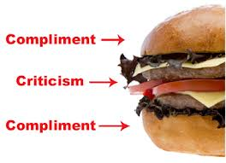
How to ensure you are constructive:
- Think about what they did well, not only what they did poorly
- Focus on the content of their writing
- Respect the effort that has been put in
- Be specific
- Employ the sandwich method
What not to do:
- Attack their character
- Focus on the negative
- Call out mistakes in front of a group of people
Take a minute to go through the following examples. Are they constructive or simply hurtful?
“The way you directed the reader to your experience in the field is great, but I think you need to explain another example of how your skills would benefit the company. I would hate it if you missed out on this opportunity by not letting them know how versatile you are.”
“I don’t think you know how to write a cover letter. There is nothing to work with here.”
“I is impressive how much effort you put into this, you are really showing the employer how much you want that job. I would suggest that you read through the second paragraph again, because it is not as clear as I know you want to be. But the formatting of the letter is spot on!”

