Microsoft Word Day 7

Objectives Learners will be able to… | Materials
Literacy skill: drafting  Computer skill: cut and paste  Computer skill: download existing document | Make Student Copies  - Microsoft Word Exercise 7 (Tab 17)  - Cover Letter Format (Tab 18)  - Prewriting Practice as needed from Day 6 (Tab 16)  Props, Technology or Other Resources  - Projector  - Computer for self and all students  - Download from USB or online Day 7 Word Cover Letter Formatting
Lesson Plan |  | Vocabulary
Warm up for today’s Lesson:  Description: Ask students what goes on in the Prewriting step of the writing process: narrowing down your topic, determining audience and then picking details that your audience needs to know. This is the brainstorming phase, where the details are only a couple of words.  Materials/Prep: (none)  Activity 1: Organizing/Drafting  Description: learners will practice drafting details of a document in order and will then type a list of their own skills in order of relevancy for the job they want  Materials/Prep: Prewriting Practice as needed, copies of Microsoft Word Exercise 7  Activity 2: Drafting  Description: learners will practice expanding details into complete sentences  Materials/Prep:  Activity 3: Cover Letter Formatting  Description: class will go over a cover letter template and then download an example of a poorly formatted and poorly worded cover letter  Materials/Prep: copies of Cover Letter Format, download Day 7 Word Cover Letter Formatting |  | - Drafting  - Chronologically  - Relevance  - Cover Letter
Teacher Directions: Activity 1: Organizing/Drafting -Microsoft Word Exercise 7
Step 1: Review steps of writing process
Ask students if they remember the steps of the writing process
Write the steps on the board, in order

- Prewriting
- Drafting
- Revising
- Editing
- Publishing

Ask students what the steps are within the prewriting stage- brainstorming for a specific topic, identifying audience, picking details to be written about
Circle the drafting step, explain that this is what we will be discussed in this class

Step 2: Introduce drafting step
Explain that the drafting step is where the ideas and details that were developed in the prewriting step are written down/typed
First it is important to organize the details in the order they should be addressed within your document
Example: If the topic was history of music, the order of my details would be chronologically
Ask if anyone knows what chronologically means
Explain that it is also possible to arrange by topic
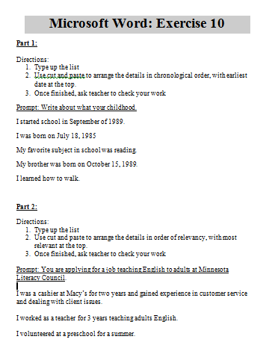
Example: If you are applying for a job, you would arrange the details by most relevant skill. When applying for a management position, you would place leadership experience at the beginning. Visually represent this process on the white board

Step 3: Independent Organizational Practice
Handout Microsoft Word Exercise 7
Read through the directions together for Part 1
Students should attempt to complete on their own
*Slower typists- you may have students who are very slow typist. For this, they should only complete part 1 and try to practice the cut and paste motion.

Step 4: Review Prewriting from Day 6
Instruct students to pull out their Prewriting Practice from the previous day regarding job skills
If students missed the previous day, have them follow along with the class and fill in with examples we go over
Review the first three parts of the handout
Instruct students to think about the type of job they would be applying for
Ask students to list off the types of jobs
Ask students to list of the skills they listed in their prewriting exercise

Step 5: Type List of Skills by Relevancy
Demonstrate putting skills into an order of relevance for a specific job
Explain that it is important to think about the kind of skills an employer would be looking for within that specific job
Instruct students to type their skills by relevancy

Teacher Directions: Activity 2: Drafting/Turning into sentences –

Step 1: Demonstrate
Explain that the next step in drafting is expanding the one word details into sentences.
Explain that the type of information that should be added to details depends on context
Example: if someone is writing an essay about Mexican food, one detail could be tacos. This could be expanded to “Tacos are a popular Mexican dish that typically include a meat, topped with different vegetables laid inside of a tortilla shell.
Explain that when writing a letter or a resume regarding a job application, the details should be expanded with experience with the skill, certifications in the skill or how you have used the skill in a previous job setting
Demonstrate turning a skill such as “computers” into a sentence- “I have taken courses to develop my computer skills in Microsoft Office programs.” Or even better “My dedication to life-long learning has brought me to take computer classes to develop my knowledge and understanding of Microsoft Office programs.

Step 2: Controlled Practice
Ask students for examples of the skills/details they have listed
Practice turning the skills into sentences with the students
Ask them where the learned the skill, when they have used it, etc.
Do this for 3-4 examples

Step 4: Individual Practice
Instruct students to look at the list they created in word and have them expand the details into sentences that would be applicable to a job they want to apply for

Teacher Direction: Activity 3: Cover Letter Formatting – Cover Letter Format
-Cover Letter Formatting
Step 1: Introduce idea of a cover letter
Now students have sentences about their skills, explain that these can now be used to create a cover letter
Explain what a cover letter is, ask if anyone has written one before. What do you include? What do you leave out? This is a review of purpose
Explain the importance of being professional in the cover letter.
Example: Signature should not be “ok bye!”

Step 2: Cover Letter Format
Hand out Cover Letter Template
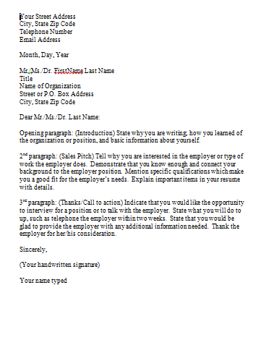
Explain that this is the template you can use for a Cover Letter; you simply fill in the blanks into a new Word Document
Read through each paragraph together

Step 3: Download Activity
If loaded to USB drives, review how to open an existing file
- Go to File>Click on Open>Click on My Computer>Click on USB Drive> Click on Word Folder>Click on Day 7 Word Cover Letter Formatting
If you need to get it from online:
Explain each of these steps thoroughly
Everyone needs to open the internet>type mnliteracy.org into the address bar>scroll down till they see “My Learning Center” and click on it> Click on the name of their learning center>Click on Curriculum Tab>Under attachments, they should see Day 7 Word Cover Letter Formatting

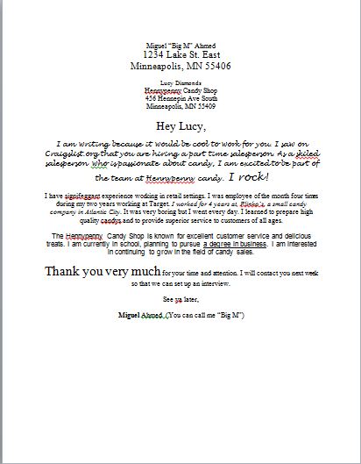
Step 4: Complete Activity Together
Work together to format the letter based on the template
Review: Times New Roman, 12pt Font, Left Aligned, Spell Check
Read through and discuss what students like and what they do not like/what is unprofessional

If you have extra time: Learners can begin entering their own details into a letter format. If learners do get to this, be sure to make a note of it in the lesson report.

Microsoft Word: Exercise 7
Part 1:

Directions:
- Type up the list below the prompt.
- Use cut and paste to arrange the details in chronological order, with earliest date at the top.
- Once finished, ask teacher to check your work
Prompt: Write about what your childhood.
I started school in September of 1989.
I was born on July 18, 1985
My favorite subject in school was reading.
My brother was born on October 15, 1989.
I learned how to walk.

Part 2:
Directions:
- Type up the list below the prompt
- Use cut and paste to arrange the details in order of relevancy, with most relevant at the top.
- Once finished, ask teacher to check your work

Prompt: You are applying for a job teaching English to adults at Minnesota Literacy Council.

I was a cashier at Macy’s for two years and gained experience in customer service and dealing with client issues.

I worked as a teacher for 3 years teaching adults English.

I volunteered at a preschool for a summer.
Cover Letter Format
Your Street Address
City, State Zip Code
Telephone Number
Email Address

Month, Day, Year

Mr./Ms./Dr. FirstName Last Name
Title
Name of Organization
Street or P.O. Box Address
City, State Zip Code

Dear Mr./Ms./Dr. Last Name:

Opening paragraph: (Introduction) State why you are writing; how you learned of the organization or position, and basic information about yourself.

2nd paragraph: (Sales Pitch) Tell why you are interested in the employer or type of work the employer does. Demonstrate that you know enough and connect your background to the employer position. Mention specific qualifications which make you a good fit for the employer’s needs. Explain important items in your resume with details.

3rd paragraph: (Thanks/Call to action) Indicate that you would like the opportunity to interview for a position or to talk with the employer. State what you will do to up, such as telephone the employer within two weeks. State that you would be glad to provide the employer with any additional information needed. Thank the employer for her/his consideration.

Sincerely,

(Your handwritten signature)

Your name typed

Microsoft Word Exercise 11: Cover Letter Formatting

Miguel “Big M” Ahmed
1234 Lake St. East
Minneapolis, MN 55406

Lucy Diamonds
Hennypenny Candy Shop
456 Hennepin Ave South
Minneapolis, MN 55409

Hey Lucy,

I am writing because it would be cool to work for you. I saw on Craigslist.org that you are hiring a part time salesperson. As a skiled salesperson who is passionate about candy, I am excited to be part of the team at Hennypenny candy. I rock!
I have signifeggant experience working in retail settings. I was employee of the month four times during my two years working at Target. I worked for 4 years at, Plinko’s, a small candy company in Atlantic City. It was very boring but I went every day. I learned to prepare high quality candys and to provide superior service to customers of all ages.
The Hennypenny Candy Shop is known for excellent customer service and delicious treats. I am currently in school, planning to pursue a degree in business. I am interested in continuing to grow in the field of candy sales.
Thank you very much for your time and attention. I will contact you next week so that we can set up an interview.
See ya later,
Miguel Ahmed (You can call me “Big M”)

