Reading and Writing for Job Search Day 9

Objectives Learners will be able to… | Materials
Computer skill: copy and paste text  Computer skill: move between tabs  Computer skill: open a new tab  Literacy skill: identify key words | Make Student Copies  - Job Search Exercise 7: Copy and Paste: 2 per page, print one per 2 students (Tab 26)  - Job Search Exercise 8: Company Research (Tab 27)  Props, Technology or Other Resources  - Projector  - Computer for every student  - USB Drives
Lesson Plan |  | Vocabulary
Warm-up:  Description: ask learners what kind of people make good references: anyone with whom you have had professional interaction, can speak to your employable skills. Who makes a poor reference: family, friends. Ask if you include references on a resume: nope. Ask when you provide references: on application or upon request. Ask what categories are included in a resume: contact information, summary of qualifications, previous experience, military, education, hobbies/volunteers  Materials/Prep:  Activity 1: Copy and Paste  Description: students will learn how to copy and paste within a document, which will then be used to copy and paste online  Materials/Prep: copies of Job Search Exercise 7: Copy and Paste  Activity 2: Tabs  Description: teacher will explain internet tabs and students will practice moving between tabs and closing tabs that are open. This will then set-up the third activity  Materials/Prep: try to locate manila folders for visual of real life tabs  Activity 3: Company Research  Description: class will use skills in copy and paste, will learn how to open a new tab and will search for company information  Materials/Prep: copies of Job Search Exercise 8: Company Research  Activity 4: Find a Job Section if time Allows  Description: students can search on their own for the remainder of class. They can use the Job Search Website handout from day 7 to locate jobs on a different website  Materials/Prep: |  | - Tabs  - Copy  - Paste  - Highlight  - Right-click  - Action Point  - Tabs  - Search Bar vs Address Bar  - Navigation bar  - Back arrow vs tabs
Teacher Directions: Activity 1: Copy and Paste -Job Search Exercise 7: Copy and Paste

Step 1: Set-up
Explain that sometimes there is information you have typed or that you find online that you know you need to include in a document/search/etc but you do not want to type it all over
Ask if anyone knows of a way to make a duplicate of information that you see on the screen?

Step 2: Define vocabulary
Copy: making a duplication, two of something
Paste: moving the text that has been copied to another place

Step 3: Demonstration
Learners should have their EYES FORWARD AND HANDS OFF OF THEIR COMPUTER
Ask students to explain how to open a new document
Write a short statement
Explain that the following steps must be done in order
Highlight (click and drag) the text>Right-click over the highlighted text>Ask if anyone sees a keyword: copy>Click on copy
Explain that we do not see that the text has been copied
How to paste:
Move the action point somewhere else on the page>right click>click on paste

Step 3: Do together
Instruct students to open a Word Document
They should type the a short sentence, of your choosing
Go through the steps from step 3 to copy all together, using appropriate vocabulary
Go through steps to paste all together, using appropriate vocabulary

Step 4: Independent
Hand out Job Search Exercise 7: Copy and Paste
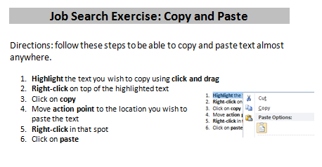
Instruct students to write a new statement
Instruct them to copy and paste it somewhere else

Step 5: Expand knowledge
Explain that right-click is the best way to copy and paste because you can also do that on the internet and other programs
BUT there are other ways to copy and paste
Point out where to find copy and paste on the ribbon (toolbars)
Explain that you can copy text from the internet and paste it in a document and vise-versa
Copy and paste can be used in any program
We will practice this more in the last activity for the day

Teacher Directions: Activity 2: TABS

Step 1: Set-up
Instruct everyone to go online and type indeed.com into the address bar
Instruct everyone to type “security” into the search bar in indeed
Instruct everyone to click on one of the results

Step 2: Tabs explanation
Everyone should have a job result open
Ask learners how you go back to the results page
Back arrow? Nope, doesn’t work
Instruct everyone to look above the address bar
Do they see different text explaining pages they might have been on?
These are tabs

Step 3: Tabs Navigation
Learners should have their EYES FORWARD AND HANDS OFF OF THEIR COMPUTER
Demonstrate how to move to the other tab
Example: internet tabs are like tabs in a file folder. You pick the one that is relevant to your needs and the tab itself lists a clue as to what is inside.
Open another result
Demonstrate how to close that tab, not the whole page

Step 4: Group Practice
As a class, practice moving between tabs and closing JUST TABS
Have learners explain the steps as they go using appropriate vocabulary

Step 5: Open a new tab
Teacher should demonstrate how to open a new tab
Students should practice as a class
Close out of the new tab

For next activity, everyone should leave one result page open that has a company name in it

Teacher Directions: Activity 3: Company Research
-Job Search Exercise 8: Company Research
Step 1: Set-up
Explain that when searching for jobs you will need more information than what is provided in the job posting
Ask students if they have ever researched information about a company with which they are applying?
Explain that researching a company can provide helpful information for the application and interview steps

Step 2: Teacher demonstration
Learners should have their EYES FORWARD AND HANDS OFF OF THEIR COMPUTER
Teacher should locate the company name from the job posting
Ask students how to copy and paste the company name
Use right-click to copy the company name
Ask students how to open a new tab
In the new tab, go to Google.com
Right-click in the search bar and click paste
Hit enter key

Step 3: Teacher demonstration of moving around website
Learners should have their EYES FORWARD AND HANDS OFF OF THEIR COMPUTER
Ask students if they see a result that looks like the website for the company
Click on the link
Use the handout that students will get to find important information
Explain important keywords on the page: navigation bar, about, contact, what we do, etc.
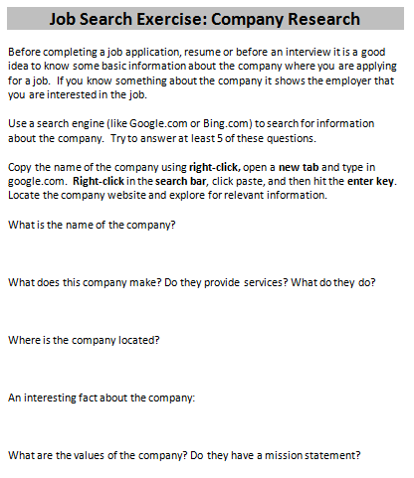
Explain that this might take some exploration; you might click and go somewhere that isn’t useful
Ask how you go back to the last page you were on: back arrow

Step 4: Group navigation
Hand out Job Search Exercise 8: Company Research
As a class, everyone should pick the same posting
Copy and paste the company name
Answer the questions on the handout all together

Teacher Directions: Activity 4: Job Search If Time Allows

Step 1: Independent exploration
Learners can search for jobs on their own
They can use websites from Job Search Website handout given on day 7

Step 2: Resume workshop
If learners would rather work on their resume with any remaining time, they are more than welcome

Job Search Exercise 7: Copy and Paste

Directions: follow these steps to be able to copy and paste text almost anywhere.

- Highlight the text you wish to copy using click and drag
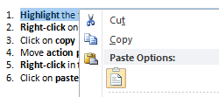
- Right-click on top of the highlighted text
- Click on copy
- Move action point to the location you wish to paste the text
- Right-click in that spot
- Click on paste

Job Search Exercise 7: Copy and Paste

Directions: follow these steps to be able to copy and paste text almost anywhere.

- Highlight the text you wish to copy using click and drag
- Right-click on top of the highlighted text
- Click on copy
- Move action point to the location you wish to paste the text
- Right-click in that spot
- Click on paste

Job Search Exercise 8: Company Research

Before completing a job application, resume or before an interview it is a good idea to know some basic information about the company where you are applying for a job. If you know something about the company it shows the employer that you are interested in the job.

Use a search engine (like Google.com or Bing.com) to search for information about the company. Try to answer at least 5 of these questions.

Copy the name of the company using right-click, open a new tab and type in google.com. Right-click in the search bar, click paste, and then hit the enter key. Locate the company website and explore for relevant information.

What is the name of the company?

What does this company make? Do they provide services? What do they do?

Where is the company located?

An interesting fact about the company:

What are the values of the company? Do they have a mission statement?

