Reading and Writing for Job Search Day 3

Objectives Learners will be able to… | Materials
Computer skill: saving a file  Computer skill: go to a website  Computer skill: use an online dictionary | Make Student Copies  - 5 Steps for an Effective Job Search (Tab 10)  - Internet Hover to Discover (Tab 11)  - Skills Assessment Results (Tab 12)  Props, Technology or Other Resources  - Projector  - Computer for every student  - USB Drives
Lesson Plan |  | Vocabulary
Warm-up: 10 minutes  Description: ask students how to open a new document. Ask where the ribbon is? Ask what is included in the ribbon? Menu tabs and toolbars Ask how you can find out what a button on the ribbon does: hover over it. Practice hovering over buttons, see if students remember what they are before you click on them  Materials/Prep:  Activity 1: Effective Job Search Reading  Description: students will read and then go over their reactions to the passage  Materials/Prep: copies of 5 Steps for an Effective Job Search  Activity 2: Intro to the Internet- 15 minutes  Description: go over basic internet vocabulary (address bar, web address) and explain how to get to a website. Students will complete a screen fill like the one they did Day 2  Materials/Prep: copies of Internet Hover to Discover  Activity 3: Online Skills Assessment  Description: students will complete the ISEEK skill assessment  Materials/Prep: copies of Skills Assessment Results |  | - Skills  - Internet  - Address Bar  - Web address  - Back Arrow  - Forward Arrow  - Minimize  - Maximize  - Close  - Website

Teacher Directions: Activity 1: Effective Job Search
-5 Steps for an Effective Job Search
Step 1:Pre-reading
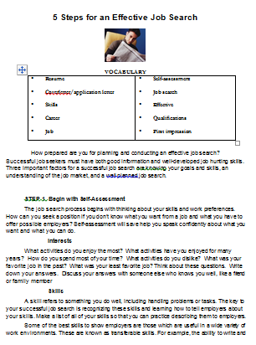
Get students ready to read by introducing key vocabulary, discussing what students have done/are doing to look for jobs and predicting what they think the 5 steps might be

Step 2: Reading
Hand out 5 Steps for an Effective Job Search Reading
Students should read through the passage on their own
Instruct them to underline anything they found interesting and then circle any words of which they are unsure the definition

Step 3: Post-reading Reflection
Ask students what their reactions are to the reading
Ask what stuck out at them/anything they agreed or disagreed with?

Teacher Directions: Activity 2: Intro the Internet
-Internet Hover to Discover
Step 1: Internet use intro
Explain that in order to find the definitions of the words that were circled we will be going onto the internet to use an online dictionary
Ask if students know how to access the internet: click on the Internet Explorer icon on the desktop
Ask where the desktop is? It’s the first screen you see when your computer turns on, it shows icons for different programs
Explain that to get to a website, users need to carefully type the web address into the address bar
Point out the address bar

Step 2: Demonstration of Web Addresses and Address Bar
Learner should have their EYES FORWARD AND HANDS OFF OF THEIR COMPUTER
Explain that you can type any web address into the address bar
Ask if students know of any websites, write examples on the board
- Google.com
- Facebook.com
- Amazon.com
Explain that the URL needs to be typed just as it is seen
Example: A web address is a lot like a home address. If I write down your home address incorrectly, I will not get to the place I intended. If you type in a web address incorrectly, you will not get where you wanted to go
Explain that there should never be spaces in a web addresses
Type a website into the address bar
Press Enter
Explain that you are now in a different website

Step 3: Hover to discover
Explain that like Word, users can take their mouse and hover over buttons to see what they do
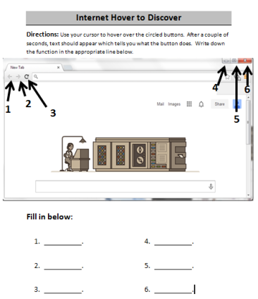
Hover over the red x in the corner, ask what it does? Close

Step 4: Independent Hover Activity
Hand out copies of Internet Hover to Discover
Instruct learners to use their cursor to hover over the buttons they see on the handout
The screen on the handout might not exactly the same as the one on their screen, but the buttons are there and do the same things

Step 5: Get to ISEEK.org
Once everyone finishes the activity
Demonstrate how to get to ISEEK.org
Instruct everyone to go to ISEEK.org

Teacher Directions: Activity 3: Online Skills Assessment -Skills Assessment Results

Step 1: Context
Ask students if anyone remembers the first step to an effective job search: Self-assessment
Ask what is included in a self-assessment: assessing interests and skill
Ask why assessing skills is important: gives you an idea of how to present yourself, what jobs to look for, and what kind of questions to ask regarding a position
Explain that today we will be doing just that- assessing our skills
Discuss what learners might see as skills/their own professional skills

Step 2: Demonstrate How we will complete skills assessment
Learners should have their EYES FORWARD AND HANDS OFF OF THEIR COMPUTER
Explain that on the internet there are many skills assessments that can be done for free
Ask learners what website they are currently at: should be ISEEK.org
Explain that this website contains a lot of job search information and we will be using it as a resource again later in class
Ask if anyone sees a place that might take you to assessments: assess yourself
Clicks on assess yourself and then click on ISEEK Skills Assessment
Read through directions

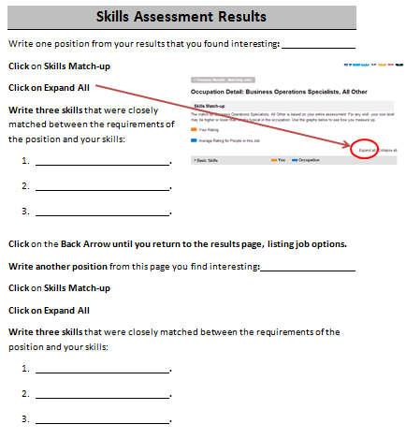
Step 3: Get to Assessment together
Ask students how to go back to ISEEK main page: click back arrow
Ask students how to get back to the Skills Assessment; they should follow steps as well

Step 4: Complete Assessment
Instruct learners to complete the assessment
Have students fill in the Skills Assessment Results Handout
Once everyone is finished, review what they see as a class
5 Steps for an Effective Job Search
VOCABULARY
▪ Resume  ▪ Coverletter/application letter  ▪ Skills  ▪ Career  ▪ Job | ▪ Self-assessment  ▪ Job search  ▪ Effective  ▪ Qualifications  ▪ First impression

How prepared are you for planning and conducting an effective job search? Successful job seekers must have both good information and well-developed job hunting skills. Three important factors for a successful job search are knowing your goals and skills, an understanding of the job market, and a well-planned job search.

STEP 1. Begin with Self-Assessment
The job search process begins with thinking about your skills and work preferences. How can you seek a position if you don't know what you want from a job and what you have to offer possible employers? Self-assessment will save help you speak confidently about what you want and what you can do.
Interests
What activities do you enjoy the most? What activities have you enjoyed for many years? How do you spend most of your time? What activities do you dislike? What was your favorite job in the past? What was your least favorite job? Think about these questions. Write down your answers. Discuss your answers with someone else who knows you well, like a friend or family member
Skills
A skill refers to something you do well, including handling problems or tasks. The key to your successful job search is recognizing these skills and learning how to tell employers about your skills. Make a list of all of your skills so that you can practice describing them to employers.
Some of the best skills to show employers are those which are useful in a wide variety of work environments. These are known as transferable skills. For example, the ability to write and speak well, and using word processing or computer software are valued skills in many different jobs.
STEP 2. Research and Explore Career Options
The next step in searching for a job is to look for jobs and careers that match your skills and interests. Many websites such as iseek.org have lots of information and videos about different careers. Workforce centers also have information about different companies and careers.
Another great way to learn about other careers is to talk to friends and relatives about their work experience or make an appointment with someone who has a job that you’re interested in.

STEP 3. Prepare Job Search Materials and Develop Job Search Skills
Once you know your job goals you can make small changes to your resumes and application letters so that they fit the qualifications of the job. For example, you should change your application letter so that it shows the skills you have that the employer is most interested in.
Most job applicants know that they need well prepared resumes and cover letters, but many do not realize that they also need to spend time learning job search skills. Learning where to look for jobs, how to interview well, and how to make a great impression are skills worth going to class to learn.

STEP 4. Plan and Conduct Your Job Search
Next, establish a target date for getting a job and decide how much time you can spend looking for a job. The more people you talk to and interviews you have, the greater the number of job offers. Therefore, it makes sense to use more than one strategy when looking for a job. Many people look for job ads in the newspaper and online but that is not always the best way to find a job. Nearly 80% of jobs are never advertised so it is also a good idea to talk to many people about your job search.
Once you have a job or company in mind, you should meet people who have that job or work in that company. These people offer you an insider's view and can sometimes help you meet other people in the company or give you information about job openings. Your network can also consist of family members, friends, classmates, teachers, and other community members.

STEP 5. Accept a Job Offer and Continue Building Your Skills
Congratulations! Your job search has been successful. You have been offered a position you wish to accept. Send a note to all the people who helped you and tell them the good news. Don’t forget to keep building your skills so that you’ll be ready the next time you’re looking for a new job.

Internet Hover to Discover
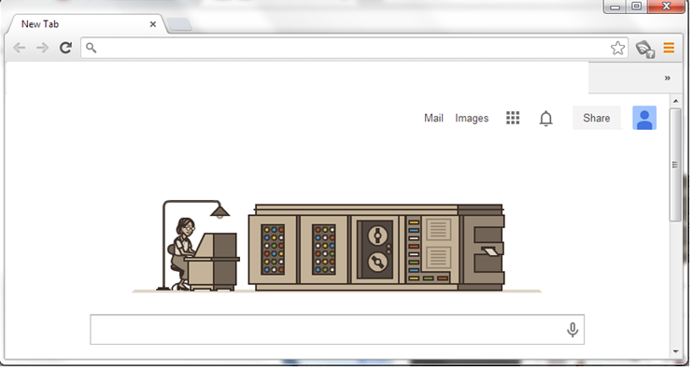
Directions: Use your cursor to hover over the circled buttons. After a couple of seconds, text should appear which tells you what the button does. Write down the function in the appropriate line below.
6
3
2
1
5
4
Fill in below:

- .
- .
- .
- .
- .
- .
Skills Assessment Results
Write one position from your results that you found interesting:
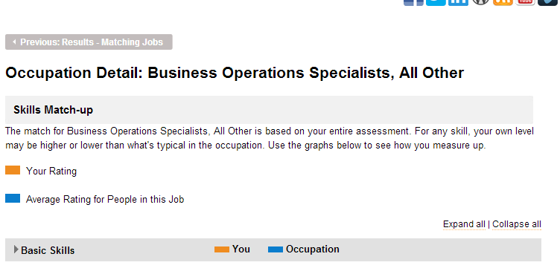
Click on Skills Match-up
Click on Expand All
Write three skills that were closely matched between the requirements of the position and your skills:
- .
- .
- .
Click on the Back Arrow until you return to the results page, listing job options.
Write another position from this page you find interesting:
Click on Skills Match-up
Click on Expand All
Write three skills that were closely matched between the requirements of the position and your skills:
- .
- .
- .

