During Day 2 you will be proctoring the North Star Digital Literacy pre-assessment.
All the of the computers that learners use need to be registered (per direction on the North Star site) for the assessment,
- This can take anywhere from 20-40 minutes depending on the number of students and number of volunteers/coordinators who are setting the assessment up.
- REGISTER THE COMPUTERS BEFORE CLASS BEGINS
  - Use the computer sign-in sheet that was filled out Day 1 to determine which computers students are using and pull them out of the COW
DO NOT PRE-TEST STUDENTS IF (Use Computer Use Questionnaires to see what kind of experience learners have with computers):
- They are very uncomfortable with the computer
- You feel taking the assessment will overwhelm them (happens with brand new computer users)
Learners who do not take the pre-assessment can:
- Log in to Mavis Beacon and practice typing
  - If they seem to need help with the mouse, help them get to http://www.skyways.org/central/mouse/page1.html , which is a mouse usage practice site (mouserobics)
Students who come in late: Determining whether or they have time to take the assessment without cutting too much into class time depends on a few things:
DO pre-test them if:
- You feel you have time to register their computer
- They have a basic knowledge of the computer
- They took the previous unit
Do NOT pre-test them if:
- They come more than 10 minutes into the testing period
- They are not familiar with the computer
- They come in late and you are busy setting up learners who showed up on time and are not taking the assessment
*****One way to ensure you get to the tests quickly is by having all of the computers registered before class begins. This takes prep time, but saves important class time. ********
Reading and Writing for Job Search Day 2

Objectives Learners will be able to… | Materials
Computer skill: highlight  Computer skill: formatting  Computer skill: saving a file  Literacy skill: scanning for information (North Star Assessment) | Make Student Copies  - Day 2 Hover to Discover (Tab 7)  - RWJ Exercise 2: Saving- if you have USB drives, print out that handout, if you do not print out “Saving a File to a Computer” (Tab 8)  Props, Technology or Other Resources  - Projector  - Computer for every student  - USB Drives  - North Star How-To (Tab 9)
Lesson Plan | Vocabulary
Warm-up:  Description: Ask students which key allows you to move down a line? Enter  Ask which key makes all the letters capital letters until you press it again? Caps lock  Ask which will make a capital letter if you press it and the letter at the same time? Shift  Ask which key erases to the left? Backspace  Ask which key erases to the right? Delete  Materials/Prep:  Activity 1: North Star Digital Literacy Assessment  Description: learners will take their Pre-Assessment and then practice typing  Materials/Prep: download page 4 of lesson plan to be projected, need to read many parts from this lesson to students  Activity 2: Highlighting and Formatting Practice  Description: practice click and drag and introduce ribbon and toolbars  Materials/Prep: copies of Day 2 Hover to Discover  Activity 3: Saving  Description: go over how to save a new file and discuss the differences between save and save as  Materials/Prep: copies of RWJ Exercise 2: Saving (two handout options, if you have USB drives use that handout) | - Formatting  - Ribbon  - Toolbars  - Click and drag  - Bold  - Italics  - Underline  - Align  - Font
Teacher Directions: Activity 1: North Star Digital Literacy Assessment
Step 1:
Take this time to explain the Microsoft Word North Star Digital Literacy Assessment and its purpose:
This can be read verbatim to the students: The North Star Digital Literacy Assessment has set the standards of what it means to be knowledgeable about different aspects of the computer. The purpose of this assessment is to provide learners with a standard with which everyone learns the computer to ensure that they will be successful outside of the classroom. The pre-assessment is meant to inform the teacher of what you know already and then we can see how you improve at the end of the class. If you pass the assessment with an 85% or higher, you will receive a certificate that proves your competency at the unit you were tested on. These certificates can also be presented to employers as proof of your computer skills when you apply for a job.
With this pre-assessment it is okay if you do not know anything. If you do not know the answer to a question, you are given the option to simply answer “I do not know” or you can take a guess. You are encouraged to guess on this assessment.

Step 2: How the assessment works
This can be read verbatim to the students: When it is time to begin, students will open the assessment titled Microsoft Word. The assessment begins with a test of the speakers. If you hear the piano playing, you will use your mouse to click the “Next” button.
Explain that if that student does not hear the piano playing, they can look above their keyboard at and they will see three buttons on the right. These are the volume buttons, one to turn down volume, turn it up, and turn it off.
Next, North Star will go through an orientation of how the assessment works. Each question asked in the assessment will be a function of the program, so your answer to the question will be performing that function. BE CAREFUL not to simply click when the page comes up because the assessment will read that as your answer and you cannot go back.
Teacher should pull up the Screen Shot page and review it with the students.

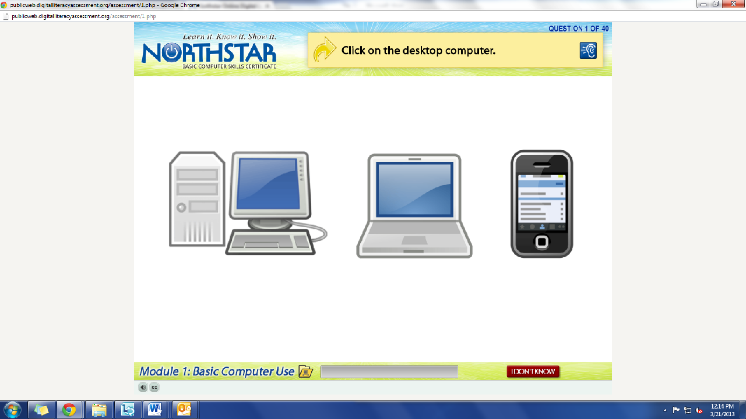
What is the question begin asked?
How do we answer it? We click on the answer.
You must listen carefully to the question being asked so that you know how to answer it.
If you miss the question when it is read, you can either read it on the top of the page, or click the on the blue ear and it will read the question again.
If you do not know and do not want to guess, but once you click it, it will ask you if you are sure you want to skip the question, you have to answer “Yes” to move on. You are, however, encouraged to guess.

Step 3: Learner Code of Conduct
Read the Learner Code of Conduct to the students:
- Learner must listen carefully to all instructions given by proctor
- Learner must treat others with courtesy and respect during assessment process
  - This means no talking to each other during the assessment, if you have a question ask the proctor. If a learner finishes early, they must remain quiet until everyone is finished
- Learner should ask questions prior to the assessment if they are uncertain about the certification process
- Learner is responsible for his or her certificate: if the certificate is lost, s/he will have to retake the assessment
- Learner should inform the proctor if he or she believes that assessment conditions affected his or her results
Ask if there are any questions
Explain that the questions will be read aloud to them, so students need to be sure they are listening carefully. If they miss the question, is it also written at the top of the page.

Step 4: Take Microsoft Word Assessment
If there are no questions, learners should scroll down the testing page and click on the Microsoft Word Assessment
If students are frazzled during the test because they missed the reading of the question, there is a blue square in the top right corner with an ear in it. When it is clicked the question is read again

Step 5: After the assessment
As learners finish the assessment, instruct and assist learners as they log onto Mavis Beacon to practice their typing
Note: If you come to a point where there is only 45 minutes left in class and some students still are not finished, hand out the reading for activity 2 and instruct learners to circle any words they do not know and underline things they find interesting.

Teacher Directions: Activity 2: Highlighting and Formatting Text
–Day 2: Hover to Discover
Step 1: Review opening programs
Ask students how to open a Microsoft Word: either from the desktop icon, start menu or All Programs

Step 2: Highlighting
Have students type their first name
Explain that we want to change the look of the text, which is known as formatting text
Demonstrate clicking and dragging to highlight the text
Practice this a few times

Step 3: Hover to find out what buttons do
Explain that above the document learners will see many buttons; these buttons are on what is known as a toolbar which is a part of the ribbon
Explain that users can take the cursor and hover over a button to find out what it does
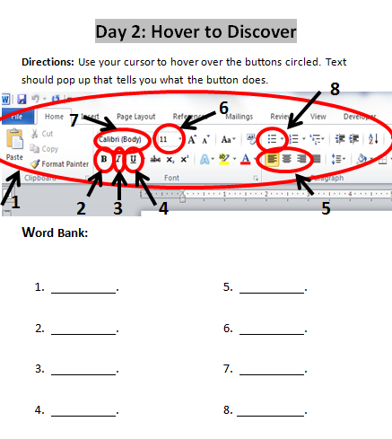
Click on the Bold button
Practice with italics, underline, font, font size, font color and align

Step 4: Introduce Hover to Discover
Handout Day 2 Hover to Discover
Explain that students will use their cursor to hover over the buttons labeled on the handout to figure out what they do
Once the text box listing the job of that button, students should fill in the appropriate blank and then click on it to see what it does exactly
IMPORTANT: Before you click on the button, be sure the appropriate text is highlighted

Step 5: Practice
Learners should work on the handout

Teacher Directions: Activity 3: Saving -Job Search Exercise 2: Saving
IMPORTANT: If you do not have access to USB drives, make sure to follow the directions from the RWJ Saving a File to the Computer instead of To the USB Drive
Step 1: Teacher Demonstration
Learners should have their EYES FORWARD AND HANDS OFF OF THEIR COMPUTER
Walk learners through the steps to save a new file
Click on file>Click on Save As>
When you do this, a dialogue box comes up: in the top left corner, the box reminds you what you are attempting to do
Click on My Computer
Explain that this is where you can find all of the different places things can be stored on the computer
Locate the USB Drive, typically the (E: ) Drive> Name the file (IMPORTANT)> Click on Save
Step 2: Controlled Practice
Go through those steps as a whole, asking the students to lead you through as much as they can remember
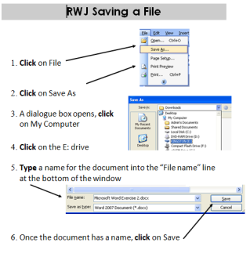
Step 3: Student led practice
Now, you should ask the students how to go about saving. They need to give you specific instructions on how to effectively save your document
Explain that this is something we will practice many times as we work on different documents
Hand out Job Search Exercise 2: Saving for their reference

North Star How-To
Teacher A- Generating Codes:
1. Go to https://www.digitalliteracyassessment.org/admin
2. Login information:
3. PLEASE SEE YOUR SITE COORDINATOR FOR NORTH STAR LOGIN INFORMATION!
4. Select your name from the drop-down menu
5. Click Submit
6. Click on Generate User Codes
7. Simply type in students’ names and a click enter
8. The code next to their name will be used to register their computer
Teacher B- Registering each computer:
1. Turn on student computers
2. Go to digitaliteracyassessment.org/assessment/proctored
3. Username: SEE YOUR SITE COORDINATOR
4. PIN: SEE YOUR SITE COORDINATOR
5. Type in student’s name and then enter the code you got from Part 1
6. Click Confirm and Start
7. Minimize the page
8. Instruct students not to close out of any programs you have opened on their computer
Note: As you spend more time in the classroom you get to know the students who show up early and who show up late. Register the students who usually show up early as soon as you arrive, that way they can begin typing as soon as they get to class.
Day 2: Hover to Discover
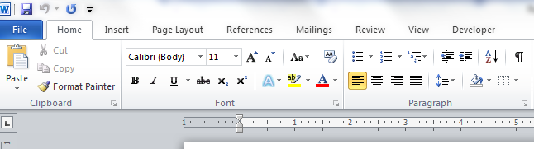
Directions: Use your cursor to hover over the buttons circled. Text should pop up that tells you what the button does.
8
7
6
Fill in below:
5
1
4
3
2

- .
- .
- .
- .
- .
- .
- .
- .

RWJ Saving a File to USB Drive

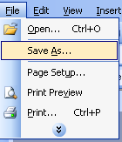
- Click on File
- Click on Save As
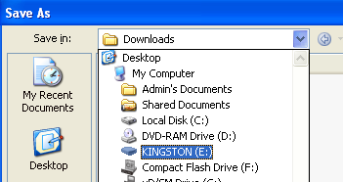
- A dialogue box opens, click on My Computer

- Click on the E: drive
- Type a name for the document into the “File name” line at the bottom of the window
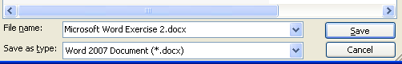

- Once the document has a name, click on Save

RWJ Saving a File to Computer

- Click on File
- Click on Save As
- A dialogue box opens, click on My Documents

- Type a name for the document into the “File name” line at the bottom of the window

- Once the document has a name, click on Save

