During Day 11 you will be proctoring the North Star Digital Literacy assessment.

All the of the computers that learners use need to be registered (per direction on the North Star site) for the assessment,
- This can take anywhere from 20-40 minutes depending on the number of students and number of volunteers/coordinators who are setting the assessment up.
- REGISTER THE COMPUTERS BEFORE CLASS BEGINS
  - Use the computer sign-in sheet that was filled out Day 1 to determine which computers students are using and pull them out of the COW

Reading and Writing for Job Search Day 11
Objectives Learners will be able to… | Materials
Computer skill: upload a document  Computer skill: correctly type in web address without help  Computer skill: navigate Schoology.com  Computer skill: identify tools on the ribbon  Literacy skill: North Star Digital Literacy Assessment- Word Assessment  Literacy skill: scan for keywords | Make Student Copies  - Job Search Exercise 10: Upload Instructions(Tab 29)  Teacher Copy  - Day 11 Review (Tab 30)  - Project Page 4 of Lesson plan: screen shot of test  Props, Technology or Other Resources  - Projector  - Computer for every student  - USB Drives  - North Star How-To (Tab 9)
Lesson Plan | Vocabulary
Activity 1: Review  Description: teacher will instruct students to complete different tasks in Microsoft Word. These tasks will be tested in the assessment.  Materials/Prep: teacher should have a copy of Day 11 Review  Activity 2: North Star Digital Literacy Assessment  Description: students will take their post-assessment  Materials/Prep: all computers MUST be registered before class begins, directions are attached in Tab 9, teacher should project Page 4 of this lesson plan  Activity 3: Job Search Website  Description: as students finish their assessment, they should complete Exercise 14  Materials/Prep: copies of Job Search Exercise 10: Upload Instructions |  | - Margins  - Copy, Cut, Paste  - Landscape  - File extensions  - Login  - Username  - Password  - Upload

Teacher Directions: Activity 1: Review -Day 11 Review

Step 1: Set-up
Ask students how to open a Word Document: double-click on Microsoft Word icon
Explain that today we will review many of the tools we have used on Word
Directions: Teacher will instruct you to complete a task. Try to do this on your own without speaking. Teacher will then ask you how you did it at which point students should explain the steps they followed to compete the task.

Step 2: Students complete review
Teacher will read steps from Day 11 Review and students should complete
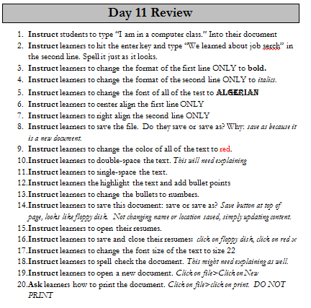
Step 3: Explain inconsistencies with assessment
Explain to learners that the assessment will ask about things that have not been covered in the class. This is meant to demonstrate what it is really like on the computer; you cannot be taught every step to complete every task you wish to do on the computer, sometimes you have to seek out the answer on your own.
Write tips for test taking on the board:
- Focus on what each question is asking you to do.
- Pick out key words and scan for them on the page. For example it might say to check the spelling, so look for the word “spell” on the screen.
- You do not have to highlight text on this assessment; simply look for the appropriate button on the toolbar.
- Look over the whole screen before answering
- If you do not know, guess!
- Do not stress about this, it is not an accurate assessment of the skills you have gained in this class.
Step 4: Quick File Extension Explanation
Explain that one question they will see is in regard to how files are saved
Write the following bullets on the board;

- .doc

- .ppt

- .xls

Explain that each of these is shorthand for a specific type of file.
Ask students what kind of file we have been creating in Word; documents
Ask which of the bulleted items would be shorthand for document: doc
Explain that .ppt=powerpoint, .xls=excel

Teacher Directions: Activity 2: North Star Digital Literacy Assessment
Step 1: Assessment Explanation and its purpose
Take this time to explain the Microsoft Word Star Digital Literacy Assessment and its purpose:
This can be read verbatim to the students: The North Star Digital Literacy Assessment has set the standards of what it means to be knowledgeable about different aspects of the computer. The purpose of this assessment is to provide learners with a standard with which everyone learns the computer to ensure that they will be successful outside of the classroom. If you pass the assessment with an 85% or higher, you will receive a certificate stating you passed the Microsoft Word assessment. These certificates can be presented to employers as proof of your computer skills when you apply for a job.
This assessment is going to be difficult for most of you because it is using a version of Windows that we have not used in class. Use the clues that are provided in the question to locate the answers that will be on the page.

Step 2: How the assessment works
This can be read verbatim to the students: When it is time to begin, students will open the assessment titled Microsoft Word. The assessment begins with a test of the speakers. If you hear the piano playing, you will use your mouse to click the “Next” button.
Explain that if that student does not hear the piano playing, they can look above their keyboard at and they will see three buttons on the right. These are the volume buttons, one to turn down volume, turn it up, and turn it off.
Next, North Star will go through an orientation of how the assessment works. Each question asked in the assessment will be a function of the program, so your answer to the question will be performing that function. BE CAREFUL not to simply click when the page comes up because the assessment will read that as your answer and you cannot go back.
Teacher should pull up the Screen Shot page and review it with the students.

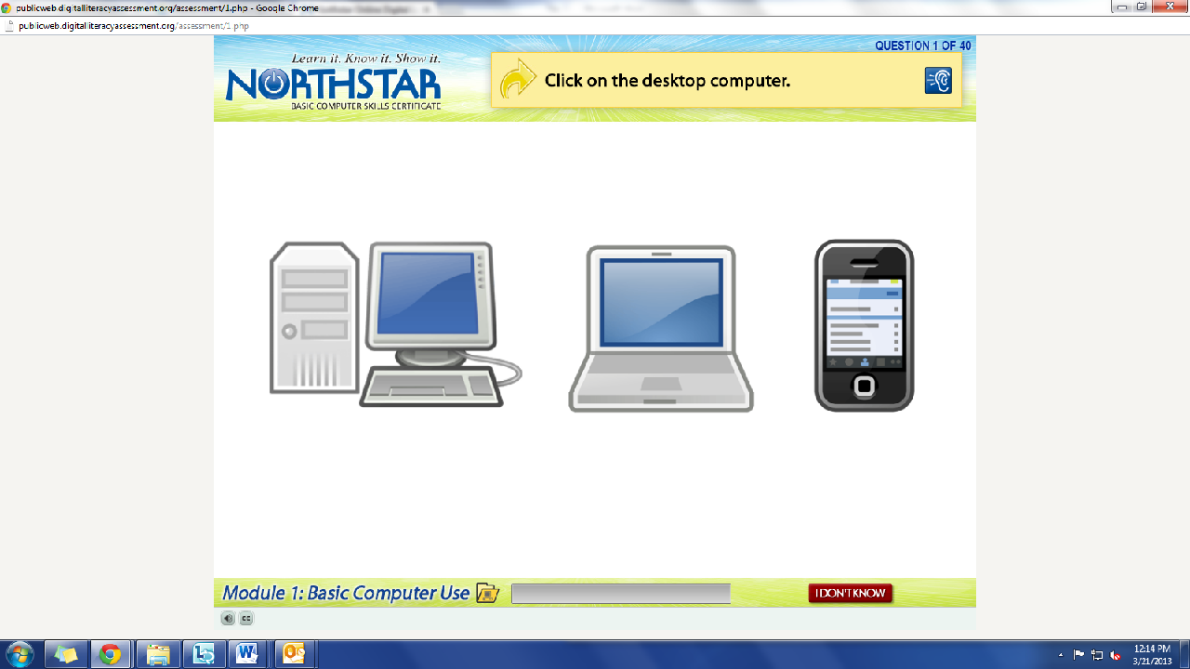
What is the question begin asked?
How do we answer it? We click on the answer.
You must listen carefully to the question being asked so that you know how to answer it.
If you miss the question when it is read, you can either read it on the top of the page, or click the on the blue ear and it will read the question again.
If you do not know and do not want to guess, but once you click it, it will ask you if you are sure you want to skip the question, you have to answer “Yes” to move on. You are, however, encouraged to guess.

Step 3: Learner Code of Conduct
Read the Learner Code of Conduct to the students:
- Learner must listen carefully to all instructions given by proctor
- Learner must treat others with courtesy and respect during assessment process
  - This means no talking to each other during the assessment, if you have a question ask the proctor. If a learner finishes early, they must remain quiet until everyone is finished
- Learner should ask questions prior to the assessment if they are uncertain about the certification process
- Learner is responsible for his or her certificate: if the certificate is lost, s/he will have to retake the assessment
- Learner should inform the proctor if he or she believes that assessment conditions affected his or her results
Ask if there are any questions
Explain that the questions will be read aloud to them, so students need to be sure they are listening carefully. If they miss the question, it is also written at the top of the page

Step 4: Take Microsoft Word Assessment
If there are no questions, learners should scroll down the testing page and click on the Microsoft Word Assessment
If students are frazzled during the test because they missed the reading of the question, there is a blue square in the top right corner with an ear in it. When it is clicked the question is read again

Step 5: Post assessment Activity
Explain that after learners finish with the assessment, they should raise their hand
Teacher should review the results with the learners
Once finished, students can take a break and then should move onto activity 3

Teacher Directions: Activity 3: Upload Resumes
-Job Search Exercise 10: Upload Instructions
Step 1: Hand out and Instructions
Hand out Job Search Exercise 10: Upload
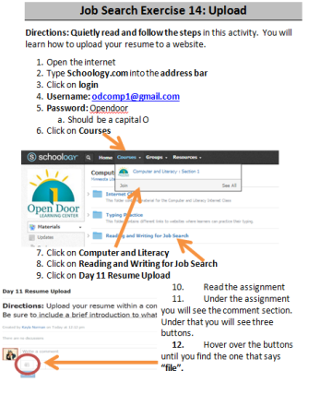
Instruct learners to follow directions, quietly that teach them how to upload a document

Step 2: As people finish
Learners should have their EYES FORWARD AND HANDS OFF OF THEIR COMPUTER
Once everyone finishes the assessment, take a minute to demonstrate how to upload a document
Use the students who have already gone through the activity to lead you through

Step 3: Do it again
Hand out Exercise 14 to those who don’t have it
All together go through the steps to upload
Ask what it means to upload: transfer (data) to another computer system

If there is time; Step 4: Open a document
Demonstrate how to open a document that has been posted online
Instruct learners to open a document
Ask: what is the name of the document?
Who created this document?
What is the document?

North Star How-To
Teacher A- Generating Codes:
1. Go to https://www.digitalliteracyassessment.org/admin
2. Login information:
3. PLEASE SEE YOUR SITE COORDINATOR FOR NORTH STAR LOGIN INFORMATION!
4. Select your name from the drop-down menu
5. Click Submit
6. Click on Generate User Codes
7. Simply type in students’ names and a click enter
8. The code next to their name will be used to register their computer
Teacher B- Registering each computer:
1. Turn on student computers
2. Go to digitaliteracyassessment.org/assessment/proctored
3. Username: SEE YOUR SITE COORDINATOR
4. PIN: SEE YOUR SITE COORDINATOR
5. Type in student’s name and then enter the code you got from Part 1
6. Click Confirm and Start
7. Minimize the page
8. Instruct students not to close out of any programs you have opened on their computer
Note: As you spend more time in the classroom you get to know the students who show up early and who show up late. Register the students who usually show up early as soon as you arrive, that way they can begin typing as soon as they get to class.

Day 11 Review
- Instruct students to type “I am in a computer class.” Into their document
- Instruct learners to hit the enter key and type “We learned about job serch” in the second line. Spell it just as it looks.
- Instruct learners to change the format of the first line ONLY to bold.
- Instruct learners to change the format of the second line ONLY to italics.
- Instruct learners to change the font of all of the test to Algerian
- Instruct learners to center align the first line ONLY
- Instruct learners to right align the second line ONLY
- Instruct learners to save the file. Do they save or save as? Why: save as because it is a new document.
- Instruct learners to change the color of all of the text to red.
- Instruct learners to undo the font color change.
- Instruct learners to double-space the text. This will need explaining
- Instruct learners to single-space the text.
- Instruct learners the highlight the text and add bullet points
- Instruct learners to change the bullets to numbers.
- Instruct learners to save this document: save or save as? Save button at top of page, looks like floppy disk. Not changing name or location saved, simply updating content.
- Instruct learners to open their resumes.
- Instruct learners to save and close their resumes: click on floppy disk, click on red x
- Instruct learners to change the font size of the text to size 22
- Instruct learners to spell check the document. This might need explaining as well.
- Instruct learners to open a new document. Click on file>Click on New
- Ask learners how to print the document. Click on file>click on print. DO NOT PRINT

Job Search Exercise 10: Upload
Directions: Quietly read and follow the steps in this activity. You will learn how to upload your resume to a website.
- Open the internet
- Type Schoology.com into the address bar
- Click on login
- Username: odcomp1@gmail.com
- Password: Opendoor
  - Should be a capital O
- Click on Courses
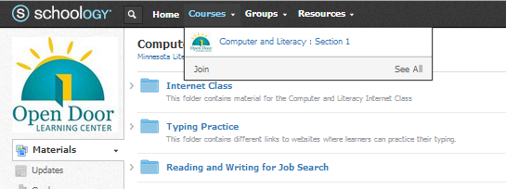

- Click on Computer and Literacy
- Click on Reading and Writing for Job Search
- Click on Day 11 Resume Upload
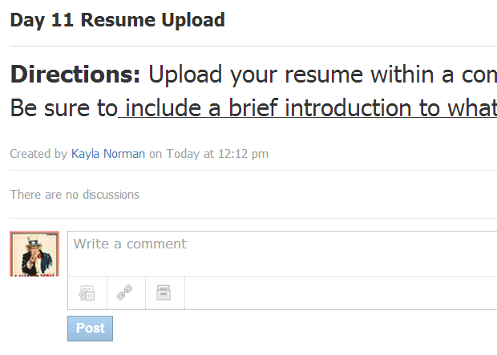
- Read the assignment
- Under the assignment you will see the comment section. Under that you will see three buttons.
- Hover over the buttons until you find the one that says “file”.
- Click on the link button
- The Open dialogue box should appear
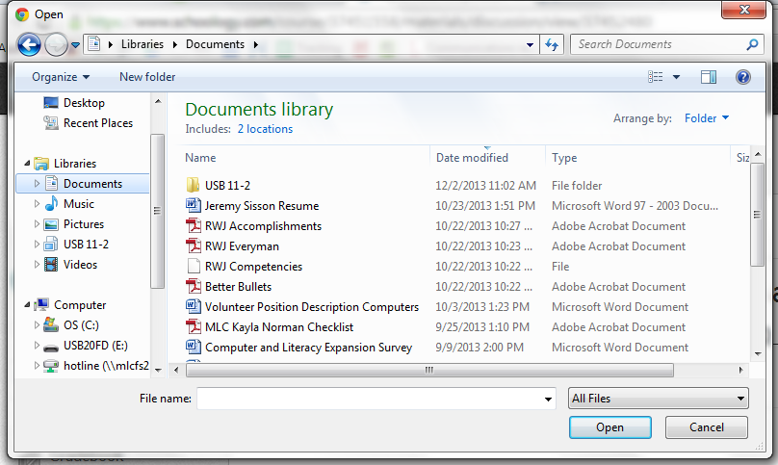
- Locate the drive where you saved your resume.
  - If you used a USB Drive: click on Computer> Double-Click on Drive (E: )
  - If you did not use a USB drive: Click on Documents
- Locate your resume
- Click Open
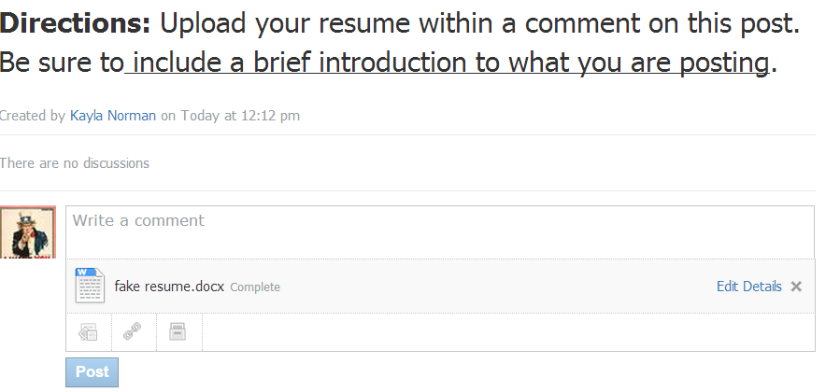
- You should see the comment box that now has the name of your resume underneath.

- Click in the comment box
- Type Your First and Last name.
- Type “Attached is my resume.”
- Click on Post
  - Hint: it is the blue button under the comment box.
- Let your teacher know when you are finished.

