**Reading and Writing for Job Search Day 10**

|  |  |
| --- | --- |
| **Objectives** *Learners will be able to…* | **Materials** |
| ***Computer skill:*** *open Internet Explorer*  ***Computer skill:*** *use back and forward arrows*  ***Literacy skill:*** *TABE test*  ***Literacy skill:*** *locate relevant information* | **Make Student Copies**   * **Job Search Exercise 9: Websites (Tab 28)**   **Props, Technology or Other Resources**   * Projector * Computer for every student * USB Drives |
|  | |
| **Lesson Plan** | Vocabulary |
| **Warm-up:**  Description: **Review Ribbon.** Ask students to open Word. Ask them  where the ribbon is  What does the ribbon include?  Where are the align buttons?  Where do you change Font size?  What about font color?  How do you change the Font to Ariel?  Materials/Prep:  **Activity 1: Job Search Activity- Leave 1 hour 5 minutes for final Activity**  Description: students will complete a job search comparison handout  Materials/Prep: copies of **Job Search Exercise 9: Websites**  **Activity 2: TABE Literacy Assessment-Leave 60 Minutes**  Description: students will take the TABE Literacy Assessment  Materials/Prep: ask the coordinator for the tests for the students | * ISEEK * Wages * Tabs * Requirements * Comparison |

**Teacher Directions: Activity 1: Job Search Comparison**

**-Job Search Exercise 9: Websites**

**Note:** If you have students who want to finish their resumes, they can do so during this time instead of completing exercise 13.

Step 1: Job Site Overview

Ask learners which job search websites we have used already? Ask if anyone brought the handout from Day 9 that lists many websites

**Explain** that today we will be looking at a few different sites and comparing job postings

**Hand out Job Search Exercise 9: Websites**

Step 2: Demonstrate

Learners should have **EYES FORWARD AND HANDS OFF OF THEIR COMPUTER**

**Use** the handout to demonstrate the steps students will accomplish

**Searching for jobs on startribune.com/jobs**

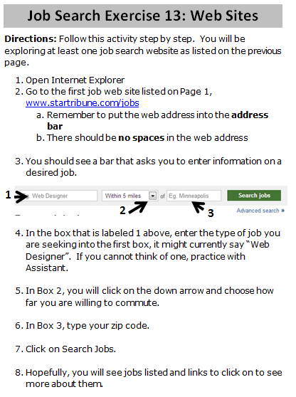

Step 3: Group Practice

Altogether, go through the steps to locate jobs in manufacturing

**Ask** students what to do?

* How do I get to the internet?
* Where am I trying to go?
* Where do I type in the web address?
* Is spelling important?
* What do I press when I type the address in? *Enter*
* Why did I not get to the website? *Spelling error*
* Where do I type in the job type?
* What are the other two boxes for?
* Are there any available jobs?
* If no jobs, am I done? *No! You can try a different name and/or try a different website.*

Step 4: Individual Practice

Instruct students to go to page two of their handout and follow the steps

They will have to fill in some information

Note: The final two pages of the handout instruct students go to a new website and compare 3 different jobs. See if they can get the hang of this on their own.

**\*\*Break:** Make sure learners get a break before the TABE test (finish Activity 1 by 6:20). They will need to put their computers away before the TABE test

**Teacher Directions: Activity 2: TABE Test**

Step 1: Set-up

**Explain** that today we will be taking the TABE literacy Assessment

This is a timed test that assesses English Literacy Skills.

It is required that all of our students take it for every class they take at MLC because it is from these tests that Open Door gets the funding to provide classes

EVERYONE SHOULD TURN THEIR CELL PHONES OFF

Step 2: Test explanation before you pass it out

**Explain** that learners have 50 minutes to complete the test

When they receive the test, there is a piece of paper in it which serves as the answer key

THEY MUST START THE TEST ON THE PAGE THAT THE ANSWER KEY IS IN

THEY SHOULD NOT ANSWER ANY OF THE SAMPLE QUESTIONS

Learners should start with question 1 on the page the answer sheet is in

When finished, learners can practice typing on Mavis Beacon or head home for the day if they choose

Step 3: Those not tested

Explain that some students will not be taking the TABE test, but will instead be completing a different literacy activity

This activity will be graded by the teacher when they are finished, and the student can take it home

Step 4: Pass out tests and complete

**Job Search Exercise 9: Web Sites**

**Directions:** Follow this activity step by step. You will be exploring at least one job search website as listed on the previous page.

1. Open Internet Explorer
2. Go to the first job web site listed on Page 1, [www.startribune.com/jobs](http://www.startribune.com/jobs)
   1. Remember to put the web address into the **address bar**
   2. There should be **no spaces** in the web address
3. You should see a bar that asks you to enter information on a desired job.

**1**

**3**

**2**

1. In the box that is labeled 1 above, enter the type of job you are seeking into the first box, it might currently say “Web Designer”. If you cannot think of one, practice with Assistant.
2. In Box 2, you will click on the down arrow and choose how far you are willing to commute.
3. In Box 3, type your zip code.
4. Click on Search Jobs.
5. Hopefully, you will see jobs listed and links to click on to see more about them.
6. Click on one of the job options.
   1. Note: If no results pop-up, try thinking of a different name for a job you would like to do.
7. Write the name of the position you clicked on here:

1. Write two requirements for the position:

(1)

(2)

1. Write the salary, if listed:

1. Is this a job you would be interested in applying for?



1. Click the back arrow, this should return you to the list of potential jobs.
2. Click on another job option.
3. Read through the information provided.

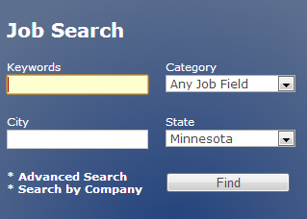

**Website #2:**

1. Type [www.minnesotajobs.com](http://www.minnesotajobs.com) into the **address bar**
2. You will see the search bar, type the job you are seeking in the keywords box.
3. Type your city into the City box
4. Click Find.
5. Click on a link and look at how the jobs are presented.
6. Click on a Job Posting and look through the information available.
7. **On the last page of this handout is a chart**, fill in the chart with whatever information you can access from the job posting.
8. Try to fill in the information for 3 job postings
9. Job Duties: Fill in 2 or three, do not write them all
10. Qualifications: Fill in 3 or 4, do not write them all

**Comparing Job Descriptions**

|  |  |  |  |
| --- | --- | --- | --- |
|  | Job 1 | Job 2 | Job 3 |
| Job Title |  |  |  |
| Job Duties |  |  |  |
| Salary |  |  |  |
| Benefits |  |  |  |
| Schedule/Number of Hours |  |  |  |
| Qualifications |  |  |  |
| Location |  |  |  |
| Things I like about this job |  |  |  |
| Things I don’t like about this job |  |  |  |
| Other notes |  |  |  |