PowerPoint: Day 6

Objectives Learners will be able to… | Materials
Computer skill: Review of materials learned  Computer skill: insert slides  Computer Skill: adding text to slides  Computer skill: locate information on the screen  Literacy Skill: scanning | Make Student Copies  - PowerPoint Packet (Tab 16)  - PowerPoint Exercise 8: Scanning (Tab 17)  Teacher Needs:  - To Project Day 6 Scanning Practice from Page 4-5 of lesson plan  Props, Technology or Other Resources  - Projector  - Computer for every student  - USB Drives
Lesson Plan |  | Vocabulary
Warm-up:  Description: Write the following example on the board: Parents, grandparents, My Family, My family has experienced many difficulties, but they persevere, My Siblings  Ask learners to take a second to determine which one is the Topic vs Main Idea vs Details. Write their suggestions in order from Topic to Details. Does it make sense? Do the details support the MI? Is the topic a broad introduction?  Example #2: Pay off loans, budgeting (T), see where your money goes, budgeting helps you learn how to save money (MI), shows how to adjust your spending  Follow Same steps.  Activity 1: Review  Description: learners will create a PPT in pairs about what they have learned in class thus far  Materials/Prep: USB drives  Activity 2: Begin Creating own PPT  Description: learners will determine main ideas and purpose of their PPT  Materials/Prep: copies of PowerPoint Presentation Packet  Activity 3: Scanning Activity  Description: learners will complete a scanning activity to practice seeking out information  Materials/Prep: Pull up Day 6 Scanning Examples from Page 4-5 of Lesson Plan, Open the Internet and go to Metro Transit. Under “Schedules”, click on a bus route and project, copies of Exercise 8 |  | - Main Idea  - Topic  - Supporting Details/Evidence  - Chronological  - Topical  - Scanning  - Key Words
Teacher Directions: Activity 1: Review
Step 1: Review activity
Instruct learners to take some time to think about this class and what they have learned so far
Pair learners off and instruct them to make a PowerPoint about what they have learned in class
Ask them to try to think of at least 5 things they have learned and put each one on its own slide
Then, they should create a slide with a list of what they are still confused about that has been discussed during this class
There should be 7 slides total, including a title page and a concluding page
Step 2:
Review what learners created and ask them to talk about what they have learned thus far

Step 3: Save
Review how to Save a new document by having the learners tell you the steps

Teacher Directions: Activity 2: Begin creating own PPT -PowerPoint Presentation Packet
-PowerPoint Requirements
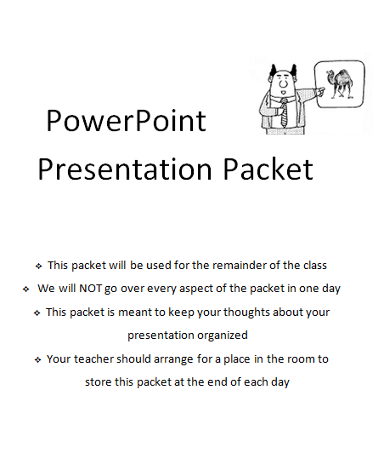
Step 1: Introduce activity and requirements
Explain that each learner will now begin the process of creating their own PowerPoint
Before getting into the creation of the PPT, first a topic must be picked
Explain that for the purposes of this class, we will be picking topics that we know about and do not require any research
Hand out PowerPoint Presentation Packet and explain that this packet will be used for the remainder of the class-go over the cover page
Instruct learners to open the packet and review with them the requirements for the PowerPoint
Give them some time to think about a potential topic

Step 2: Practice outlining
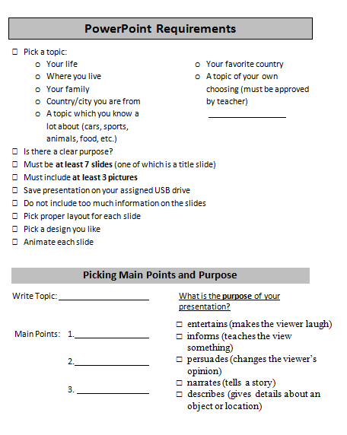
Everyone should look at the bottom of the Requirements page under Picking Topic, Details and Purpose
Use examples to review how to pick details in regard to a topic and have learners give you some ideas, do not simply tell them the main idea options (learners can come up with their own, the examples below are simply what can be used if they cannot come up with anything)
Note: Learners should NOT write these examples into their packet, they can write them down on scratch paper
- Example Option: Topic: Minnesota
  - Details: 1. Demographic, 2. Climate, 3. My favorite place
- Example Option: Topic: My childhood
  - Details: 1. Where born, 2. School, 3. Interests
Remind learners to pick a topic they know about

Step 3: Individual Practice
Instruct learners to complete the Picking Topic, Details and Purpose Portion of their packet
Circulate to assist students

Packets should be kept in the classroom, not taken home.

Teacher Directions: Activity 3: Literacy Activity Project Day 6 Scanning Practice (next page)
-PowerPoint Exercise 8: Scanning Practice
As you move through this activity, there will be scanning TIPS: write these tips on the side of the board for student reference

Step 1: Introduce Skill
Ask if anyone has ever been looking for something on the computer and were not able to find it
What did they do to try to find what they were looking for?
Example: Open Microsoft PowerPoint. Explain that you want to view your Slideshow
Ask where students might look to find the answer? What are some words they might be looking for?
Explain that a quick way to find information is to scan for it> click on SlideShow menu tab>click on View Show

Step 2: Define Scanning
What is scanning? Scanning is a reading skill you use when you want to locate a single fact or a specific bit of information without reading every part of a story, article, list or document.
Explain that the words used to scan for information are called key words
TIP: Always determine key words before you begin scanning
Ask what the key words are when scanning for slide transitions? Transitions
Scanning is not only a life-skill, but also incredibly beneficial when using computers

Step 3: Examples on Computer
Explain that when on the computer you might be asked to do something or find something that you have never learned before, that is OKAY, because we have the tools to find that information
Pull up the next page of this Lesson plan
- Key Words=folder and taskbar, do you see a folder on the taskbar?
- Key Words=printer
Day 6 Scanning Practice
Directions: Project this for the class to see, they have not learned these tools directly, but they can look for key words (hints) to find the answers.
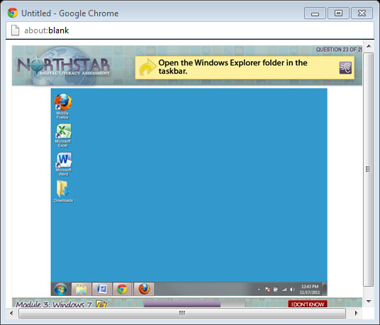
#1. What are the key words?
#2. Where would I go to connect a printer to my computer?
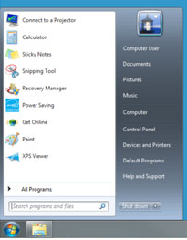
Step 4: Demonstrate
Explain that you will demonstrate how to scan for information. This example will go over looking through a chart
Open the Internet and go to Metro Transit. Under “Schedules”, click on a bus route
Explain that you will demonstrate how to find information about a specific bus line
TIP: Determine order of information
Ask if learners see any sort of order in the chart we are looking at- by location and by time
TIP: scanning means to seek out accurate information and do it TIP: quickly
Examples: What time does the bus leave from 38th St Station if you want to leave as close to 8am
as possible?
What bus stop is between” W Broadway Ave and Emerson” and “6th St S and Nicollete Mall”?
TIP: scanning means to seek out accurate information and do it TIP: quickly

Step 5: Controlled Practice
Instruct learners to open up their start menu
Ask where they might look to change any computer settings? What might “control” the settings of the computer?
Open the control panel
Ask what sort of order the information is in? alphabetical
Go through how to scan to find information on computer safety- key words=computer safety
Scan to find information/ settings regarding the battery use-key words=battery
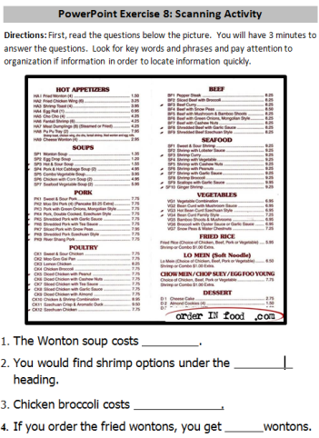
Step 5: Individual Practice
If you do not get to this, be sure to write that in the lesson report.
Explain that students will now be completing a scanning activity
It will be timed, to ensure that learners move quickly
Review the tips that were written on the board with the class
Hand out PowerPoint Exercise 8: Scanning
Complete number 1 and number 2 with the learners
Instruct learners to complete the rest of the handout, they have 15 minutes to complete as much as possible

STUDENTS MUST RETURN POWERPOINT PACKET AT THE END OF THE DAY. THESE PACKETS SHOULD NOT GO HOME WITH STUDENTS.

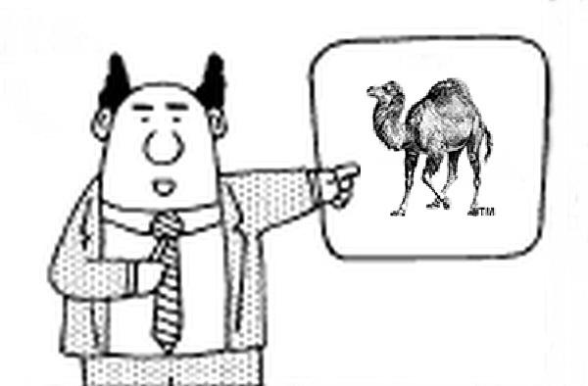

PowerPoint Presentation Packet

- This packet will be used for the remainder of the class
- We will NOT go over every aspect of the packet in one day
- This packet is meant to keep your thoughts about your presentation organized
- Your teacher should arrange for a place in the room to store this packet at the end of each day
PowerPoint Requirements
- Pick a topic:

  - Your life
  - Where you live
  - Your family
  - Country/city you are from
  - A topic which you know a lot about (cars, sports, animals, food, etc.)
  - Your favorite country
  - A favorite tradition
  - A topic of your own choosing (must be approved by teacher)

- Is there a clear purpose?
- Must be 6 slides (including title and closing slide)
- Must include at least 3 pictures
- Save presentation on your assigned USB drive
- Do not include too much information on the slides
- Pick proper layout for each slide
- Pick a design you like
- Add a transition to each slide

Picking Topic, Details and Purpose
Write Topic:
Main Idea:
Supporting Details:
1.
2.
3.
What is the purpose of your presentation?
- entertains (makes the viewer laugh)
- informs (teaches the view something)
- persuades (changes the viewer’s opinion)
- narrates (tells a story)
- describes (gives details about an object or location)

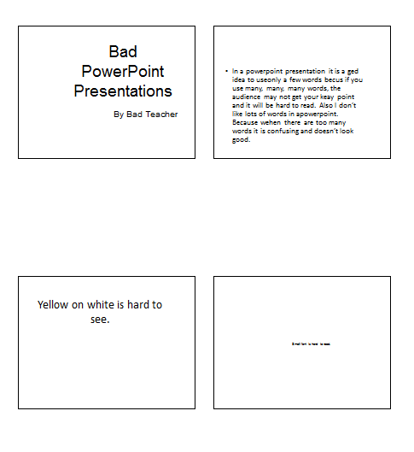
Day 7 Bad PowerPoint

Day 7 Good PowerPoint
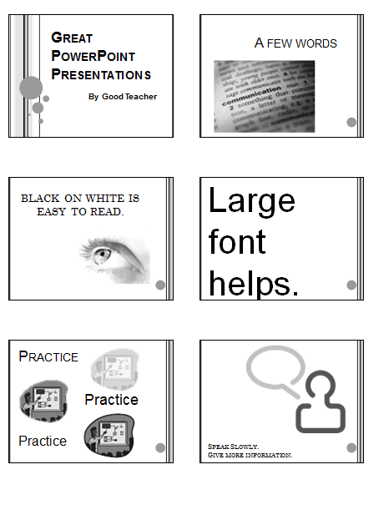

Teacher Practice Outline
- Introductory slide
Title: .
b. .
c. Any visuals?
- Supporting Detail -
  - .
  - .
  - Any visuals?
- Supporting Detail -
  - .
  - .
  - Any visuals?
- Supporting Detail-
  - .
  - .
  - Any visuals?
- Closing-
  - .
  - .
  - Any visuals?
- Any questions?

Day 7 Student Outline
Title:
1. Introductory slide
  - .
  - .
  - Any visuals?
- First Detail-
  - .
  - .
  - Any visuals?
- Second Detail -
  - .
  - .
  - Any visuals?
- Third Detail -
  - .
  - .
  - Any visuals?
- Closing
  - .
  - .
  - Any visuals?
- Any questions?

Day 7 PowerPoint Presentation Rubric
 | 1 | 2 | 3
 | - needs work | ok | - great!
Content | Presentation has many ideas. | Presentation has a main idea. | Presentation develops main idea with details.
Length | Less than 5 slides | 8 slides or more | 5, 6, or 7 slides
PowerPoint Skills | May have 2 or less of the following:  - Images on topic  - Transitions  - Attractive slide design and font  - Varied slide layouts  - Spell Checked work. | Presentation includes 3 or 4 of the following:  - Images on topic  - Transitions  - Attractive slide design and font  - Varied slide layouts  - Spell Checked work. | Presentation includes:  - Images on topic  - Transitions  - Attractive slide design and font  - Varied slide layouts  - Spell Checked work.
Presentation Skills | - Does not speak clearly and slowly.  - Text is not legible from across the room.  - Slides have everything the person said on them. | - Presentation includes 2 of the following:  - Speaks clearly and slowly.  - Text is legible from across the room.  - Has key points on slides, but says more. | - Speaks clearly and slowly.  - Text is legible from across the room.  - Has key points on slides, but says more.
Day 7 PowerPoint Rubric

This presentation mainly:

- entertains (For example - makes the viewer laugh)
- informs (for example - teaches the view something)
- persuades (For example - changes the viewer’s opinion)
- narrates (for example – tells a story)
- describes (for example – gives details about an object or location)

Write each answer in a complete sentence.
The main idea of this presentation was:

________________________________________________________________________________

Write something you enjoyed about the presentation:

Write something you believe could be improved about the presentation:

Day 8 PowerPoint Presentation Rubric
 | 1 | 2 | 3
 | - needs work | ok | - great!
Content | Presentation has many ideas. | Presentation has a main idea. | Presentation develops main idea with details.
Length | Less than 5 slides | 8 slides or more | 5, 6, or 7 slides
PowerPoint Skills | May have 2 or less of the following:  - Images on topic  - Transitions  - Attractive slide design and font  - Varied slide layouts  - Spell Checked work. | Presentation includes 3 or 4 of the following:  - Images on topic  - Transitions  - Attractive slide design and font  - Varied slide layouts  - Spell Checked work. | Presentation includes:  - Images on topic  - Transitions  - Attractive slide design and font  - Varied slide layouts  - Spell Checked work.
Presentation Skills | - Does not speak clearly and slowly.  - Text is not legible from across the room.  - Slides have everything the person said on them. | - Presentation includes 2 of the following:  - Speaks clearly and slowly.  - Text is legible from across the room.  - Has key points on slides, but says more. | - Speaks clearly and slowly.  - Text is legible from across the room.  - Has key points on slides, but says more.

Day 8 PowerPoint Presentation Rubric

This presentation mainly:

- entertains (For example - makes the viewer laugh)
- informs (for example - teaches the view something)
- persuades (For example - changes the viewer’s opinion)
- narrates (for example – tells a story)
- describes (for example – gives details about an object or location)

Write each answer in a complete sentence.
The main idea of this presentation was:

________________________________________________________________________________

Write something you enjoyed about the presentation:

Write something you believe could be improved about the presentation:

Day 8 Slide Transitions
Directions: Below you will see space to write down the steps to add transition to a slide. Work with your classmates and your teachers to come up with the steps. You can then use these for your own reference in the future.
Write steps below:

PPT True or False:
- PowerPoints should be presented like an essay, with all of the words available for the audience to read.
- PowerPoints should include transitions that take a long time to move from one slide to another.
- Information on a PowerPoint should be short and concise.
- A slide with yellow background and green text is easy to read.
- You can change the format of text after you have typed it in.
- Pictures should not be included on slides.

Day 10 PowerPoint Presentation Rubric

This presentation mainly:

- entertains (For example - makes the viewer laugh)
- informs (for example - teaches the view something)
- persuades (For example - changes the viewer’s opinion)
- narrates (for example – tells a story)
- describes (for example – gives details about an object or location)

Write each answer in a complete sentence.
The main idea of this presentation was:

________________________________________________________________________________

Write something you enjoyed about the presentation:

Write something you believe could be improved about the presentation:

Day 10 PowerPoint Presentation Rubric
 | 1 | 2 | 3
 | - needs work | ok | - great!
Content | Presentation has many ideas. | Presentation has a main idea. | Presentation develops main idea with details.
Length | Less than 5 slides | 8 slides or more | 5, 6, or 7 slides
PowerPoint Skills | May have 2 or less of the following:  - Images on topic  - Transitions  - Attractive slide design and font  - Varied slide layouts  - Spell Checked work. | Presentation includes 3 or 4 of the following:  - Images on topic  - Transitions  - Attractive slide design and font  - Varied slide layouts  - Spell Checked work. |  | Presentation includes:  - Images on topic  - Transitions  - Attractive slide design and font  - Varied slide layouts  - Spell Checked work.
Presentation Skills | - Does not speak clearly and slowly.  - Text is not legible from across the room.  - Slides have everything the person said on them. | - Presentation includes 2 of the following:  - Speaks clearly and slowly.  - Text is legible from across the room.  - Has key points on slides, but says more. | - Speaks clearly and slowly.  - Text is legible from across the room.  - Has key points on slides, but says more.

Day 11 Partner Assessment Rubric

This presentation mainly:

- entertains (For example - makes the viewer laugh)
- informs (for example - teaches the view something)
- persuades (For example - changes the viewer’s opinion)
- narrates (for example – tells a story)
- describes (for example – gives details about an object or location)

Write each answer in a complete sentence.
The main idea of this presentation was:

________________________________________________________________________________

Write something you enjoyed about the presentation:

Write something you believe could be improved about the presentation:

Day 11 Partner Assessment
 | 1 | 2 | 3
 | - needs work | ok | - great!
Content | Presentation has many ideas. | Presentation has a main idea. | Presentation develops main idea with details.
Length | Less than 5 slides | 8 slides or more | 5, 6, or 7 slides
PowerPoint Skills | May have 2 or less of the following:  - Images on topic  - Transitions  - Attractive slide design and font  - Varied slide layouts  - Spell Checked work. | Presentation includes 3 or 4 of the following:  - Images on topic  - Transitions  - Attractive slide design and font  - Varied slide layouts  - Spell Checked work. |  | Presentation includes:  - Images on topic  - Transitions  - Attractive slide design and font  - Varied slide layouts  - Spell Checked work.
Presentation Skills | - Does not speak clearly and slowly.  - Text is not legible from across the room.  - Slides have everything the person said on them. | - Presentation includes 2 of the following:  - Speaks clearly and slowly.  - Text is legible from across the room.  - Has key points on slides, but says more. | - Speaks clearly and slowly.  - Text is legible from across the room.  - Has key points on slides, but says more.

PowerPoint Exercise 8: Scanning Activity
Directions: First, read the questions below the picture. You will have 3 minutes to answer the questions. Look for key words and phrases and pay attention to organization if information in order to locate information quickly.

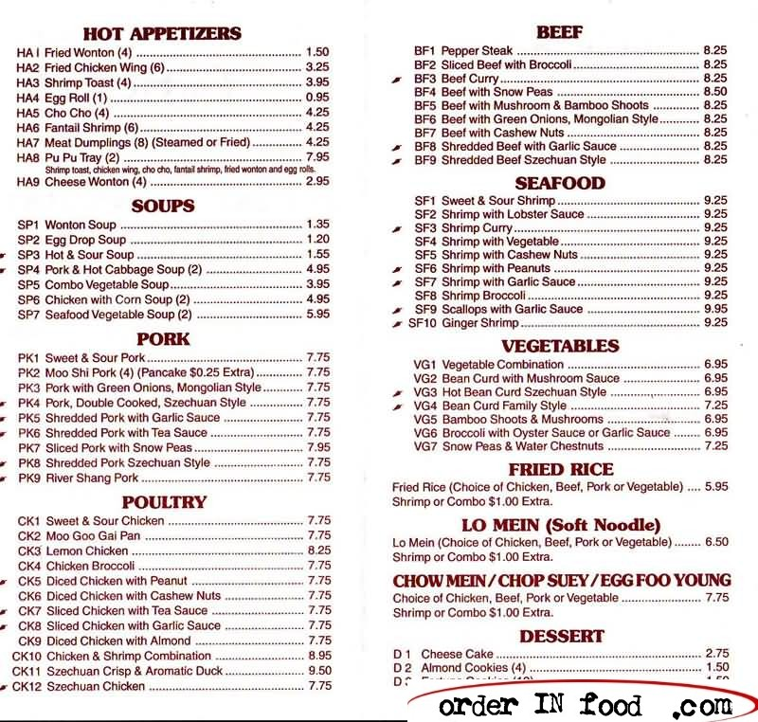
- The Wonton soup costs .
- You would find shrimp options under the heading.

- Chicken broccoli costs .
- If you order the fried wontons, you get wontons.

