**PowerPoint: Day 5**

|  |  |
| --- | --- |
| **Objectives** *Learners will be able to…* | **Materials** |
| ***Computer skill****: adding text to slides*  ***Computer skill:*** *inserting slides*  ***Computer skill****: adding a design to slide s*  ***Computer skill:*** *identify difference between save and save as*  ***Literacy skill:*** *create a basic outline*  ***Literacy Skill:*** *identify details to describe main idea and topic* | **Make Student Copies**   * **PowerPoint Exercise 7: Parts 1 & 2 (15)**   **Props, Technology or Other Resources**   * Projector * Computer for every student * USB Drives * **Download Main Idea Practice PowerPoint from Day 4** |
|  | |
| **Lesson Plan** | Vocabulary |
| **Warm-up:** If the teachers from Day 4 did not finish Day 4 Main Idea Practice PowerPoint, go through what is left with the learners.  **Activity 1: Review**  Description: students will review the steps for how to do a few of the things we have discussed in class.  Materials/Prep  **Activity 2: Creating an Outline, Picking Details**  Description: discuss how to determine what to cover for specific topics, practice using main idea to determine details, and then have students create a PowerPoint  Materials/Prep: copies of **PowerPoint Exercise 7: Outlining Part 1**  **Activity 3: Practice what we learned**  Description: learners will practice picking details, picking a topic/title and making up their own examples  Materials/Prep: copies of **PowerPoint Exercise 7: Part 2** | * Ribbon * Menu Tabs * Desktop * Supporting Details/Evidence * Main Idea * Topic * Organizing * Outline |

**Teacher Directions: Activity 1: Review**

Step 1: How to open PowerPoint

**Ask** learners how to open PowerPoint. Instruct them to provide you the steps using the appropriate vocab

**Encourage students to write down steps so they can be referred to at a later date.**

**Example:**

1. Locate the PowerPoint **Icon** on the **Desktop Screen.**
2. **Double-click** on the **icon.**

Step 2: How to insert a slide

Students should lead again, using appropriate vocabulary

1. Click on the **New Slide** button on the **Ribbon. <ribbon is important to know for the assessment**

Step 3: How to change design

Same for this portion

1. Click on **Design Menu Tab**
2. Pick from the list on the **ribbon**

Step 4: How to save

1. Click on the **File Menu Tab**
2. Click on Save As
3. Locate appropriate drive
4. Type a name into **File name**
5. Double check that you are in the right place (look in **File In line)**
6. **Click on Save**

Step 4: Review questions

1. Where can you look to see what programs you have open? *Taskbar*
2. How many programs does the teacher have open?
3. How do you minimize the page? *Upper-right corner, small line*
4. How do you maximize the page? *The middle button*
5. How can we figure out what a button does? *Hover over it with our cursor, without clicking*

**Teacher Directions: Activity 2: Creating an Outline, Picking Details**

**-PowerPoint Exercise 7: Outlining Part 1**

Step 1: Context

**Explain** that when creating a PPT, it is important to remember that there is often a lot of information to discuss, but you want to limit information shown on a slide

* People are supposed to be listening to you, not reading a slide
* Reading from a slide is not presenting, the presentation is an AID, not a CRUTCH

What goes on a slide? Only the main points of the topic, the supporting details

Step 2: Example

Topic of presentation: Sports

Main Idea: Sports are fun

Add a slide, type:

Sports allow people to come together to work towards a common goal. They get to celebrate each other’s successes, work towards ways to improve, and build friendships beyond the field. When I play sports, I enjoy

Add another slide, include:

* Common Goal
* Celebrate successes
* Friendship

**Explain** that you pick out key words from what you want to say, and then expand on them in the speaking portion of the presentation

**PowerPoint is like a list of directions, leading the audience through the presentation**

**Explain** that this takes quite a bit of practice

Step 2: Demonstrate creating an outline

**Learners should have EYES FORWARD AND HANDS OFF OF COMPUTER**

On the board write:

Topic: Different Modes of Transportation

Main Idea: Each mode of transportation has its advantages

**Ask** learners what might be discussed: *different modes of transportation*

**List on board as shown below (can use alternate student suggestions):**

* Bike

1. .
2. .
3. .

* Bus

1. ..
2. ..
3. ..

* Drive

a..

b..

c..

**Ask** learners what might be some points to discuss about each mode- ask what the main idea is to focus ideas

Explain that each point should support the main idea

Each point should be short on the slide, but expanded in presentation

Narrow down to max of three points for each

**Explain** that what they see is an **outline**

**Ask** what outlines help with: organization of ideas

Step 3: Controlled Practice

Hand out **PowerPoint Exercise 7: Outlining**

**Students will use this to insert their information as discussion**

Instruct students to come up with points for the disadvantages of these modes of transportation

**Ask** students what they just created? *An outline*

**Ask** if an outline includes a lot of text? *No, just like a PowerPoint should not*

Step 4: Turn into a PowerPoint

**Instruct and assist** learners to turn the outline into a PowerPoint

This will probably require a discussion of what should be included in each slide

**Explain** that learners should use the handout

Step 5: Save PowerPoint

**Review** how to Save a Document

**Review** Save vs Save As: Save As when it’s a document never saved before, save when you have saved it before but you are updating content

**Point out the Save button on the Ribbon**

**Teacher Directions: Activity 3: Practice with Picking Details based of Main Idea and Picking a Title based off of details**

**-PowerPoint Exercise 7: Part 2**

Step 1: Directions

**Handout Exercise 7: Part 2**

**Read through the directions with the class.**

**Go through the example asking learners why they would be the details, why that makes sense**

Step 2: Controlled Practice

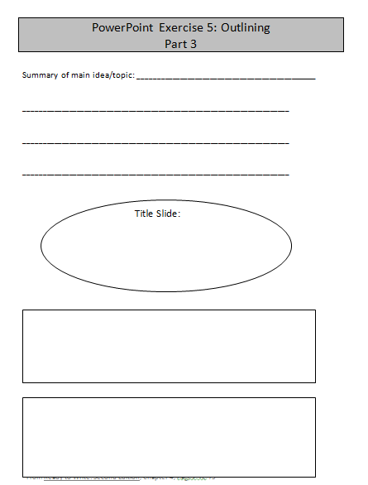Complete at least #1 together

Do more if you feel necessary

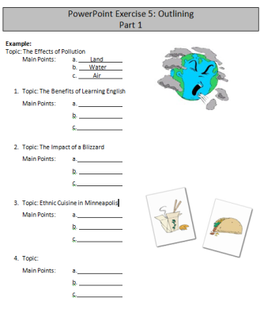

Step 3: Peer practice

Students can work on the exercise together

Teacher should circulate to answer questions

**Have extra time?**

Step 4: Create PowerPoint

Learners should now take the information from the slide organizer and put it into PowerPoint Slides

Remind learners to save their work

PowerPoint Exercise 7: Outlining

Part 1

Main Idea: ___________________________________________ _____

Slide #3: Detail 2

Title Slide:

Slide #2: Detail 1

Slide #4: Detail 3

Concluding Slide:

PowerPoint Exercise 7: Outlining

Part 2

**Directions:** Each problem has blank spaces that need to be filled in. For some, you will determine what details you will discuss in regard to the topic and main idea, for others you will pick a topic that describes the main idea and details and the last question has you create your own topic, main idea and details.

**Example:**

**Topic: Pollution**

**Main Idea:** *Pollution negatively affects the Earth in all ways*.

**Details:** a. Land

b. Water

c. Air

1. **Topic: Ethnic Cuisine in Minneapolis**

**Main Idea:** *there are many options to fit any preference*

**Details:** a. .

b. .

c. .

1. **Topic: The Impact of a Blizzard**

**Main Idea:** *Blizzards make life more* (Fill in the blank).

**Details:** a. .

b. .

c. .

1. **Topic:**

**Main Idea:** *Learning English makes life in America easier****.***

C:\Users\knorman\AppData\Local\Microsoft\Windows\Temporary Internet Files\Content.IE5\UBX7GWSH\MC900290707[1].wmf **Details:** a. Easier to do simple things like grocery shopping

b. Easier to get a good job

c. Most commonly used language

1. **Topic:**

**Main Idea:** *Microsoft Office provides many tools to create all kinds of documents****.***

**Details:** a. Microsoft Word.

b. Microsoft Excel.

c. .

1. **Pick a Topic:**

**Main Idea:**

**Details:** a. .

b. . .

c. . .