Internet: Day 9

Objectives Learners will be able to… | Materials
Computer skill: search techniques  Computer skill: online job application  Literacy Skill: reading comprehension | Make Student Copies  - Lesson Summary (Tab 15)  Props, Technology or Other Resources  - Projector  - Computer for every student  - Day 9 Swat Questions (Tab 25)  - Day 9 Swat Pictures (Tab 25)  - 2 Fly swatters/Markers/Erasers
Lesson Plan |  | Vocabulary
Warm-up: SWAT  Description: Tape the pictures/words to the board and divide the class into two. One learner from each team will come up to the board and the T will ask the pair a question. The students will answer the question by touching the answer with a white-board marker/fly swatter/eraser.  Materials/Prep: If not done and in binder already Make a copy of Day 9 SWAT and cut each picture/text into its own square and tape each one to the front of the board, make sure you have the Day 9 Questions as well  Activity 1: Login to Schoology  Description: review and instruct everyone to log in to Schoology  Materials/Prep:  Activity 2: Copy and Paste  Description: demonstrate (I-we-you) how to copy and paste using right-click  Activity 3: Filling out forms online-Schoology Activity  Description: learners will read a passage about a job seeker and then complete comprehension questions in Schoology  Materials/Prep:  Activity 4: Lesson Summary  Description: learners will summarize today’s lesson  Materials/Prep: copies of Lesson Summary |  | - Click and drag  - Copy  - Paste  - Online Forms

Teacher Directions: Activity 1: Log in to Schoology

Step 1: Log in to Schoology
Instruct learners to open a new tab and go to Schoology.com and log in
Student Username: odcomp#@gmail.com
Teacher Username: comp.lit.opendoor@gmail.com
Password: Opendoor
Note: if they use Internet Explorer for some reason the password does not show up as they are typing, but they are entering text

Step 2: Locate class information
Click on courses>Click on Computers and Literacy>Click on Internet
Click on Day 9 Copy and Paste Practice
This will set them up for the rest of the day

Schoology does not work? If Schoology is not working, have learners practice copying and pasting within the Internet Browser. IE, copy a URL from Google Search results and paste it into the address bar.

Teacher Directions: Activity 2: Copy and Paste
We will use right-click for this class. It is the most transferable and visual way to copy and paste.

Step 1: Context
Explain that the computer offers many shortcuts that make your life easier
One of those shortcuts allows you to take information from somewhere and paste it somewhere else
This is called Copy and Paste
Ask if anyone knows what it means to copy? Make two of something
Ask if anyone know what it means to paste? Stick it somewhere

Step 2: Set-up
Go to news.google.com
Pick an article
Explain that sometime you might be looking at something and see a word or phrase you want to learn more about
Explain that instead of looking at it, opening and new tab, and typing it into google again, you can simply make a copy of it

Step 3: Demonstrate
Demonstrate click and drag motion to copy
Note: it is important to explain and show that using two hands to click and drag can make things easier, also, if you click and mess up, as long as you are still clicking the mouse, you can move the highlighted section around
Right-click on the highlighted section, see menu open, click on Copy
Ask learners how to open a new tab
In new tab go to google.com
Explain that as long as you clicked copy, you can paste almost anywhere typing is accepting
Right-click in the search bar, click on paste in the drop down menu

Step 3: Controlled Practice
Explain that we have been writing out URLs on our handouts, but we can simply copy and paste them into the comment we post on Schoology
Instruct everyone to find an article (ideally the same one)
Demonstrate how to copy and paste the article into the comment section of Schoology’s Day 9 Copy and Paste Practice
Students should lead you through the steps, with you asking how to do it, and then they should complete the steps together as well

Step 4: Individual Practice
Open a new tab, go to Google.com
Learners should locate a website that discusses some aspect of their research topic
Learners should copy and paste the URL into the Day 9 Copy and Paste assignment, including their Name and Research Topic

Teacher Directions: Activity 3: Online Form
Step 1: Context
Ask how many learners have had to fill out any sort of form online? What kinds of forms?
Explain that these days it is hard to find employment without applying online

Step 2: Set-up
Instruct learners to locate Day 9 Job Application
Read through the passage with the learners and explain that they will be using the information in the passage to answer questions

Step 3: Controlled Practice
Explain that learners will have time to attempt to answer each question on their own, and then everyone will complete it together

Teacher Directions: Activity 4: Lesson Summary –Lesson Summary
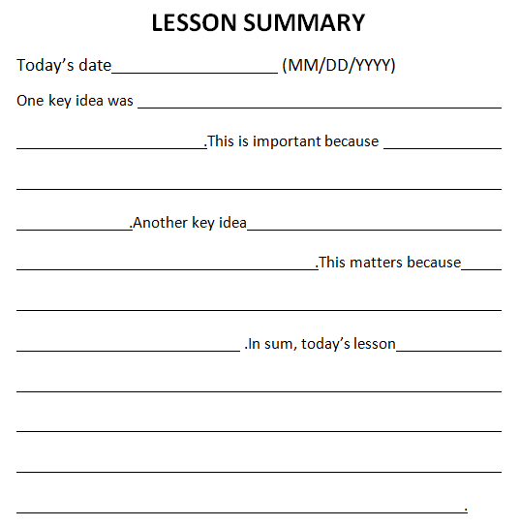
Step 1: Set-up
Hand out Lesson Summary
Instruct learners to fill it in for today’s events

Day 9 SWAT

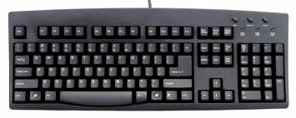

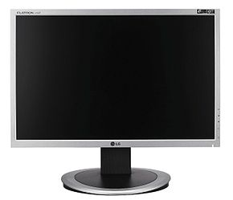
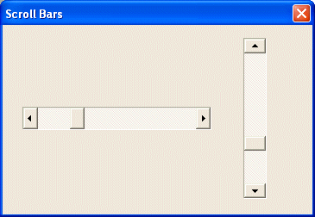
URL

https://

Domain Extensions

Pop-up

Hyperlink
CTRL +

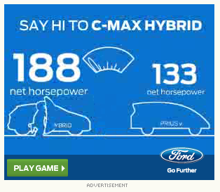
Questions
- Where is the address bar?
- What do you plug into the address bar? URL
- What do you click on to open a new tab? The small box next to the current tab
- .com, .gov, . edu are all examples of what? Domain Extensions
- If you click on this it will take you to a new page? Hyperlink
  - Bonus question: What color signifies that the word is a hyperlink? blue
  - Bonus question: What does the cursor look like when it is over a hyperlink? A hand
- Which button takes you back to the previous web page? Back arrow
- Which button takes you to the home page? Home button
- Which button will “refresh” the page? Green arrows
- Websites with a URL that starts with this are identified as being secure. https://
- What key website feature allows you to move up and down a page to see more information? Scroll bars
- Which one is the monitor?
- What key do you press once you have typed in a website? Enter, should be selected on the keyboard picture
- Touch each of the Web Browsers on the board: Internet Explorer, Google Chrome, Mozilla, Safari
- Where is the start menu?
- Which one is the taskbar?
- Which keys do you press at the same time to zoom in on a page? CTRL +
- Which picture is of an advertisement?
  - How do you know?

LESSON SUMMARY
Today’s date (MM/DD/YYYY)
One key idea was .This is important because .Another key idea .This matters because .In sum, today’s lesson .

Copyright ©Raymond C. Jones. All Rights Reserved ReadingQuest Permission Granted for Classroom Use www.readingquest.org

