Internet: Day 7

Objectives Learners will be able to… | Materials
Computer skill: internet search  Computer skill: new tabs  Computer skill: moving between tabs  Literacy Skill: summarize  Literacy Skill: determine key words | Make Student Copies  - Internet Search Summary (Tab 23)  - Lesson Summary (Tab 15)  If Schoology does not work:  - Internet Exercise 7: Research Topic (Tab 28)  Props, Technology or Other Resources  - Projector  - Computer for every student
Lesson Plan | Vocabulary
Warm-up:  Description: Ask learners what an Internet Browser is? Ask what is an example of an internet browser? We have learned Internet Explorer and Google Chrome. Ask where do you type a web address into an internet browser? Address bar. Ask where do you type in key words? Search bar.  Materials/Prep:  Activity 1: Creating Tabs-25 minutes max  Description: explain what a tab is, how to open one, how to move between tabs and how to close them  Materials/Prep: try to locate a tabbed manila folder for imagery  Activity 2: Login to Schoology  Description: learners will follow direction to login to Schoology  Activity 3: Picking topics-20 minutes  Description: Teacher will introduce the research project and assist students as they pick out a topic  Materials/Prep: copies of Internet Exercise 7: Research Topic  Activity 4: Summarize Websites-40 minutes  Description: learners will begin searching for websites and summarizing the information found  Materials/Prep: copies of Internet Search Summary  Activity 5: Lesson Summary  Description: learners will summarize what they learned  Materials/Prep: copies of Lesson Summary | - Summary  - Tabs  - Key Words
Teacher Directions: Activity 1: Creating Tabs
Step 1: Set-up
Instruct everyone to open an Internet browser (either Internet Explorer or Google Chrome)
Point out the top of the webpage and explain that currently you have one webpage open
Explain that within an internet browser, it is possible to have many webpages open at one time
Point out the new tab box (it sits next to the current tab)
Instruct learners to hover their cursor over the box, ask them what the box does: new tab

Step 2: What is a tab?
Ask if anyone knows what an internet tab is
Explain that tabs are a lot like tabs on a folder (if you have a folder or two, use them as visuals)
Tabs allow users to have many websites open at one time, which would allow them to move back and forth between those sites without having to retype the URL in every time

Step 3: Demonstrate Opening Tabs
Learners should have their EYES FORWARD AND HANDS OFF OF THEIR COMPUTER
Go to mnliteracy.org in your original browser
Explain each of the following steps as you go
Open a new tab, go to google.com
Point out that the names of the websites are shown at the top of each tab

Step 4: Demonstrate Moving Between Tabs
Learners should have their EYES FORWARD AND HANDS OFF OF THEIR COMPUTER
Demonstrate how to move back to the MNliteracy website
Move back to Google

Step 5: Demonstrate Closing Tabs
Learners should have their EYES FORWARD AND HANDS OFF OF THEIR COMPUTER
Point out using the “X” on the tab itself to close just that tab
Explain that if users want to simply close the tab, they use that x
Ask what the red x would do? Close the entire window
Remind learners to be careful about using the red x

Step 6: Controlled Practice
Teacher and learners will do this together
Instruct learners to open a new tab
Instruct learners to go back to original tab and type in google.com
Instruct learners to go back to new tab
Instruct learners to close the tab
Instruct learners to go to schoology.com in the new tab
Everyone should have Google open in one tab and Schoology in the other, leave it like this
Teacher Directions: Activity 2: Log in to Schoology

Step 1: Front page of Schoology>Review
Instruct learners to type “schoology.com” into the address bar
Once they have done that, everyone should be on the main page for the Schoology Website
Ask if anyone sees a place where it looks like they can “log in”
In the upper right hand corner of the page

Step 2: Login to Schoology>Review
Instruct learners to log in to their Schoology account, Teacher should also sign in
Student Usernames: odcomp(comp#)@gmail.com
Password: Opendoor (same for all)
Teacher login: comp.lit.opendoor@gmail.com
Password: Opendoor

Step 3: Locate assignment>Review
Review how to get to the class site: Courses> Computer and Literacy
Review how to access documents for the class we are in: Click on Internet Class
Ask what assignment goes along with Day 7: Day 7 Research Topic

Teacher Directions: Activity 3: Picking Topics and Keywords
-Day 7 Research Topic from Schoology
Step 1: Set-up
Explain that for the next couple of days we will be researching different topics
Everyone should have Day 7 Research Topic open on their computer

Step 2: Picking a topic
Explain that learners should pick a topic that they do not know much about but that they are interested in
Read through the topic options
Explain that learners can pick another option, but the T should approve it
Give learners a few minutes to think it over
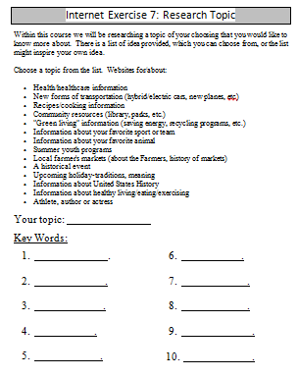
Teacher’s research topic: Fort Snelling

Step 3: Demonstrating how to pick key words
Once learners have determined their topics, they will have to think about a list of key words they can type in the search box in regard to the topic
Ask learners to come up with ideas for key words for the T’s project: Fort Snelling
Demonstrate how to come up with those words

Step 4: Controlled Practice
Do another example, but have students come up with key words
Note: you can pick a different topic, but try to make sure the learners know something about it
Search topic: Events in Minneapolis
Potential Key words:

  - Summer
  - Winter
  - Free
  - Cheap
  - Music
  - Outdoor

Step 4: Learner practice
Learners should now post a comment that follows the following format:
Their name, Their Topic, Key Words
Example: Teacher, Events in Minneapolis, Key Words: Summer, Winter, Free, Cheap, Music, Outdoor
Demonstrate how to post a comment on the Schoology Assignment

Teacher Directions: Activity 4: Summarize Websites –Internet Search Summary

Step 1: Context
Explain that in order to be effective with internet research (or any research) it is important to keep track of sources and what that source had to say
Explain that there are many ways to keep track of this information, ask students what storage ideas they can think of

- Paper
- Email
- USB Drive
- Etc.

This class will be saving work we find on the Schoology site, in addition to keeping paper records of what is found

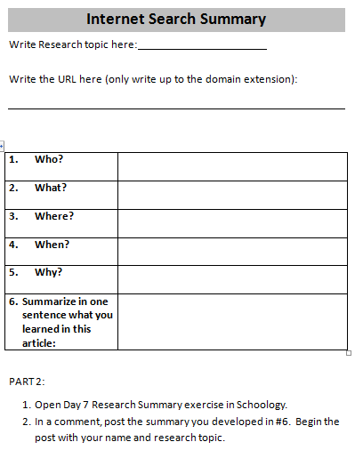
Step 2: Activity Directions
Hand out Internet Search Summary Handout
Read through the handout. Point out the Part 2
Explain that students need to open a new tab and go to Google.com, they should then search for information about their Research Topic

Step 3: Demonstrate Summarizing
Do a keyword search for the teacher’s research topic and pick a website
Read through website and complete handout students will complete, circle relevant words so that students can visualize
Demonstrate posting to the Schoology website
- How to get back to Schoology tab?
- Where is Day 7 Research Summary Assignment? How do I open it?
- How do I post a comment?

Step 4: Controlled Practice
Do this again, but have the learners assist you through the search and summary

Step 5: Learner practice
Learners should now do this for their own research topic
Hand out one copy of Internet Search Summary to each learner
They will fill in the sheet and then go back to the Schoology tab and post a comment to the Day 7 Research summary assignment

Step 6: If learners finish early
Have them write another summary

Teacher Directions: Activity 5: Lesson Summary –Lesson Summary
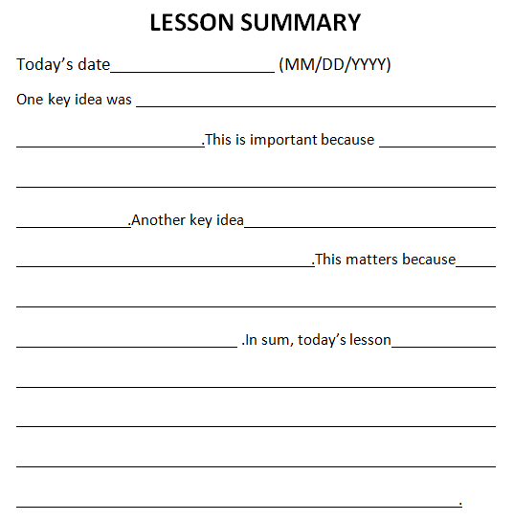
Step 1: Set-up
Hand out Lesson Summary
Instruct learners to fill it in for today’s events

Internet Exercise 7: Research Topic
Within this course we will be researching a topic of your choosing that you would like to know more about. There is a list of idea provided, which you can choose from, or the list might inspire your own idea.
Choose a topic from the list. Websites for/about:

- Health/healthcare information
- New forms of transportation (hybrid/electric cars, new planes, etc)
- Recipes/cooking information
- Community resources (library, parks, etc.)
- "Green living" information (saving energy, recycling programs, etc.)
- Information about your favorite sport or team
- Information about your favorite animal
- Summer youth programs
- Local farmer's markets (about the Farmers, history of markets)
- A historical event
- Upcoming holiday-traditions, meaning
- Information about United States History
- Information about healthy living/eating/exercising
- Athlete, author or actress
Your topic:

Key Words:

- .
- .
- .
- .
- .
- .
- .
- .
- .
- .
Internet Search Summary

Write Research topic here:

Write the URL here (only write up to the domain extension):

- Who?
- What?
- Where?
- When?
- Why?
- Summarize in one sentence what you learned in this article:

PART 2:
- Open Day 7 Research Summary exercise in Schoology.
- In a comment, post the summary you developed in #6. Begin the post with your name and research topic.

LESSON SUMMARY
Today’s date (MM/DD/YYYY)
One key idea was .This is important because .Another key idea .This matters because .In sum, today’s lesson .

Copyright ©Raymond C. Jones. All Rights Reserved ReadingQuest Permission Granted for Classroom Use www.readingquest.org

