Internet: Day 6

Objectives Learners will be able to… | Materials
Computer skill: investigate a new browser  Computer skill: learn about Wiki’s  Literacy Skill: similarities and differences  Literacy skill: summarize | Make Student Copies  - Internet Exercise 6: Google Chrome (Tab 21)  - Day 6 Intro to Wiki PPT-print with 4 slides per page (Tab 22)  - Lesson Summary (Tab 15)  If Schoology does not work:  - Review (Tab 20)  Props, Technology or Other Resources  - Projector  - Computer for every student  - Day 6 Intro to Wiki PPT
Lesson Plan |  | Vocabulary
Warm-up:  Description: Instruct learners to log on to Schoology, directions are under Activity 1  Materials/Prep:  Activity 1: Review Quiz on Schoology  Description: learners will take a review quiz on the class Schoology page, it goes over important topics we have learned so far in class and can take up to 55 minutes  Materials/Prep:  Activity 2: Investigate new Browser  Description: learners will investigate a Google Chrome and list the similarities and differences in a chart  Materials/Prep: copies of Internet Exercise 6: Google Chrome  Activity 3: Wiki Intro  Description: take some time to discuss Wikipedia and its standing as a “reliable source”, learners will them summarize what Wiki’s are in one sentence  Materials/Prep: download Day 6 Intro to Wiki PPT, print with 4 slides per page for learners  Activity 4: Lesson Summary  Description: learners will summarize what they learned  Materials/Prep: copies of Lesson Summary |  | Review:  - Scroll bar  - URL  - Home Page  - Domain Extensions  - Hyperlink  - Advertisements  New:  - Google Chrome  - Wikipedia

Teacher Directions: Activity 1: Review on Schoology
If Schoology is not working, paper copy of Review can be found in Tab 20
Step 1: Front page of Schoology>Review
Instruct learners to type “schoology.com” into the address bar
Once they have done that, everyone should be on the main page for the Schoology Website
Ask if anyone sees a place where it looks like they can “log in”
In the upper right hand corner of the page

Step 2: Login to Schoology>Review
Instruct learners to log in to their Schoology account, Teacher should also sign in

Student Usernames: odcomp(comp#)@gmail.com
Password: Opendoor (same for all)
Teacher login: comp.lit.opendoor@gmail.com
Password: Opendoor

Step 3: Locate assignment>Review
Review how to get to the class site: Courses> Computer and Literacy
Review how to access documents for the class we are in: Click on Internet Class
Ask what assignment goes along with Day 6: Day 6 Review

Step 4: Explain Assignment
Learners will complete the review quiz
This will involve students answering multiple choice, fill in the blank and re-ordering questions
Instruct learners to click on the assignment
Go through the practice questions with the learners
Matching: Click in empty space and type letter of matching word

Step 5: Complete Review
Instruct learners to complete the review assignment
They should be able to see their answers at the end of the assignment
Instruct learners to stay logged into Schoology, it will be used for the next exercise

Teacher Directions: Activity 2: New Browser -Internet Exercise 6: Google Chrome

Step 1: Set-up
Explain that for the first part of today we will be exploring one of the other popular internet browser options: Google Chrome
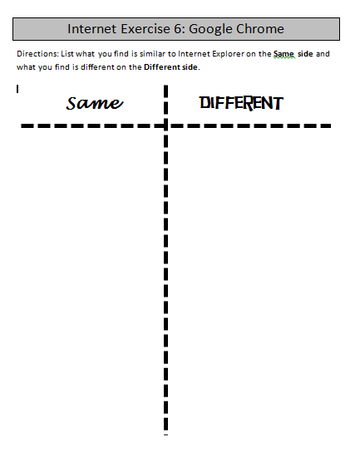
Ask what is the name of the internet browser we have been using: Internet Explorer
Explain that we will be looking at the similarities and differences between the two web browsers

Step 2: Explore basic functions
Hand out Internet Exercise 6: Google Chrome
Draw the chart on the board and fill in it with a few examples as you go
Instruct learners to write down the similarities and differences on the appropriate side
First, have learners look for the back, forward, refresh and home buttons
Ask if they are there? Are they different in appearance? Do they perform the same function?

Step 3: Address Bar and Search bar
Next, look for the address bar, ask if it looks the same
Ask if they see a search bar? No, Google chrome is different in this aspect. In Google Chrome, the Address bar and the search bar are the same.

Step 5: Further Investigation
Instruct learners to explore Google a bit
Instruct them to go to different websites: webmd.com, umn.edu
Questions to ask:
- Is Google Chrome faster than Internet Explorer?
- Are there any toolbars missing?
- Does the page look different?
Take time to explain that Google Chrome is a safer browser. Like Gmail, Chrome has many safety features installed from the beginning, which allows you to avoid many issues

Step 6: Review Hand out
Take time to go through the similarities and differences that students found between Google Chrome and Internet Explorer
Explain that the purpose of this is to show that while Browsers may look difference, they all have the same kind of tools somewhere on the screen and perform the same basic functions
If learners choose to use Chrome for the remainder of the course, that is perfectly fine

Teacher Directions: Activity 3: Wiki Intro -Download Day 6 Wikipedia Intro PPT
-Print Day 6 Wikipedia Intro PPT 4 Slides per Page

Step 1: Context
Ask if anyone used a website that had “Wikipedia” in the URL
Ask if anyone knows what a Wiki site is? What it means? It means that it is information that anyone can edit.
Discuss whether this can cause issues when looking for reliable resources.

Step 2: Overview
Download Day 6 Intro to Wiki PPT
Go through, purpose is to explain the pro’s and con’s

Step 2: Show them
Instruct everyone to go to Wikipedia.com
Select English
Ask them which features they see on the page automatically, any ads?
Ask if they see a search bar?
Locate the search bar
Type in Barack Obama

Step 3: Wiki page
Scroll down the page and show them how many people have edited the page
Explain that while anyone can update a page, it is regulated by the site
Explain that information can be valid on Wiki sites, but it is best to double check the information

Step 4: Hyperlinks
Point out the text in the page
Ask if learners see any text that is blue, what does that mean? Hover cursor over text
Cursor should turn into a hand, what does that mean? Hyperlink
Hyperlink when clicked, takes you to another page
Many exist on Wikipedia and other articles

Step 4: Individual Practice
Ask students to go to a Wikipedia page (you decide, options below) and count the number of edits, if possible
Instruct them to click on a link on the page and go to another page to count the edits
This is practice with moving around the page and the internet
Possible searches:
- George Washington
- Electric Cars
- Computers
- Groundhog Day

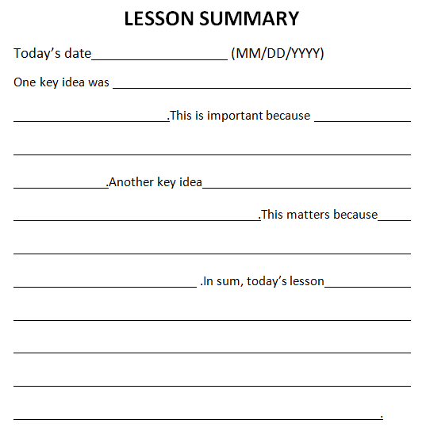
Teacher Directions: Activity 4: Lesson Summary –Lesson Summary
Step 1: Set-up
Hand out Lesson Summary
Instruct learners to fill it in for today’s events
NOTE: Encourage learners to summarize what a Wiki is.

Internet Exercise 6: Google Chrome
Directions: List what you find is similar to Internet Explorer on the Same side and what you find is different on the Different side.

Different
Same

LESSON SUMMARY
Today’s date (MM/DD/YYYY)
One key idea was .This is important because .Another key idea .This matters because .In sum, today’s lesson .

Day 6 Review
Note: Only use paper copy if Schoology is no longer working.
- Match the vocabulary word to the appropriate picture or definition by drawing a line.
Browser

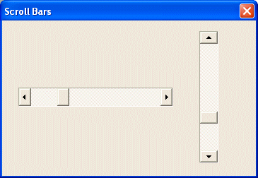
- Monitor
- Keyboard
- Scroll bar
Address Bar
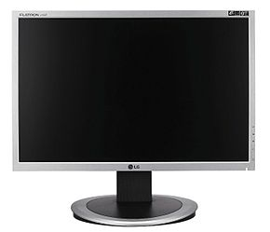
- Takes you back to the previous webpage
- Takes you to the home page
- Synonym for Web Address
Search Bar
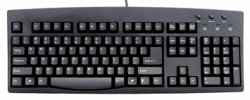
- Place where you type in a Web Address
- Place where you place key words to find information on the internet
URL
- A software application for retrieving, presenting and traversing information resources on the World Wide Web

- Check all of the following that show real domain extensions.

  - .url
  - .comm
  - .gov
  - .website
  - .com
  - .org
  - .edu

- When the cursor is placed over a hyperlink, it changes for look like an arrow.
  - True
  - False
- When a user clicks on a hyperlink, it typically takes them to another page.
  - True
  - False
- Circle each example of an advertisement. Hint: Two of the choices are advertisements.
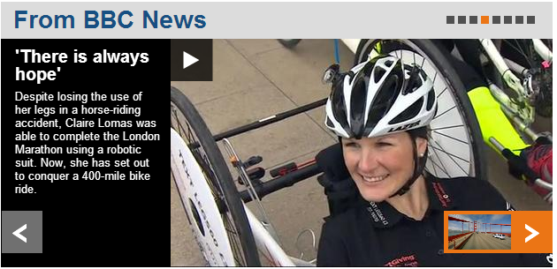

- Circle each Web Browser.

A. 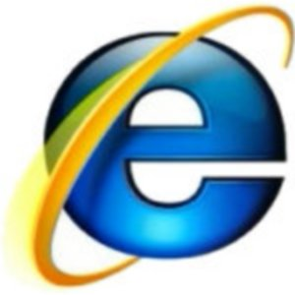 B.
C. D.

- If you wish to zoom in on webpage information, you would press down the CTRL button and + at the same time.
  - True
  - False
- Which of the following is a URL?
  - www.gmail@com
  - www.google.com
  - ww.google.com
  - frank@gmail.com

- When completing an internet search, you should type full questions into the search bar.
  - True
  - False
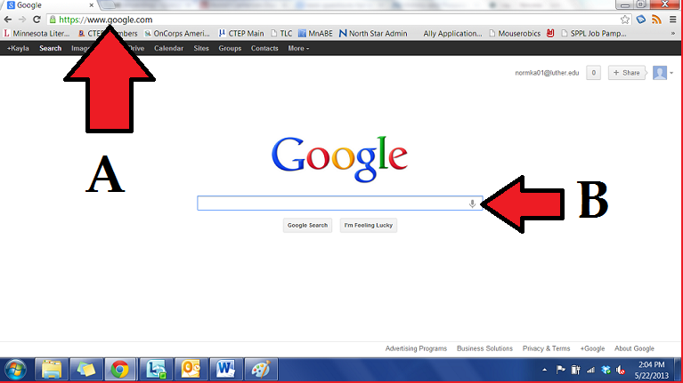
Use the picture below to answer the questions 10 and 11.
- What do you enter into the space labeled “A”?
  - Search terms
  - Email Addresses
  - URL
  - Pictures
- What do you enter into the space labeled “B”?
  - Search terms
  - Email Addresses
  - URL
  - Pictures

Copyright ©Raymond C. Jones. All Rights Reserved ReadingQuest Permission Granted for Classroom Use www.readingquest.org

