**Internet Day 4**

|  |  |
| --- | --- |
| **Objectives** *Learners will be able to…* | **Materials** |
| ***Computer skill:*** *decipher between web content and ads*  ***Computer skill:*** *locate common website features*  ***Literacy skill:*** *Summarizing text*  ***Literacy skill:*** *scanning to locate information* | **Make Student Copies**   * **Day 4 Warm-up (Tab 11)** * **Internet Exercise 4: Identifying Advertisements** **(Tab 12)** * **Common Website Features Index (Tab 13)** * **Internet Exercise 5: Website Features (Tab 14)** * **Lesson Summary (Tab 15)- use colorful paper** * **If students want: Helpful Career and Job Search Websites (Tab 16)**   **Props, Technology or Other Resources**   * Projector * Computer for every student |
|  | |
| **Lesson Plan** | Vocabulary |
| **Warm-up:**  Description: Learners should look through the flyers and locate a URL. They should then open the internet and type the URL into the address bar and then complete the questions in the handout  Materials/Prep: grab some flyers from the office, make sure they have website addresses on them, copies of **Day 4 Warm-up**  **Activity 1: Web Content vs. Advertisements**  Description: a discussion on how to tell the difference between web content and advertisements  Materials/Prep: copies of **Internet Exercise 4: Identifying Advertisements**  **Activity 2: Common Website Features**  Description: learners will learn common website features and practice locating them on a webpage  Materials/Prep: copies of **Common Website Features Index** and **Internet Exercise 5: Website Features**  **Activity *3:*  Practice**  *Description:* learners will practice their skills while looking up jobs and then review summarizing tools  *Materials/Prep:* for those interested, hand out **Helpful Career and Job Search Websites**  **Activity 4: Summary of Lesson**  *Description:* learners will summarize what they learned in class today  *Materials/Prep:* copies of **Lesson Summary** | * Advertisement * Web content * Features * Summary * Navigation Bar * Tabs * Hyperlinks/Links |

**Teacher Directions: Activity 1: Web Content vs. Ads**

**- Internet Exercise 4: Identifying Advertisements**

Step 1: Context

**Ask** how many learners have been on the internet and been offered a FREE IPAD?

**Ask** how many learners have clicked on something on a website and were taken to another site that they did not want to go to?

**Explain** that today we will be learning some tips for determining what is actual **web content** and what is an **advertisement**   
**Ask** students if they know what the definition of **advertisement** is: *a form of communication meant to sell a product, service or idea*

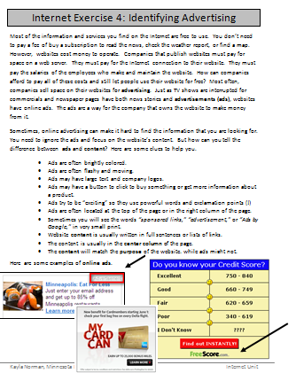**IMPORTANT:** This is not an Internet Safety day, instead we are going to learn what websites typically consist of and what to avoid. Day 5 will be an Internet Safety day.

Step 2: Introduction Reading

Hand out **Internet Exercise 4: Identifying Advertisements**

**Read through** the first page with learners and answer questions as you go

**Explain** that learners **should not go ahead to the questions yet**

Step 3: Review and Demonstrate

**Review** how to open Internet Explorer

**Ask** learners what Internet Explorer is: *internet browser*

**Ask** learners what the first page that shows up when a browser is opened is called: *home page*

**Ask** where you might type in a web address: *address bar*

**Ask** what another name is for web address: *URL*

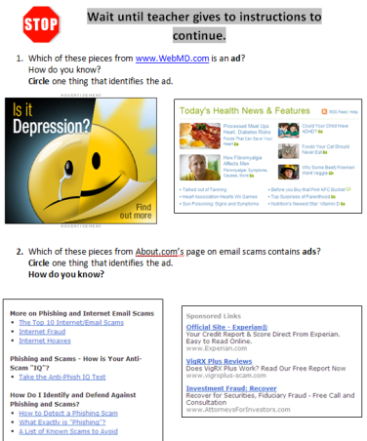**Instruct** everyone to go to bbc.com

**Ask** learners what the **domain extension** is: .com

**Ask** what some of the other domain extensions are: .org, .gov, .edu

**Ask** if anyone sees anything that looks like an ad. Point out all of the ads on the page

**Explain** how you know it is an advertisement using the clues from the handout

Step 4: Individual Practice

**Instruct** learners to now try to answer the questions starting on **Page 2 of Internet Exercise 4: Identifying Advertisements**

Circulate to answer questions

**Teacher Directions: Activity 2: Common Website Features**

**-Common Website Features Index**

Step 1: Context **-Internet Exercise 5: Website Features**

**Explain** that websites often look different, which can make it difficult to find the things you are looking for, but there are some **common website features** that users can look out for

These features make it easier to navigate the Internet

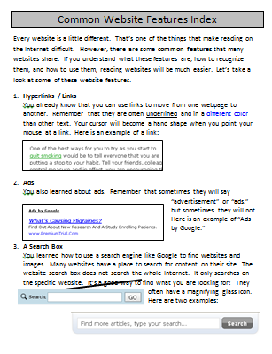Step 2: Basics and vocabulary

Hand out **Common Website Features Index**

**Read through** the handout with learners and answer questions as you go

Step 3: Controlled Practice- Everyone Does Together

Go to bbc.com, webmd.com and mnliteracy.org

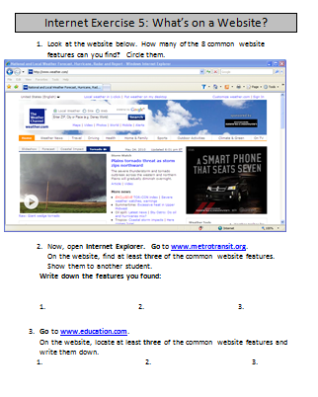Go through with learners and point out common website features on each website (you can pick more websites of your choosing, be sure they are appropriate for the classroom)

Step 4: Individual Practice

**Hand out Internet Exercise 5: Common Features**

**Instruct** learners to complete the exercise

Circulate to answer questions

**Teacher Directions: Activity 3: Practice**

Step 1: Context

**Explain** that we will now be completing an internet search to **locate Job Search Websites**

**Ask** learners where to go if we want to search for information: search engine

**Instruct** learners to go to **google.com**

**Ask** them what google.com is: *a web address/URL*

**Ask** what google is: *a search engine*

**Ask** them where they type it in: *address bar*

Step 2: Key words

**Ask** learners what might be some key words I can type in

Make a list on the board

Type some into Google

Step 3: Identify google ads

**Ask** learners if they see any ads, how do they know?

**Ask** about what is included in the results, where can you see URL/domain extension

Click on a result

Step 4: Identify common features

**Learners should have eyes forward and hands off of their computers**

**GO through the website, what do learners see? Which of the features are there? Many?**

**Step 5: More examples**

**Ask** learners how to go back to the results page: *click back arrow next to address bar*

Instruct learners to click on a result and work in pairs to find common features

**NOTE:** If many of the same questions arise, take a minute to show everyone how to answer them

Step 6: Summarize postings

Write Who, What, Where, When, Why on the board

Open a job post and answer these questions to summarize the post

**Teacher Directions: Activity 4: Summary of Lesson -Lesson Summary**

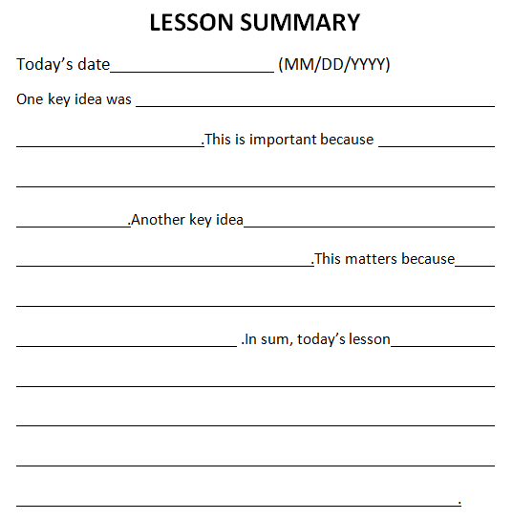Step 1: Context

Explain that after each class, students will now be required to summarize what was learned in the class

Hand out one copy of **Lesson Summary** to each learner

Step 2: Explain directions

Explain that each learner will fill one of these out at the end of every class

The handout is set up with a series of blanks that you will fill in with the main points from the class

The first one will be done as a class

Step 3: Controlled Practice

Fill in the blanks as a class, max of on sentence per blank

Note: if there is somewhere around the room to post these, do so and be sure to copy onto colorful paper.

**Day 4 Warm-up**

**Directions:** Teacher will hand out a flyer. On the flyer, locate the URL and type the URL into the Address Bar. Once you get to the website, answer the questions below.

1. What is the URL for this organization?
2. Circle the domain extension of the URL, what kind of group operates this URL?
3. WHAT does this group provide? Do they sell things or offer services?
4. WHERE is this organization?
5. WHO is their target population?
6. Use the answers to questions 2-5 to write a one sentence, brief, summary of the organization.

Internet Exercise 4: Identifying Advertising

Most of the information and services you find on the Internet are free to use. You don’t need to pay a fee of buy a subscription to read the news, check the weather report, or find a map. However, websites cost money to operate. Companies that publish websites must pay for space on a web server. They must pay for the Internet connection to their website. They must pay the salaries of the employees who make and maintain the website. How can companies afford to pay all of these costs and still let people use their website for free? Most often, companies sell space on their websites for **advertising**. Just as TV shows are interrupted for commercials and newspaper pages have both news stories and **advertisements (ads)**, websites have online ads. The ads are a way for the company that owns the website to make money from it.

Sometimes, online advertising can make it hard to find the information that you are looking for. You need to ignore the ads and focus on the website’s content. But how can you tell the difference between **ads** and **content**? Here are some clues to help you.

* Ads are often brightly colored.
* Ads are often flashy and moving.
* Ads may have large text and company logos.
* Ads may have a button to click to buy something or get more information about a product.
* Ads try to be “exciting” so they use powerful words and exclamation points (!)
* Ads are often located at the top of the page or in the right column of the page.
* Sometimes you will see the words *“sponsored links,” “advertisement,”* or *“Ads by Google,”* in very small print.
* Website **content** is usually written in full sentences or lists of links.
* The content is usually in the **center column** of the page.
* 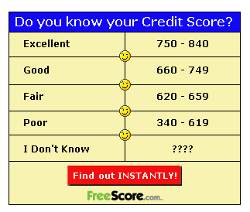The **content** will match the **purpose** of the website, while ads might not.

Here are some examples of **online ads**.

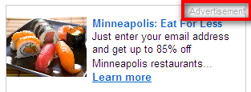MC900411244[1] **Wait until teacher gives to instructions to continue.**

1. Which of these pieces from [www.WebMD.com](http://www.WebMD.com) is an **ad**?  
   **Circle** one thing that identifies the ad.

**How do you know?**

1. Which of these pieces from About.com’s page on email scams contains **ads**?  
   **Circle** one thing that identifies the ad.  
   **How do you know?**

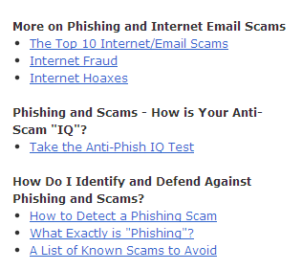



1. Circle the **ad** on this website.

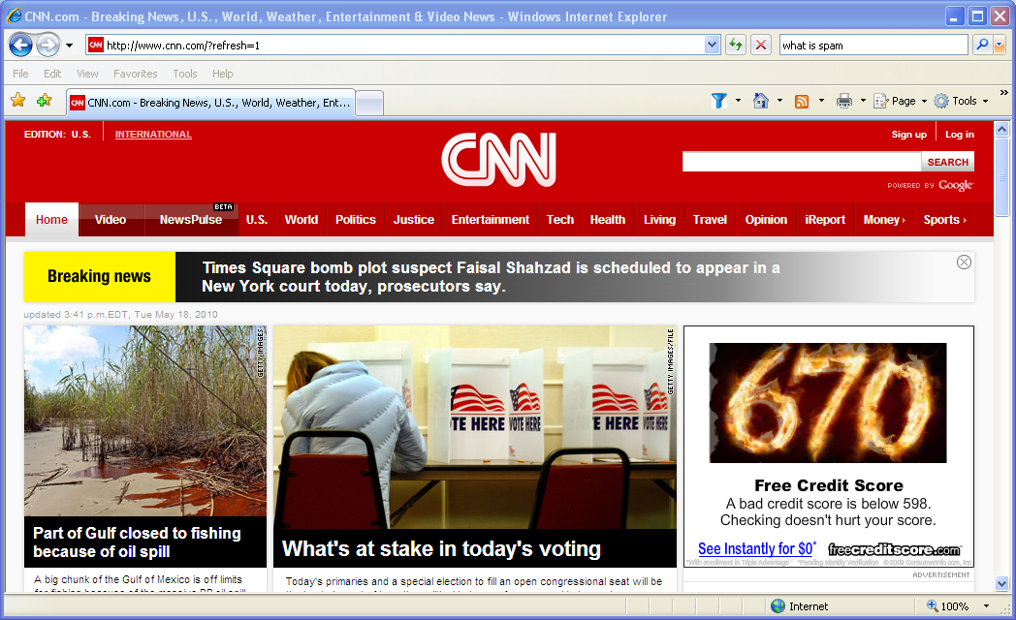Now, open Internet Explorer.

Go to <http://www.rentals.com/Minnesota/>.

1. **How many ads do you see?**

Your teacher will sign in this box:

Common Website Features Index

Every website is a little different. That’s one of the things that make reading on the Internet difficult. However, there are some **common features** that many websites share. If you understand what these features are, how to recognize them, and how to use them, reading websites will be much easier. Let’s take a look at some of these website features.

1. **Hyperlinks / Links**  
   You already know that you can use links to move from one webpage to another. Remember that they are often underlined and in a different color than other text. Your cursor will become a hand shape when you point your mouse at a link. Here is an example of a link:

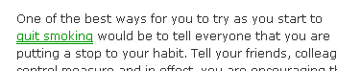

1. 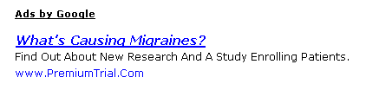**Ads**  
   You also learned about ads. Remember that sometimes they will say “advertisement” or “ads,” but sometimes they will not. Here is an example of “Ads by Google.”
2. **A Search Box**  
   You learned how to use a search engine like Google to find websites and images. Many websites have a place to search for content on their site. The website search box does not search the whole Internet. It only searches on the specific website. It’s a good way to find what you are looking for! They often have a magnifying glass icon. Here are two examples:
3. **Tabs** Tabs are a way of organizing content on a website.

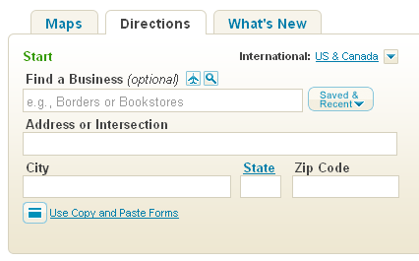MCj04260580000[1]They are like the tabs on folders that tell you what is inside.  
  
In this example from [www.mapquest.com](http://www.mapquest.com), you see that the browser now has the “Directions” tab open. To see “Maps” or “What’s New” you could click one of those tabs. (It has been updated, so the website itself does not have tabs anymore)

1. 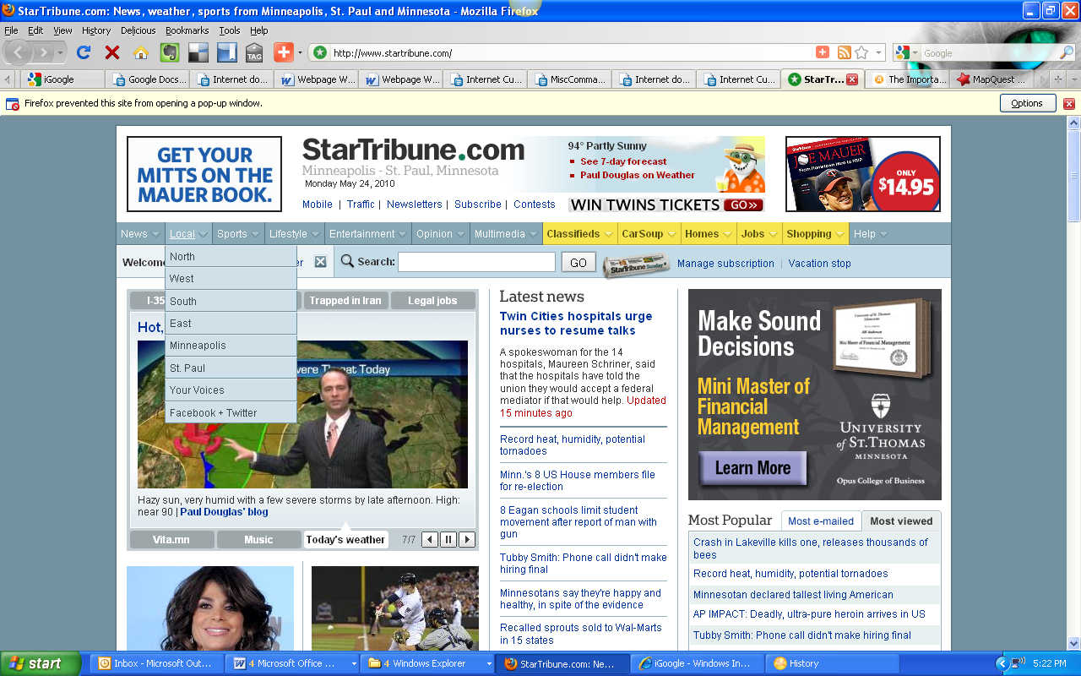**A Top Navigation/Menu Bar**  
   “Navigation” means moving around. A navigation bar is a tool to help you move around the website and find content. Usually, if you point your mouse to one of the items in the navigation bar, you can see what is in that section of the website. You move the cursor down the list and click the section you want to go to. Here is an example from [www.startribune.com](http://www.startribune.com).
2. 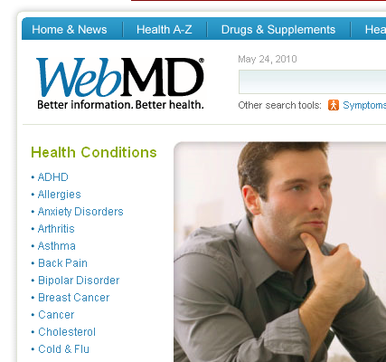**Left Sidebar Navigation**  
   Sometimes websites put their navigation on the left sidebar of the website instead of across the top. Some websites, like [www.webmd.com](http://www.webmd.com), are so big and complex that they have navigation on both the top of the site and the left sidebar

The sidebar navigation is another way to find what you are looking for.

1. **A place to Login or Register**  
   Many websites have tools that you can use to leave comments on stories and communicate with other people who use the website. To use these tools, you have to register for a username and password, and then login. On many websites you will see something like this:   
    Sometimes the website may say, “Sign up” instead of “Register.”
2. **Videos**

Many websites have videos that you can watch.  
If you see something like this:  
You can click the button to start playing the video.

The icon is usually a triangle in a circle.

BE CAREFUL not to open videos that are part of an advertisement.

Internet Exercise 5: What’s on a Website?

1. 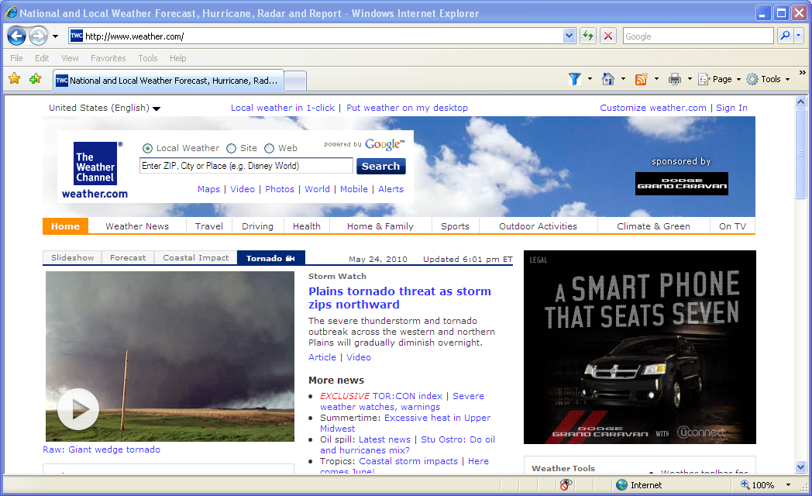Look at the website below. How many of the 8 common website features can you find? Circle them.
2. Now, open **Internet Explorer. Go** to [**www.metrotransit.org**](http://www.metrotransit.org).   
   On the website, find at least **three** of the common website features. Show them to another student.

**Write down the features you found:**

1.

2.

3.

1. **Go** to [**www.education.com**](http://www.education.com).  
   On the website, locate at least **three** of the common website features and write them down.

1. 2. 3.

4. Circle the **domain extensions** of the websites you looked at.

**Helpful Career and Job Search Websites**

**Career Resources and Labor Market Information-General**

|  |  |  |
| --- | --- | --- |
| **ISEEK** | Minnesota’s career, education and job resource websites | [www.iseek.org](http://www.iseek.org) |
| **CareerOneStop** | National career, education and job resource website. | [www.careeronestop.com](http://www.careeronestop.com) |
| **O*Net** | Find skill, knowledge, tools, technology and typical tasks associated withjobs. | [www.onetonline.org](http://www.onetonline.org) |
| **MyNextMove** | Explore careers and industries, or take an interest assessment | [www.mynextmore.org](http://www.mynextmore.org) |
| **Occupational Outlook Handbook** | This career guide is published by the national Bureau of Labor Statistics | [www.blc.gov/ooh](http://www.blc.gov/ooh) |
| **Occupations in Demand** | Explore occupations in demand for 13-regions in Minnesota | mn.gov/deed/oid |
| **Job Skills Transfer Assessment Tool (JobSTAT)** | Find occupations that use the same skills, knowledge and abilities as your previous work experience, and link to Minnesota Career information, training and jobs. | mn.gov/deed/jobstat |
| **Minnesota Salary Survey** | Find out what occupations in your local area pay. | mn.gov/deed/oes |

**Career Resources-Specialty**

|  |  |  |
| --- | --- | --- |
| **MyMNCareers** | Career and education resources for English Language learners and working adults | www.mymncareers.org |
| **MnGreenCareers** | Research green jobs, training and how to search for one. | [www.mngreencareers.org](http://www.mngreencareers.org) |
| **MnManufacturingCareers** | Explore manufacturing and production careers and training. | [www.mnmanufacturingcareers.org](http://www.mnmanufacturingcareers.org) |
| **Virtual Career Network for Healthcare** | Explore health care careers and training | www.vcn,irg |

**Career/Job Resources- Ex-Offenders**

|  |  |  |
| --- | --- | --- |
| **STEP AHEAD** | Career planning for people with criminal convictions in Minnesota. | [www.iseek.org/exoffenders](http://www.iseek.org/exoffenders) |
| **Council on Crime and Justice** | Minnesota nonprofit with services and resources for ex-offenders | [www.crimeandjustice.org](http://www.crimeandjustice.org) |
| **Work Opportunity Tax Credit** | Employer hiring ex-felons may be eligible for the Work Opportunity Tax Credit. | mn.gov/deed/wotc |
| **Federal Bonding Programs** | Bonding is an incentive for an employer to hire and at-risk job applicant. | www.bonds4jobs.com |

**Career/Job Resources – Veterans**

|  |  |  |
| --- | --- | --- |
| **MyNextMove for Veterans** | Explore careers, industries and find occupations that match your military expereicence. | [www.mynextmove.org/vets](http://www.mynextmove.org/vets) |
| **Veterans ReEmployment** | One-stop site for employment, training and financial help after your military service. | [www.careeronestop.org/reemployment/veterans](http://www.careeronestop.org/reemployment/veterans) |
| **Veterans’ Employment and Training Services** | Career, training and benefit resources from the U.S. Department of Labor | [www.dol.gov/vets](http://www.dol.gov/vets) |
| **MyMilitary GPSLifePlan** | MyMilitary GPS LifePlan helps veterans, Servicemembers and their families set goals and design plasn that will lead them to the success the desire. | www.GPSLifePlan.org/mnscumilitary |
| **GI Bill** | The home for all educational benefits provided by the Department of Veterans Affairs. | www.GIbill.va.gov |

**Job Boards- Minnesota**

|  |  |  |
| --- | --- | --- |
| **MinnesotaWorks.net** | The NO FEE job bank for finding jobs and employees in Minnesota. | www.MinnesotaWorks.net |
| **State of Minnesota** | Find Job Opportunities with the state agencies. | www.careers.state.mn.us |
| **Federal Government** | The official site for federal jobs, including those located in Minnesota. | www.usajobs.gov |
| **Minnesota State Colleges and Universities (MnSCU)** | Find job opportunities with MnSCU system office and campuses around the state. | www.mnscu.edu/about/jobopportunities |
| **League of Minnesota Cities** | Lists job openings in cities across Minnesota. | www.lmc.org |
| **Association of Minnesota Counties** | Lists job openings in counties across Minnesota. | www.mncounties.org/employment |
| **Minnesota Council of Nonprofits** | Opportunities in nonprofit organizations around Minnesota. | www.minnesotanonprofits.org/jobs |

**LESSON SUMMARY**

Today’s date (MM/DD/YYYY)

One key idea was .This is important because .Another key idea .This matters because .In sum, today’s lesson .

[1]

1. Copyright ©Raymond C. Jones. All Rights Reserved ReadingQuest

   Permission Granted for Classroom Use www.readingquest.org