**During Day 2 you will be proctoring the North Star Digital Literacy pre-assessment.**

All the of the computers that learners use need to be registered (per direction on the North Star site) for the assessment,

* This **can take anywhere from 20-40 minutes** depending on the number of students and number of volunteers/coordinators who are setting the assessment up.
* **REGISTER THE COMPUTERS BEFORE CLASS BEGINS**
  + Use the computer sign-in sheet that was filled out Day 1 to determine which computers students are using and pull them out of the COW

**DO NOT** PRE-TEST STUDENTS IF (Use Computer Use Questionnaires to see what kind of experience learners have with computers):

* They are very uncomfortable with the computer
* You feel taking the assessment will overwhelm them (happens with brand new computer users)

**Learners who do not take the pre-assessment** can:

* Log in to Mavis Beacon and practice typing
  + If they seem to need help with the mouse, help them get to http://www.skyways.org/central/mouse/page1.html , which is a mouse usage practice site (mouserobics)

**Students who come in late:** Determining whether or they have time to take the assessment without cutting too much into class time depends on a few things:

**DO pre-test** them if:

* You feel you have time to register their computer
* They have a basic knowledge of the computer
* They took the previous unit

**Do NOT pre-test** them if:

* They come more than 10 minutes into the testing period
* They are not familiar with the computer
* They come in late and you are busy setting up learners who showed up on time and are not taking the assessment

*****One way to ensure you get to the tests quickly is by having all of the computers registered before class begins. This takes prep time, but saves important class time. ********

**Internet Day 2**

|  |  |
| --- | --- |
| **Objectives** *Learners will be able to…* | **Materials** |
| ***Computer skill:*** *learners will**be able to type in a website accurately*  ***Computer skill:*** *identify key buttons on the internet*  ***Computer skill:*** *North Star Digital Literacy World Wide Web Assessment*  ***Literacy skill:*** *scanning* | **Make Student Copies**   * **Day 2 Warm-up (Tab 6)** * **Internet Exercise 3: Screen Fill-** there are 2 per page, so print one per 2 students **(Tab 7)**   **Props, Technology or Other Resources**   * Projector * Computer for every student * **North Star How-To (Tab 8)** |
|  | |
| **Lesson Plan** | Vocabulary |
| **Warm-up:**  Description: Learners will write sentences describing each word listed on the handout  Materials/Prep: **Day 2 Warm-up** (answer key is in the same tab as the warm-up)  **Activity 1: North Star Digital Literacy Assessment**  Description: learners will take the World Wide Web Digital Literacy Pre-Assessment  Materials/Prep: all computers must be registered before class begins, **pull up** the test page print screen within the lesson plan to project onto the board  **Activity 2: Getting Starting with the Internet**  Description: learners will develop understanding of basic internet vocabulary  Materials/Prep:  **Activity 3: Log in to Schoology (pronounces School-O-G**  Description: introduction to class website Schoology  Materials/Prep: | * Home page * Web page * Address Bar * Web Address * Web Page * Scanning |

**Teacher Directions: Activity 1: North Star Digital Literacy Assessment**

Step 1:

Take this time to explain the **World Wide Web** North Star Digital Literacy Assessment and its purpose:

**This can be read verbatim to the students:** The North Star Digital Literacy Assessment has set the standards of what it means to be knowledgeable about different aspects of the computer. The purpose of this assessment is to provide learners with a standard with which everyone learns the computer to ensure that they will be successful outside of the classroom. The pre-assessment is meant to inform the teacher of what you know already and then we can see how you improve at the end of the class. If you pass the assessment with an 85% or higher, you will receive a certificate that proves your competency at the unit you were tested on. These certificates can also be presented to employers as proof of your computer skills when you apply for a job.

With this pre-assessment it is okay if you do not know anything. If you do not know the answer to a question, you are given the option to simply answer “I do not know” or you can take a guess. You are encouraged to guess on this assessment.

Step 2: How the assessment works

**This can be read verbatim to the students:** When it is time to begin, students will open the assessment titled **Windows**. The assessment begins with a test of the speakers. If you hear the piano playing, you will use your mouse to click the “Next” button.

**Explain** that if that student does not hear the piano playing, they can look above their keyboard at and they will see three buttons on the right. These are the volume buttons, one to turn down volume, turn it up, and turn it off.

Next, North Star will go through an orientation of how the assessment works. Each question asked in the assessment will be a function of the program, so your answer to the question will be performing that function. **BE CAREFUL not** to simply click when the page comes up because the assessment will read that as your answer and you cannot go back.

**Teacher should pull up the Screen Shot page and review it with the students.**

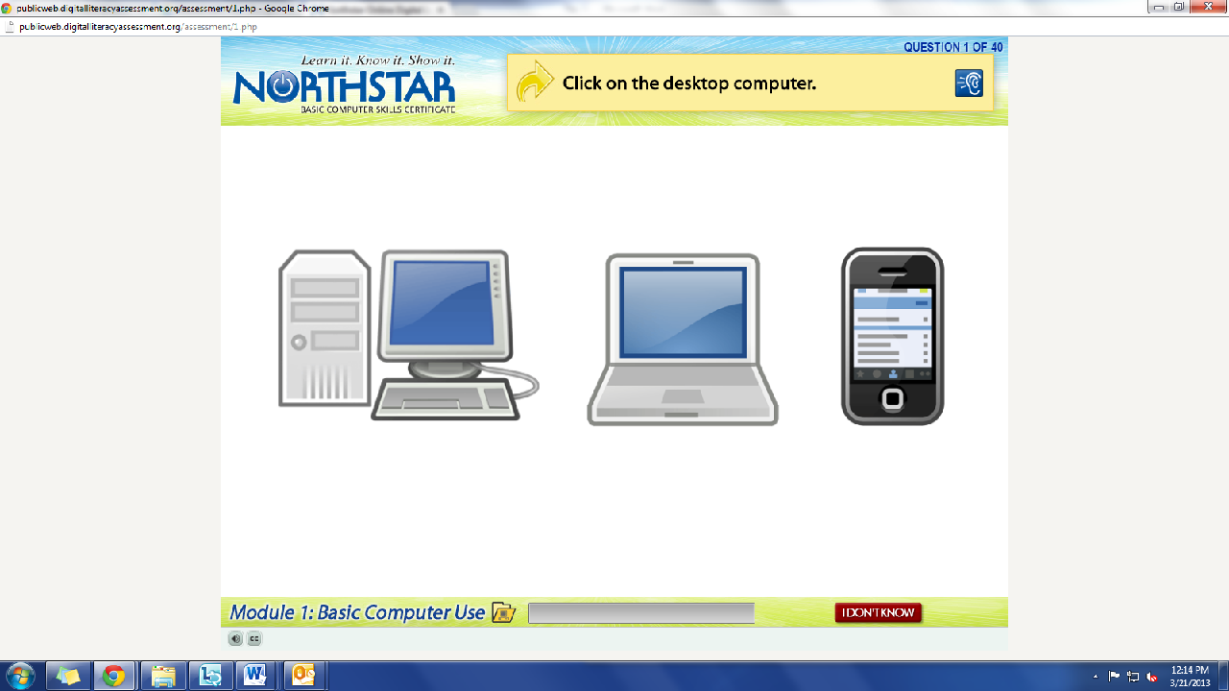

What is the question begin asked?

How do we answer it? We click on the answer.

You **must listen carefully** to the question being asked so that you know how to answer it.

If you miss the question when it is read, you can either read it on the top of the page, or click the on the blue ear and it will read the question again.

If you do not know and do not want to guess, but once you click it, it will ask you if you are sure you want to skip the question, you have to answer “Yes” to move on. You are, however, encouraged to guess.

Step 3: Learner Code of Conduct

**Read** the **Learner Code of Conduct** to the students:

* Learner must listen carefully to all instructions given by proctor
* Learner must treat others with courtesy and respect during assessment process
  + This means no talking to each other during the assessment, if you have a question ask the proctor. If a learner finishes early, they must remain quiet until everyone is finished
* Learner should ask questions prior to the assessment if they are uncertain about the certification process
* Learner is responsible for his or her certificate: if the certificate is lost, s/he will have to retake the assessment
* Learner should inform the proctor if he or she believes that assessment conditions affected his or her results

**Ask** if there are any questions

Explain that the questions will be read aloud to them, so students need to be sure they are listening carefully. If they miss the question, is it also written at the top of the page.

Step 4: Take **World Wide Web Assessment**

If there are no questions, learners should scroll down the testing page and click on the **World Wide Web Assessment**

*If students are frazzled during the test because they missed the reading of the question, there is a blue square in the top right corner with an ear in it. When it is clicked the question is read again*

Step 5: After the assessment

Once the assessment is completed, learners should open up Mavis Beacon and practice typing.

**Teacher Directions: Activity 2: Getting Started with the Internet –Screen Fill**

Step 1: Open Internet Explorer

**Ask** learners if they can tell you how to open the internet browser

**Demonstrate** how to open internet from the desktop and start menu

Step 2: Home page

**Explain** that everyone might not see the same thing when they open their internet browser

The first page that opens up when Internet is started is known as the **home page**

**Why page?** The screen you are on within the internet is often referred to as a **page** or **web page,** like a page in a book

**Ask** if anyone can find a button on the page we are currently on that might always “bring them back home”? –Home button

Step 3: Address bar

Show where the **address bar** is and **explain** that this is where **web addresses** should be typed in, only this space, not the **search box (point out the search box)**

**Explain** that when typing in a web address, if you put it in incorrectly it will not work

* No spaces
* No punctuation other than periods
* If you mess up, you do not have to type it all again, bring cursor to the mistake and use keys like backspace or delete to fix it

**Instruct** learners to type “mapquest.com” into the **address bar**

To get to the page, hit the **enter key** on the keyboard once the website is typed in **correctly**

Step 4: Back, forward, refresh and stop loading

**Ask** learners if they remember which button will take them back to their home page-Home

**Ask** if they see any buttons that would allow then to go back to the page they were previously at?

**Demonstrate** hovering the cursor over buttons to find out what they do

**Demonstrate** the back, forward and refresh buttons

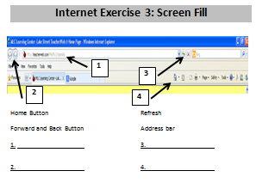**Explain** that these might look slightly different on different browsers, and sometimes buttons might be missing, but if you **scan** the page, there is likely a button that looks familiar

Step 5: Screen Fill

Hand out **Internet Exercise 3: Screen Fill**

Learners should fill in the answers

**Teacher Directions: Activity 3: Intro to Schoology (pronounced School-ogy)**

Step 1: Introduction to Schoology

**Explain** that this class will be using a website to store class information and handouts, additionally; learners will find resources to practice their skills outside of class

Step 2: Front page of Schoology

Instruct learners to type “schoology.com” into the address bar

Once they have done that, everyone should be on the main page for the Schoology Website

**Ask** if anyone sees a place where it looks like they can “log in”

In the upper right hand corner of the page

Step 3: Login to Schoology

**Instruct** learners to log in to their Schoology account, Teacher should also sign in

**Student** Usernames: odcomp(comp#)@gmail.com

Password: Opendoor (same for all)

**Teacher login:** comp.lit.opendoor@gmail.com

Password: Opendoor

Step 4: Schoology Pages

**Explain** that Schoology is built to act like Facebook

The first page everyone sees is a sort of “News Feed”, it would show anything you posted or the class you are in posted

Give students some time to look around the site, **ask** if anyone can find the Computer and Literacy course page

To get to course: **Click** on **Courses on the top bar>Click** on **Computer and Literacy**

Folders pop up

**Explain** that these are all **hyperlinks**

**Instruct** learners to **click on Internet Class-**this is where many of the assignments for this class will be

**Day 2 Warm-up**

**Directions**: Write a definition for each vocabulary word. Try to do it without looking at old handouts.

1. Modem:
2. Monitor:
3. Mouse:
4. Laptop:
5. - What does this cursor do?
6. Browser:

**Day 2 Warm-up Answer key**

**DO NOT REPLICATE- FOR TEACHER USE ONLY**

**Directions**: Write a definition for each vocabulary word. Try to do it without looking at old handouts.

1. Modem:

Transmits data, most often internet data, to the computer

1. Monitor:

This is the screen of the computer that displays the information.

1. Mouse:

A piece of hardware that allows a user to navigate the computer and its contents. 

1. Laptop:

This is a portable computer that we will be using in class.

1. - What does this cursor do?

A web browser is a software application for retrieving, presenting and traversing information resources on the World Wide Web.

This cursor signifies a hyperlink, which, when clicked, will take a user from where they are to another space on the computer.

1. Browser:

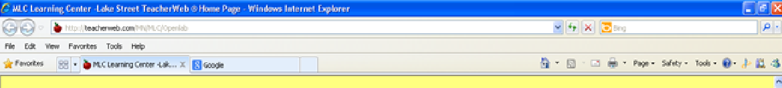**Internet Exercise 3: Screen Fill**

**1**

**4**

**3**

**2**

Home Button

Forward and Back Button

Refresh

Address bar

1.

2.

3.

4.

**Internet Exercise 3: Screen Fill**

**1**

Home Button

**4**

**2**

**3**

Forward and Back Button

Refresh

Address bar

1.

2.

3.

4.

**North Star How-To**

**Teacher A- Generating Codes:**

1. Go to [https://www.digitalliteracyassessment.org/admin](https://www.digitalliteracyassessment.org/admin/login.php)

2. **Login information**:

3. PLEASE SEE YOUR SITE COORDINATOR FOR NORTH STAR LOGIN INFORMATION!

4. Select your name from the drop-down menu

5. Click Submit

6. Click on **Generate User Codes**

7. Simply type in students’ names and a click enter

8. The code next to their name will be used to register their computer

**Teacher B- Registering each computer:**

1. Turn on student computers

**2.** Go to digitaliteracyassessment.org/assessment/proctored

3. Username: SEE YOUR SITE COORDINATOR

4. PIN: **SEE YOUR SITE COORDINATOR**

5. Type in student’s name and then enter the code you got from Part 1

6. Click Confirm and Start

7. Minimize the page

8. Instruct students not to close out of any programs you have opened on their computer

**Note:** As you spend more time in the classroom you get to know the students who show up early and who show up late. Register the students who usually show up early as soon as you arrive, that way they can begin typing as soon as they get to class.