Excel Day 9

Objectives Learners will be able to… | Materials
Computer skill: creating graphs  Literacy skill: fractions and percentages | Make Student Copies  - Excel Exercise 12: Percentages (Tab 18)  - Excel Exercise 13: Chart Wizard (Tab 19)  Props, Technology or Other Resources  - Projector  - Computer for every student  - USB Drives
Lesson Plan | Vocabulary
Activity 1: Dream Budget- 35 minutes  Description: learners will create new budget as if they had won 10,000 in the lottery  Materials/Prep: Use the Personal Budget Checklist from Day 7 to ensure learners are accomplishing everything, Teacher should open the Teacher Budget Example attached to lesson plan (used for Activity 3)  Activity 2: Fractions and Percent’s -35 minutes  Description: explain how to use proportions to create percentages in order to demonstrate the idea of “parts of a whole”  Materials/Prep: copies of Excel Exercise 12: Percentages  Activity 3: Create Graphs  Description: teach learners how to turn their budgets into a graph, to visualize the percentages they came up with in Activity 2  Materials/Prep: copies of Excel Exercise 13: Chart Wizard (step by step instructions), be sure Teacher Budget Example is open | - Percentages  - Rounding  - Chart  - Graph  - Chart Wizard  - Pie  - Line  - Bar

Teacher Directions: Activity 1: Dream Budget
Step 1: Open Personal Budget created Day 7
Have students tell you how to open a previously saved document
Have learners lead you through how to open a previously saved document
Start>My computer> locate drive>locate file>Click Open
OR if in Excel already
File>Open>same steps from My computer

Step 2: Copy and Paste Review
Ask learners how to copy the first budget that was created: highlight the budget, click copy/right-click/CTRL C
Ask learners how to go to a new tab in the workbook: click on the third tab at the bottom
How to paste? Either button on toolbar/right-click/CTRL V

Step 3: Insert Lottery Winnings
Review how to insert a new source of income
Remind learners to check their equations after they insert new rows
Demonstrate checking equations to make sure the appropriate cells are selected

Step 4: Update Budget
Instruct learners to update their budget to reflect what they would do if they won $10,000 in the lottery
Remind them to save as they work through the budget
Teacher should copy and paste Teacher Practice Budget (attached) into Excel

Step 5: Save
Instruct learners to save their updates

Teacher Directions: Activity 2: Fractions and Percent’s - Teacher Practice Budget
-Excel Exercise 12: Percentages
Step 1: Context
Explain that it is important to not only know the total amount you spent, but also to know what chunk of your income is spent on what
This can be especially eye opening

Step 2: Parts of a whole
Explain that what we will be looking at is part of a whole
Ask if anyone has learned this concept before?
Ask if anyone knows the most common way parts of whole are represented? Percentages
What is a percentage? a number or ratio as a fraction of 100.
Example: On your test, you got 80%. That is 80 out of 100. (Write this on the board)
Ask learners where else they see percentages?
Percentages are typically out of 100, that is what we will be working with

Step 2: Demonstrate
Write all of the examples on the board in fraction/ratio form
Example: If I spent a total of $100 in July, and $18 of that was spent on clothes, what percent of the total expenses was spent on clothes?
Example: We know we spend X on Rent. That is x out of the total expenses. But how can we see what percentage of total expenses that is?
x/total= ?/100
Equation:
$$\frac{Category Amount}{Total Exp or Income} x \frac{\%}{100}$$

We need to cross multiply, (x times 100)/total
That’s are to do in your head, so we will need a calculator

Step 3: Introduce Computer Calculator
Show students where to find a calculator on their computer
Start menu>All Programs>Accessories>Calculator

Step 4: Demonstrate using the calculator
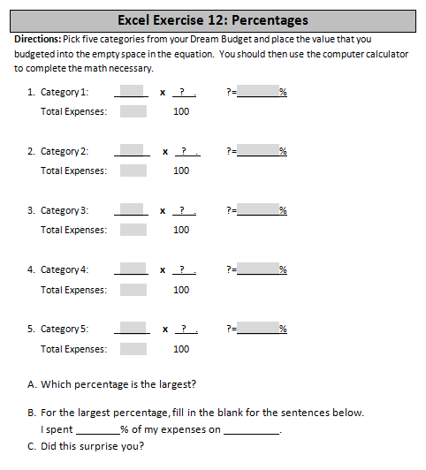
Use the calculator to complete the multiplication

Step 4: Find percentages of Teacher Example
Go through the Teacher Budget Example and find the percentages of each category
Have students come up to the board and write out the equation
Instruct students to round to the tens decimal place: ie 10.4
It will probably be necessary to explain rounding

Step 5: Individual Practice
Hand out Excel Exercise 12: Percentages
Learners will pick five categories and fill in the numbers into the equations and then complete the math
Demonstrate how to complete an example using the Teacher Budget Example

Teacher Directions: Activity 3: Graphs - Teacher Budget Example
-Excel Exercise 13: Chart Wizard
Step 1: Context
Ask learners if they can think of a way we often see percentages/parts of a whole displayed?
Explain that percentages are often displayed using charts : A sheet of information in the form of a table, graph, or diagram
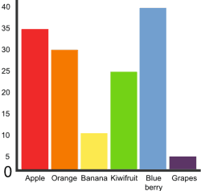
Excel offers a tool to create charts and place them on a spreadsheet
Column

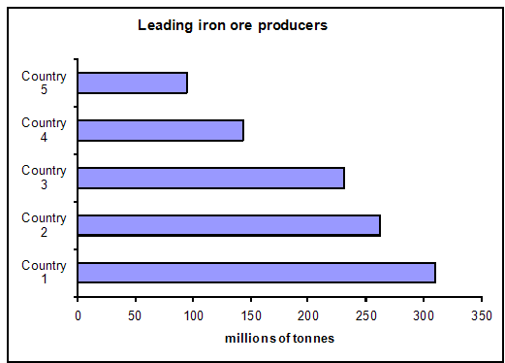
Step 2: Display Charts
Explain that often the words chart and graph are used interchangeably
A graph is a type of chart
Ask if anyone knows an example of a graph?
Draw a Bar graph and a Column Graph the vaguely represents the percentages that were developed in Teacher Budget Example (examples ->)
Bar
Ask learners which one they think is the column graph- just like columns in a spreadsheet
Label what the graph types are
Draw a Pie Chart- explain that this is the best way to percent percentages, because
Percentages represent parts of a whole

Step 3: Demonstrate Chart Wizard
Learners should have their EYES FORWARD AND HANDS OFF OF THEIR COMPUTER
Highlight the budget information
Locate the Chart Wizard button by hovering over the buttons on the toolbar
Choose a graph type
Label the graph- give it a name, just like you would name a spreadsheet that was being saved- we need to know what we are looking at

Step 4: Demonstrate moving the chart and making it smaller/larger
Explain that often Excel places the chart in an inconvenient spot, so it needs to be moved or made smaller
Point out the black boxes around the graph
Explain these are used to make graph bigger/smaller
Demonstrate using click and drag to expand, shrink the chart
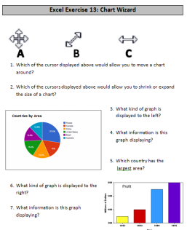
Point out what the cursor looks like when size change is possible
Point out what the cursor looks like when you can move the whole chart

Step 5: Controlled Practice
Work through inserting a Bar Graph with the class
They should lead you through, but can work on their own computers

Step 6: Individual Practice
Learners should create a Bar and Pie Chart on their own
Circulate to assist students

Step 7: Save
Instruct learners to save their workbook

Step 8: Activity, if there is time
As leaners finish inserting their charts, handout Excel Exercise 13: Chart Wizard
If they do not get to this, write it in the lesson report. It can be used as a warm-up for Day 10

Excel Exercise 12: Percentages
Directions: Pick five categories from your Dream Budget and place the value that you budgeted into the empty space in the equation. You should then use the computer calculator to complete the math necessary.
- Category 1: x ? . ?= %
Total Expenses: 100

- Category 2: x ? . ?= %
Total Expenses: 100

- Category 3: x ? . ?= %
Total Expenses: 100

- Category 4: x ? . ?= %
Total Expenses: 100

- Category 5: x ? . ?= %
Total Expenses: 100

- Which percentage is the largest?
- For the largest percentage, fill in the blank for the sentences below.
I spent % of my expenses on .
- Did this surprise you?

Excel Exercise 13: Chart Wizard

C
B
A

- Which of the cursor displayed above would allow you to move a chart around?

- Which of the cursors displayed above would allow you to shrink or expand the size of a chart?

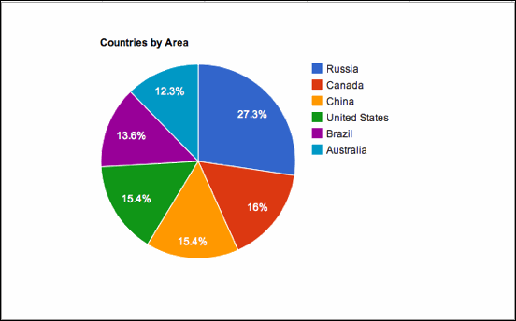
- What kind of graph is
displayed to the left?
Countries by Area

- What information is this
graph displaying?

- Which country has the
largest area?
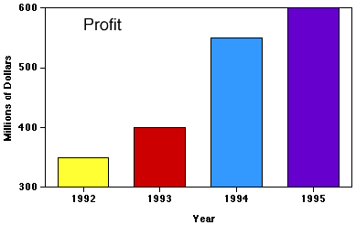
- What kind of graph is displayed to the right?

- What information is this graph displaying?

Teacher Budget Example
Copy and Paste into Excel
Use for Activity 2 and 3
Teacher Budget Practice
Income
Lottery Winnings | $ 10,000.00
Pay Check | $ 2,115.90
Total Income | $ 12,115.90
Expenses
Rent | $ 880.00
Gas | $ 70.00
Groceries | $ 95.00
Netflix | $ 15.00
Internet | $ 30.00
Misc. | $ 115.00
Car Repairs | $ 65.00
Total Expenses | $ 1,270.00

