**Excel Day 8**

All files that inform you to “download” can be found on the USB drives. If not there, direct students to the MN Literacy Computer Curriculum page where they can also download the file.

|  |  |
| --- | --- |
| **Objectives** *Learners will be able to…* | **Materials** |
| ***Computer skill:*** *subtraction equations*  ***Computer skill:*** *copy and paste*  ***Literacy skill:*** *finding profit* | **Make Student Copies**   * Day 8 SWAT- no student copies, simply follow directions under materials **(Tab 16)** * **Copy and Paste Reference Form (Tab 17)**   **Props, Technology or Other Resources**   * Projector * Computer for every student * USB Drives |
|  | |
| **Lesson Plan** | Vocabulary |
| **Warm-up:**  Description: Divide the class into two teams, one member from each team will take their turn coming up to the board. You will ask the pair a question, the first one to touch the answer gets a point for their team. Use the questions from the handout in the Tab with the Pictures (also attached to this Lesson)  Materials/Prep: (if not done and in binder already), copy Day 8 SWAT and cut each vocab word/picture apart. Tape each word/picture to the board, grab two fly swatters/board markers or erasers  **Activity 1: Finding Profit**  Description: teach how to determine profit in a budget using an equation in Excel  Materials/Prep: make sure **Excel Exercise 11: Finding Profit** is on the USB drives in the Excel Folder  **Activity 2: Copy and Paste**  Description: explain and practice the different ways of copying and pasting text, at the end of which learners will copy their budget into another page in the spreadsheet (workbook)  Materials/Prep: copies of **Copy and Paste Reference Form**  **Activity 3: Reduced Budget**  Description: learners will take the budget they had and imagine how they would cut down on costs if their income was cut in half | * Profit * Copy * Paste * Tab * Workbook |

**Teacher Directions: Activity 1: Finding Profit -Excel Exercise 11: Finding Profit**

Step 1: Open Personal Budget create Day 7

Have learners lead you through how to open a previously saved document

**Start>My computer> locate drive>locate file>Click Open**

OR if in Excel already

**File>Open>same steps from My computer**

***If learners were not present for Day 7 assist them with downloading **Personal Budget Example** from USB Drive

Step 2: Review Sum Formula

**Instruct** everyone to delete the contents of the cell with their totals in them

Go through the steps to sum again with the class

Highlight the numbers you wish to total> Locate the Sum button on the toolbar>You should have your total

Step 3: Introduce Profit

**Ask** learners what **profit** is? *A financial gain, esp. the difference between the amount earned and the amount spent in buying, operating, or producing something.*

**Reiterate** that it is the difference between amount earned and amount spent- **ask** what are some other words we have learned that mean the same thing-**income** and **expenses**

**Do the math on the board**- total income minus total expenses

Step 4: Translating to Excel terms

Next to the Income total, write the cell you found that total in inside parenthesis

Do the same for the expense total

Income total (Cell1)-Expense Total (Cell2)=Profit

Step 4: Demonstrate equation in Excel

Learners should have their **EYES FORWARD AND HANDS OFF OF THEIR COMPUTER**

**Demonstrate** completing the equation in Excel

**Explain** that Excel equations always start with =

Type profit in a cell, hit tab

In the cell next to Profit type =

Then click on the cell that has the Income total

Then type –

Click on cell that has expense total

Should look like =Cell1-Cell2

Hit ENTER

Step 5: Controlled Practice

Work through the steps as a class

If you click on the wrong cell, what do we do? UNDO BUTTON

**Explain** that you can also type the cell names into the equation instead of clicking on the cell

Step 6: Save and close

**Instruct** learners to save and close this spreadsheet

Step 7: Open Practice Activity

Explain that the activity is located on the students USB Drives, so they need to open it

Go through the steps of opening a previously saved document

Spreadsheet is in the USB Drive Excel Class folder, **Excel Exercise 11: Finding Profit**

Step 8: Exercise

**Explain** that in the activity, there are many cells that need a profit listed

Use the information given to find the profit using the equation we learners

**As a class,** do at least one example together

Learners should check their answers with a partner

**Teacher Directions: Activity 2: Copy and Paste -Copy and Paste Reference Form**

Step 1: Context

Today we will be using the budget we made during Day 7 and will be making some adjustments

Instead of re-typing everything, we have an option to simply **copy** the text and place it somewhere else

What does **copy** mean? *To make two of something*

What does it mean to **paste** something? Stick it somewhere else, just like tape

Step 2: Demonstrate Copy and Paste

Click on one cell

**Ask** learners if they can find the **copy button** on the **toolbar***: it looks like to pieces of paper*

**Click** on the copy button

**Click** in a new cell

**Ask** learners to locate the **paste** button on the **toolbar**: *looks like a clipboard*

**Click** on paste

The contents of the cell are now in the new cell

Step 3: Practice This method

Class as a whole should copy a cell, and paste it to a new place

Copy a group of cells and paste it to a new place

Step 4: Demonstrate method #2

Demonstrate how to use right click to copy and paste

Step 5: Practice using right click

Step 6: Demonstrate Method #3

Introduce learners to the short cuts

Copy=CTRL C

Paste=CTRL V

Step 7: Practice with shortcuts

Once done with practice, delete all of the pasted cells to leave the budget as it was

Step 8: Copy and Paste Budget into new tab

**Ask** learners if they see the tabs at the bottom of the spreadsheet

Click on them

**Explain** that we are going to use copy and paste to place the previously created budget into this tab

**Spreadsheets on multiple tabs=workbook**

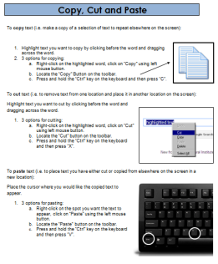**Instruct** learners to use whichever method they prefer to copy their budget and paste it into the new workbook

Step 9: Hand outs

While learners are copy and pasting, hand out **Copy and Paste Reference Form** which lists the options for copy and pasting text

**Teacher Directions: Activity 3: Reduced Budget**

Step 1: Context

Imagine your income was cut in half all of a sudden

**Ask** learners what expenses they would cut/would be able to cut

This is the basis for today’s final activity

Learners will need to rework their budget to fit their new income

If they reduce the amount the spend on something, they should type in the box next to it how they were able to reduce that amount

Step 2: Circulate and assist

Work with learners to cut down their budget

Step 3: Profit

Remind learners to use the profit function to find total amount you have

They should also use the sum function

Step 4: Inserting above functions

Take a minute to explain what to do if you forgot a category and need to insert a row above a sum function

**Explain** that if you insert a row above a sum function, as long as it is after the upper limit and above the lower limit, that number will be included in the total

Step 5: Review

The last few minutes of class have learners review what they ended up cutting

Did they find this difficult? Why?

Unfortunately, this is something that happens all the time

**Explain** that for next time, we are going to create a dream budget. So learners should think about what they would do if they won the lottery?

Step 6: Save and close

**Instruct** learners to save and close the **workbook**

**Day 8 SWAT Questions**

1. Locate a column.
2. Locate a row.
3. Which icon would you click on to open Excel?
   1. Follow up question for same pair-Would you single click or double-click on it?
4. What would you click on to SAVE a document? *Floppy disk*
5. What is created in Excel? *Spreadsheets*
6. If you took a collected data about whether people in this class had brown hair or blonde hair, what kind of data did you collect? *qualitative*
7. If you took a survey to determine number of people in Minneapolis with brown hair, what kind of data did you collect? *Quantitative*
8. If you are saving a file that you have never saved before, which option do you use? *Save As*
9. If you want to change the name of a file, do you click on Save or Save As? *Save As*
10. If you click on a cell and the information that appears in the cell is the same as the information in the formula bar, the data is…:*static*
11. If you click on a cell and you see something different in the formula bar (perhaps an equation), the data is…: *dynamic*
12. This tool allows you to find a total amount of data: *Auto Sum sigma button*
13. What button do you press if you want to BOLD text: *B*
14. What button do you look for if you want to adjust the alignment of text? *Alignment buttons*
15. When you insert a column, does it insert to the left or to the right? *To the left*
16. When you insert a row, does it insert above or below the selected row? *Above*
17. Where is the toolbar? *Above the spreadsheet*
18. What do I click to turn data into dollar amounts? *Currency button/Dollar Sign*
19. Where are the menu tabs? *Above the tool bar*
20. Which menu tab do you click on to Save a new document? *file*
21. Which cursor do I look for if I want to fill in all of the days after Tuesday?*Skinny plus sign*
22. http://www.computergaga.com/excel/2003/foundation/creating_a_workbook/images/resizing_arrows.JPGWhich cursor allows you to adjust the size of a cell?
23. Which cursor signifies that you can select a cell?
24. What button allows you to undo something you just did? *Backward arrow*

**Spreadsheets**

**Qualitative**

**Quantitative**

**Dynamic**

**Static**

**Survey**

**To the Left**

**To the Right**

  

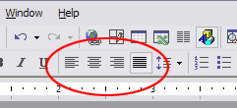

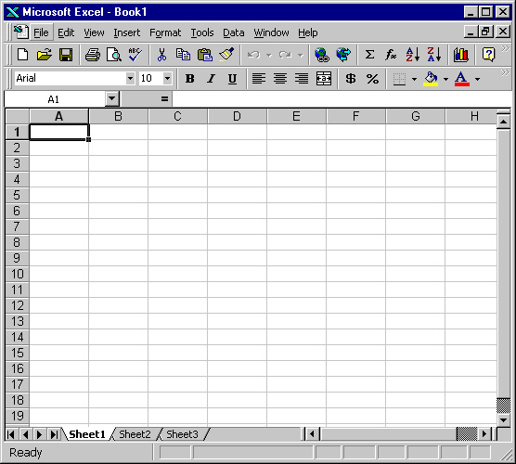

 

http://www.computergaga.com/excel/2003/foundation/creating_a_workbook/images/resizing_arrows.JPG

Copy, Cut and Paste

To **copy** text (i.e. make a copy of a selection of text to repeat elsewhere on the screen):



1. Highlight text you want to copy by clicking before the word and dragging across the word.
2. 3 options for copying:
   1. Right-click on the highlighted word, click on “Copy” using left mouse button.
   2. Locate the “Copy” Button on the toolbar.
   3. Press and hold the “Ctrl” key on the keyboard and then press “C”.

To **cut** text (i.e. to remove text from one location and place it in another location on the screen):

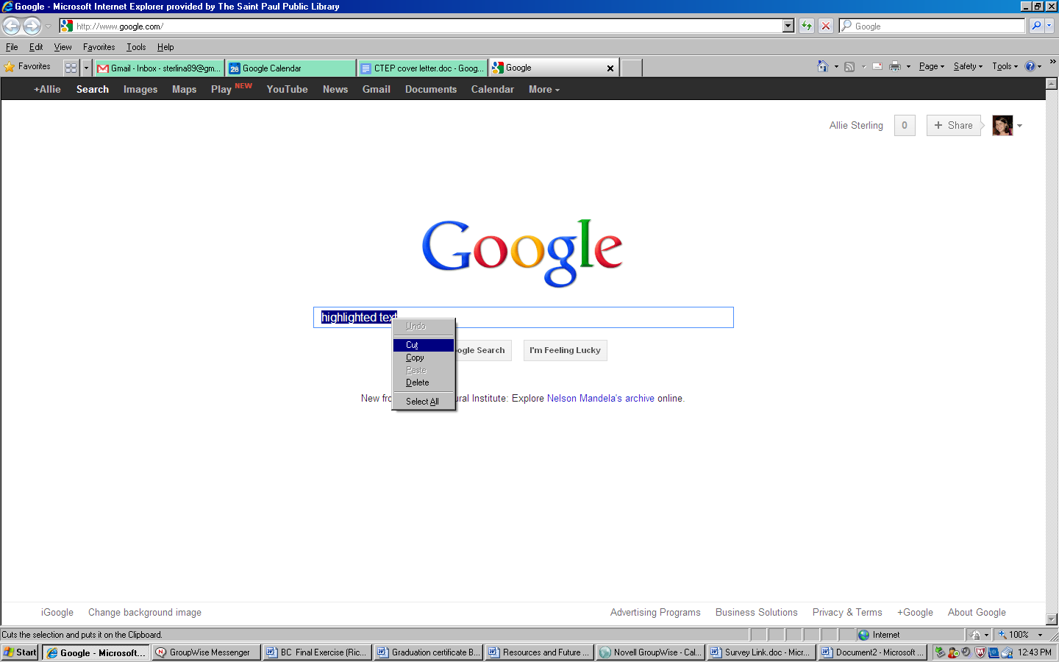Highlight text you want to cut by clicking before the word and dragging across the word.

1. 3 options for cutting:
   1. Right-click on the highlighted word, click on “Cut” using left mouse button.
   2. Locate the “Cut” button on the toolbar.
   3. Press and hold the “Ctrl” key on the keyboard and then press “X”.

To **paste** text (i.e. to place text you have either cut or copied from elsewhere on the screen in a new location):

Place the cursor where you would like the copied text to appear.

1. 3 options for pasting:
   1. Right-click on the spot you want the text to appear, click on “Paste” using the left mouse button.
   2. Locate the “Paste” button on the toolbar.
   3. Press and hold the “Ctrl” key on the keyboard and then press “V”.