Excel Day 5

Objectives Learners will be able to… | Materials
Computer skill: currency function  Computer skill: undo button  Computer skills: click and drag  Computer skills: identify buttons on the toolbar  Literacy skill: making inferences | Make Student Copies  - Excel Exercise 7: Elsie’s Budget (Tab 11)  - Excel Exercise 8: Inferences (Tab 12)  Props, Technology or Other Resources  - Projector  - Computer for every student  - USB Drives  - Day 5 Inference Practice PPT
Lesson Plan | Vocabulary
Warm-up: 10 minutes Review  Description: Ask students how you could open a previously saved document? Have them lead you through the steps. Start menu>My Computer>Locate Removable Disk Drive, often (E:) Drive>Locate File Name.  How to adjust column width? Place cursor between two column, look for cursor with arrows out each side, click and drag. OR when you see the appropriate cursor, double click.  How to insert a column? If I click on column B>right-click>insert where will the new column appear?  Save and close  Materials/Prep:  Activity 1: Introduction to Budgets  Description: learners will get an intro to what budgets are and important vocabulary in addition to learning the currency button  Materials/Prep: copies of Excel Exercise 7: Elsie’s Budget  Activity 2: Formatting-15 minutes  Description: learners will get a quick reminder of the formatting toolbar, specifically bold and align  Materials/Prep:  Activity 3: Inferences  Description: learn how to make inferences-draw conclusions from fact given  Materials/Prep: copy and paste spreadsheet from page 4 into Excel doc, Download Day 5 Inference Practice PPT | - Budget  - Income  - Expenses  - Categorize  - Ribbon  - Toolbar  - Bold  - Align  - Inference
Teacher Directions: Activity 1: Intro to Budgets -Excel Exercise 7: Elsie’s Budget
Step 1: Get a sense of what we know and introduce budgets
Explain that today we are going to learn another common use of spreadsheets
Ask what kind of data we have collected in spreadsheets thus far: surveys, qualitative, quantitative
Ask if students keep track of what they spend money on? If so, how? Online? Checkbook? Categorize?
Example: You keep a table of what you spend on Gas, Rent and Groceries and put the totals for the month next to each one. Then you compare it to your income.
Ask if anyone knows what this method of organizing money is called? Budget

Step 2: Definition of Budget
Budget: An estimate of income and expenses for a set period of time.
Ask learners what income is/means?
Ask what expenses are? What is a typical expense?
Write the expanse examples on the board

Step 3: Show a Budget
Copy the budget below and paste it into an Excel File then project onto the board
Ask what the purpose of a budget might be? To get an idea of what you spend your money on, to see how much extra cash you have to spend/put into saving, etc.
Ask learners how the columns are labeled?
Ask what kind of data is collected in a budget? MONEY, spent and earned

Expenses | June | July | Aug
Rent | 450 | 450 | 450
Phone | 37 | 37 | 37
Internet | 40 | 40 | 40
Utilities | 40 | 60 | 55
Groceries | 70 | 85 | 60
Entertainment | 60 | 90 | 30
Misc | 110 | 20 | 1

Step 4: Parts of a budget
Point out where each part of a budget is placed, specifically the labels
Totals: explaining this might lead to discussion on the sum function, which will not take place until day 2, so no need to bring this up

Step 5: Currency function
Explain that Excel has a tool that allows you put numbers into dollar form
This is called the currency function
Explain that learners can hover their cursor over the toolbar buttons (point out where the toolbar is) to see what the buttons do (text will appear to tell you without clicking on it)
Instruct learners to locate the currency function
****NOTE: Beneficial to point out the UNDO button ****

Step 6: Create Own Spreadsheet
Instruct learners to copy the text of the projected budget into their own spreadsheet, they should not worry about adding dollar signs, simply insert the numbers

Step 7: Demonstrate currency function
Once everyone gets most of the spreadsheet entered, learners should have their EYES FORWARD AND HANDS OFF OF COMPUTERS
Demonstrate how to use click and drag to turn numbers into dollar amounts
IMPORTANT to reinforce need to highlight when you are changing something (formatting) about text/numbers in a spreadsheet

Step 8: Controlled Practice
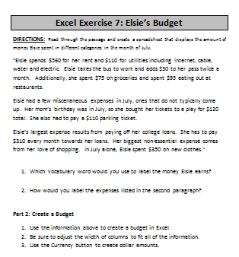
Ask learners how to undo what you just did (turning numbers into currency): use the undo button
Instruct learners to walk you through how to change numbers into currency
Highlight the selected text using click and drag>click on Currency Button

Step 9: Group/Individual Practice
Hand out Excel Exercise 7: Elsie’s Budget
Go through the handout with the learners, they should guide you to the answers
Ask questions like: How would I label column 2? What number goes next to rent?
ANSWERS:
- Income 2. Miscellaneous

Teacher Directions: Activity 2: Formatting Text-15 Minutes

Step 1: Review Toolbar
Day 1 we went over the ribbon, which includes the Menu Tabs and Toolbars
Ask which menu tab we have used quite a bit? File
Explain that the toolbar offers options to Format text

Step 2: What is Formatting?
Ask if anyone remembers what formatting means? The way in which something is arranged
The toolbar offers many formatting options

Step 3: Hover to discover
Explain that we do not know what all of those buttons do, but we have a way of finding over
If you hover your cursor over any button without clicking, text will appear describing what the button does

Step 4: Demonstrate Bold and Align buttons
Ask learners to locate the bold button
Explain that learners need to click on the cell they want to bold, then click on the bold button

Step 5: Controlled Practice
Work with the class to make all of the labels in the budget bold
Work together to align all of the expenses to the right
BE SURE to reiterate that learners must select cells they wish to format before using the buttons on the toolbar, same as using the currency button

Teacher Directions: Activity 3: Inferences - Excel Exercise 8: Inferences
-Day 5 Inference Practice PPT
Step 1: Context
Project the budget below (beneficial to copy and paste into Excel)

Expenses | Aug | Sept | Nov | Dec
Groceries | 80 | 70 | 90 | 85
Cell Phone | 50 | 50 | 90 | 50
Rent | 450 | 450 | 450 | 450

Ask learners if anything seems fishy in this budget?
Explain that budgets can also be helpful in determining if you are spending too much money on something/someone is charging too much for something
This person paid $40 more on their cell phone in November than all other months
What do we know: This person paid $40 more on their cell phone in November than all other months. We know they paid too much because of what they spent in the surrounding months
We can infer that this person was charged too much for their cell phone bill in November

Step 2: Define Inference
What does it meant to infer?
Inference is the act or process of determining logical conclusions from information known to be true.
Repeat this a few times.

Step 3: Examples from downloadable PowerPoint
Teacher should Download Day 5 Inference Practice PPT
Go through the examples with the students, directions are on the slides
Students do NOT need to download the PPT
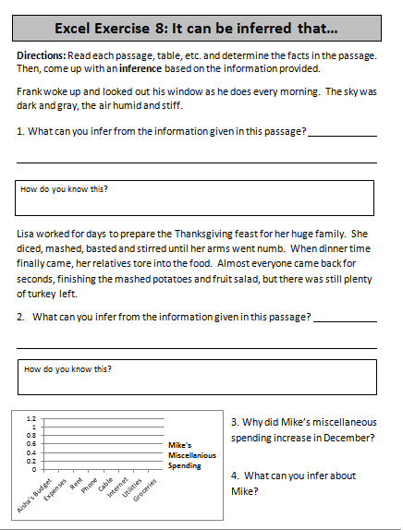
Step 4: Individual Practice
Hand out Excel Exercise 8: Inferences
Explain that the handout contains different types of information that learners can make inferences from, but the same ideas apply
They can work in pairs if desired

Circulate to answer questions
Excel Exercise 7: Elsie’s Budget
DIRECTIONS: Read through the passage and create a spreadsheet that displays the amount of money Elsie spent in different categories in the month of July.
“Elsie spends $560 for her rent and $110 for utilities including internet, cable, water and electric. Elsie takes the bus to work and adds $30 to her pass twice a month. Additionally, she spent $75 on groceries and spent $95 eating out at restaurants.
Elsie had a few miscellaneous expenses in July, ones that do not typically come up. Her mom’s birthday was in July, so she bought her tickets to a play for $120 total. She also had to pay a $110 parking ticket.
Elsie’s largest expense results from paying off her college loans. She has to pay $310 every month towards her loans. Her biggest non-essential expense comes from her love of shopping. In July alone, Elsie spent $350 on new clothes.”

- Which vocabulary word would you use to label the money Elsie earns?
- How would you label the expenses listed in the second paragraph?
Part 2: Create a Budget
- Use the information above to create a budget in Excel using appropriate labels.
- Be sure to adjust the width of columns to fit all of the information.
- Use the Currency button to create dollar amounts.
- Insert a column between the list of expenses and July amounts in order to enter information for June.
- Save the spreadsheet.

Excel Exercise 8: It can be inferred that…
Directions: Read each passage, table, etc. and determine the facts in the passage. Then, come up with an inference based on the information provided.

Frank woke up and looked out his window as he does every morning. The sky was dark and gray, the air humid and stiff.

1. What can you infer from the information given in this passage?
How do you know this?

Lisa worked for days to prepare the Thanksgiving feast for her huge family. She diced, mashed, basted and stirred until her arms went numb. When dinner time finally came, her relatives tore into the food. Almost everyone came back for seconds, finishing the mashed potatoes and fruit salad, but there was still plenty of turkey left.
2. What can you infer from the information given in this passage?
How do you know this?

- What has the most significant change in this chart?

- What can you infer from that change?
Each bar represents a month.
“Tommy!” Mom called out as she walked in the front door. “Tommy,” she continued shouting, “I sure could use some help with these groceries.” There was still no reply. Mom walked into the kitchen to put the grocery bags down on the counter when she noticed shattered glass from the window all over the living room floor and a baseball not far from there. “Are you kidding me, Tommy!” Mom yelled to herself as she realized that Tommy’s shoes were gone.
5. What happened to the window? ______________________________________________________
^{How do you know this?}

Aisha's Budget
Expenses
Rent | $ 500.00
Phone | $ 40.00
Cable | $ 30.00
Internet | $ 30.00
Utilities | $ 50.00
Groceries | $ 5.00
Entertainment | $ 80.00
Gas | $ 80.00

6. What can you infer about Aisha’s from her budget?
____________________________________
How do you know this?

Rob's Budget
Expenses
Rent | $ 450.00
Phone | $ 55.00
Cable | $ 40.00
Groceries | $ 60.00
Entertainment | $ 80.00
Gas | $ 70.00
Medical | $ 1,500.00
7. What can you infer Rob from his budget?
____________________________________
How do you know this?

Answer Key for Teachers Only!
- It is going to storm.
  - The color of the storm
- The food was good, but maybe the turkey wasn’t.
  - Everyone wanted more.
- Heat has gone up
- It got colder outside.
- Someone hit a ball through the window.
  - There was a broken window with a ball and some shattered glass laying nearby.
- She receives some sort of assistance with her food purchases.
  - She only paid $5 for food.
- He has some sort of medical condition or got into an accident.
  - He spent 1500 on medical.

