Excel Day 4

Objectives Learners will be able to… | Materials
Computer skill: Insert columns and rows  Computer skill: Adjust the size of cells  Computer skill: click and drag  Computer skills: open a saved spreadsheet  Literacy skill: Reading comprehension  Literacy skill: scanning for key parts | Make Student Copies  - Excel Exercise 4: Information Gap-see printing directions under “Materials”(Tab 8)  - Excel Exercise 5: Insert Columns and Rows-2 on each page, so print 1 per 2 students (Tab 9)  - Excel Exercise 6: Save and Open (Tab 10)  Props, Technology or Other Resources  - Projector  - Computer for every student  - USB Drives
Lesson Plan | Vocabulary
Warm-up: 10 minutes max  Description: Think, Pair, Share. Write Save and Save as on the board. Ask learners to think quietly to themselves about when they would use each one for one minute. They should then pair up and discuss their conclusion with their partner and try to determine when you use Save and when you use Save As. After a couple of minutes, learners should share their thoughts with the whole class.  Save: when you are simply updating content of a file  Save as: when you are saving for the first time or changing the name/where the file is saved  Activity 1: Information Gap  Description: learners will work in pairs to finish an activity  Materials/Prep: copies of Excel Exercise 4: Information Gap***Half of the students should get Student A and the other half should get Student B, the Master page is for the teacher to keep track of answers  Activity 2: Adjust Cell Size  Description: explain how to adjust the size of cells to fit all of the information  Activity 3: Insert Columns and Rows  Description: explain how to insert columns and rows into a spreadsheet  Materials/Prep: copies of Excel Exercise 5: Insert Columns and Rows  Activity 4: Open a Previously Saved Document  Description: explain how to open a previously saved document  Materials/Prep: If there is time, make copies of Excel Exercise 6: Save vs Open | - Insert  - Menu Tabs  - Adjust  - Click and Drag  - Scanning
Teacher Directions: Activity 1: Information Gap -Excel Exercise 4: information Gap
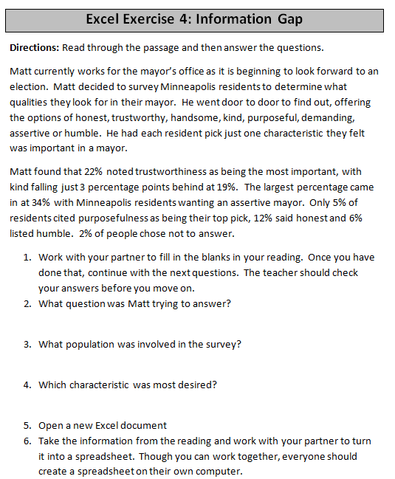
Step 1: Explain and Model
Explain that everyone will be paired up and then each learner will read through a passage that is missing information. Learners will have to ask their partner for that information in order to fill in the blanks.
Example: T pretend to read through the passage and ask partner for the necessary info to fill in first blank
Leaners should NOT simply copy the information from their partner’s passage, we need to hear conversation!

Step 2: Pair students off
Put the leaners into pairs
Ideal pair: one learner is a bit more of an advanced English speaker, but without a huge margin of difference
One student gets Student A handout and one gets Student B
The first page of activity in Tab X is the Master page, for you to check answers

Step 3: Complete Exercise
Learners should read through the passages and then elicit answers to questions from their partner to fill in the empty information

Step 4: Explain scanning to find information faster
Student should say key word, look for that word and it is easier to find the answer, look for key words

Step 5: After everyone finishes the questions
As you see students wrap up the questions and begin their spreadsheet, take a minute to set up the spreadsheet
Learners should have their EYES FORWARD AND HANDS OFF OF THEIR COMPUTER
Ask what should go into column A: characteristics
Ask what goes into cell A1: this is where the label should go, simply type Desired Characteristics
Ask what goes into column B: Percentage of Minneapolis residents

Step 6: Create Spreadsheet
Once you have ensure the groundwork for the spreadsheet, allow learners to finish filling it in on their own

Step 7: Review Spreadsheet
Have students review what they put and where they put it

Step 8: Save the document
Review how to save a new document
Save or Save As: Save As
Have learners lead you through the steps
File> Save As>My Computer>Removable disk drive, typically (E: )

Teacher Directions: Activity 2: Adjusting Column Width

Step 1: Context
Ask learners if they have ever gone to put information into a cell and they have not been able to see it all
Type 20 numbers into a cell
Explain that the cell is too small to hold all of the information, so we have to make it bigger

Step 2: Demonstrate to ways to adjust cell size
Explain that learners should have their eyes forward and hands off of their computers for this portion
Show learners how the cursor changes shape when placed between two columns (line with an arrow out of each side)
Explain that this cursor allows you to change the size of a cell
One way to change cell size is to double click when that cursor appears between two columns
This will automatically adjust the width to fit the information inside
#2: Click and drag the column to create own width

Step 3: Click and Drag Explanation
Demonstrate how to click and drag
On touchpad: easier if one hand is in charge of clicking and the other drags
Instruct learners to practice clicking and dragging
Mess something up? UNDO

Step 4: Controlled practice
Work with learners to change the width of their cells to fit all of their information and make it visible

Step 5: Save Review
Ask if they should click Save or Save As: Save
Why? Only changing the content, not where it is saved or what it is named

Teacher Directions: Activity 3: Insert Rows and Columns
- Excel Exercise 5: Insert Columns and Rows
Step 1: Context
Explain that sometimes you create a spreadsheet and then decide you need to add another column or row
Example: Matt from Activity 1 might want to ask St Paul Residents the same question, or he might want to add another characteristic

Step 2: Demonstrate inserting columns
STUDENTS: Eyes forward, no typing, hands off of computer
Explain that you want to INSERT a column into this spreadsheet
First, always click on the column to the left of the space you want the new column to be
Ask where learners might find the tool to INSERT a column
What word are we looking for? Insert
Click on Insert menu tab
Option #2: Click on the column, right click, click insert

Step 3: Controlled Practice
Learners should now insert a column into their spreadsheet

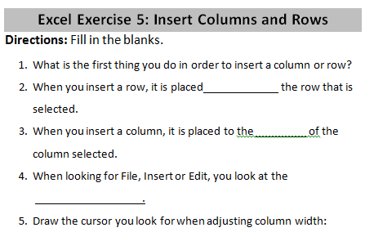
Step 4: Insert a Row
Demonstrate how to insert a row
Click on row below the space you want a new one inserted
Same steps as inserting column, simply click row

Step 5: Controlled Practice
Instruct learners to insert a row

Step 6: Practice
Hand out Excel Exercise 5: Insert Columns and Rows
Step 7: Save and Close
Learners should save their progress and then close out of the document

Teacher Directions: Activity 4: Open Previously Saved Documents

Step 1: Context
Explain that you realized you forgot something on your spreadsheet, so you want to look at it again

Step 2: Demonstrate
Instruct learners to keep their eyes forward and their hands off of their computer
Demonstrate how to open the file
Point out that many of the steps are the same as saving, but the name of the Dialogue box is different
Start menu>My Computer>Removable disk drive>Locate File Name

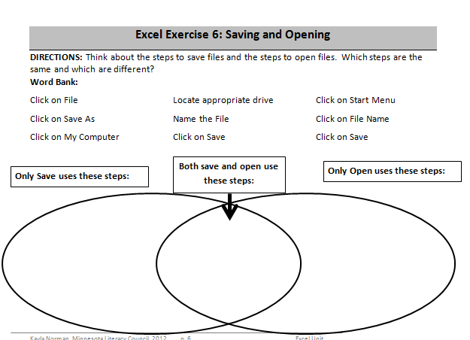
Step 3: Controlled Practice
Explain that learners can now use their computers as you go through the steps together

Step 4: If there is time activity
Hand out the cut up steps from Excel Exercise 6: Saving and Opening
Model how to complete the hand out using a few of the words from the word bank

Step 5: Save and close
Students should save and close out of any open documents

Excel Exercise 4: Information Gap
Directions: Read through the passage and then answer the questions.
Matt currently works for the mayor’s office as it is beginning to look forward to an election. Matt decided to survey Minneapolis residents to determine what qualities they look for in their mayor. He went door to door to find out, offering the options of honest, trustworthy, handsome, kind, purposeful, demanding, assertive or humble. He had each resident pick just one characteristic they felt was important in a mayor.
Matt found that 22% noted trustworthiness as being the most important, with kind falling just 3 percentage points behind at 19%. The largest percentage came in at 34% with Minneapolis residents wanting an assertive mayor. Only 5% of residents cited purposefulness as being their top pick, 12% said honest and 6% listed humble. 2% of people chose not to answer.
- Work with your partner to fill in the blanks in your reading. Once you have done that, continue with the next questions. The teacher should check your answers before you move on.
- What question was Matt trying to answer?
- What population was involved in the survey?
- Which characteristic was most desired?
- Open a new Excel document
- Take the information from the reading and work with your partner to turn it into a spreadsheet. Though you can work together, everyone should create a spreadsheet on their own computer.

Excel Exercise 4: Information Gap
Student A
Directions: Read through the passage and then answer the questions.
Matt currently works for the mayor’s office as it is beginning to look forward to an election. Matt decided to survey Minneapolis residents to determine what qualities they look for in their mayor. He went door to door to find out, offering the options of honest, trustworthy, handsome, kind, purposeful, demanding, assertive or humble. He had each resident pick just one characteristic they felt was important in a mayor.
Matt found that 22% noted trustworthiness as being the most important, with kind falling just 3 percentage points behind at . The largest percentage came in at 34% with Minneapolis residents wanting an assertive mayor. Only 5% of residents cited as being their top pick, 12% said honest and listed humble. 2% of people chose not to answer.
- Work with your partner to fill in the blanks in your reading. Once you have done that, continue with the next questions. The teacher should check your answers before you move on.
- What question was Matt trying to answer?
- What population was involved in the survey?
- Which characteristic was most desired?
- Open a new Excel document
- Take the information from the reading and work with your partner to turn it into a spreadsheet. Though you can work together, everyone should create a spreadsheet on their own computer.
Excel Exercise 4: Information Gap
Student B
Directions: Read through the passage and then answer the questions.
Matt currently works for the mayor’s office as it is beginning to look forward to an election. Matt decided to survey Minneapolis residents to determine what qualities they look for in their mayor. He went door to door to find out, offering the options of honest, trustworthy, handsome, kind, purposeful, demanding, assertive or humble. He had each resident pick just one characteristic they felt was important in a mayor.
Matt found that noted trustworthiness as being the most important, with falling just 3 percentage points behind at 19%. The largest percentage came in at with Minneapolis residents wanting an assertive mayor. Only 5% of residents cited purposefulness as being their top pick, 12% said honest and 6% listed humble. 2% of people chose .
- Work with your partner to fill in the blanks in your reading. Once you have done that, continue with the next questions. The teacher should check your answers before you move on.
- What question was Matt trying to answer?
- What population was involved in the survey?
- Which characteristic was most desired?
- Open a new Excel document
- Take the information from the reading and work with your partner to turn it into a spreadsheet. Though you can work together, everyone should create a spreadsheet on their own computer.
Excel Exercise 5: Insert Columns and Rows
Directions: Fill in the blanks.
- What is the first thing you do in order to insert a column or row?

- When you insert a row, it is placed the row that is selected.
- When you insert a column, it is placed to the of the column selected.
- When looking for File, Insert or Edit, you look at the
.
- Draw the cursor you look for when adjusting column width:

Excel Exercise 5: Insert Columns and Rows
Directions: Fill in the blanks.
- What is the first thing you do in order to insert a column or row?

- When you insert a row, it is placed the row that is selected.
- When you insert a column, it is placed to the of the column selected.
- When looking for File, Insert or Edit, you look at the
.
- Draw the cursor you look for when adjusting column width:

Excel Exercise 6: Saving and Opening
DIRECTIONS: Think about the steps to save files and the steps to open files. Which steps are the same and which are different?
Word Bank:

Click on File
Click on Save As
Click on My Computer
Locate appropriate drive
Name the File
Click on Save
Click on Start Menu
Click on File Name
Click on Open

Only Save uses these steps:
Only Open uses these steps:
Both save and open use these steps:

