Email: Day 5

Objectives Learners will be able to… | Materials
Computer skill: forward emails  Literacy Skill: email etiquette  Literacy Skill: determine tone | Make Student Copies  - Email Exercise 7: Forward Emails (Tab 12)  - Day 5 Email Etiquette PPT printed with 4 slides per page for students (Tab 13)  Props, Technology or Other Resources  - Projector  - Computer for every student  - Day 5 Email Etiquette PPT
Lesson Plan | Vocabulary
Warm-up:  Description: Write the following sentences on the board:  - Would it be possible for you to submit that report today?  - Submit the report by 2pm.  - I cannot believe I have to remind you AGAIN, submit the report by no later than 2pm.  - Hey girl, tryna get that report done today?  When class begins, ask student what kind of tone is evoked when reading each sentence. Is one more demanding than the other? Is one more angry/professional/informal?  Materials/Prep:  Activity 1: Send and Forward  Description: learners will send a partner an email and then forward it to another student  Materials/Prep:  Activity 2: Email Etiquette  Description: go over appropriate times to forward an email and inappropriate times  Materials/Prep: download Day 5 Email Etiquette PPT, markers and sheets of paper | - Etiquette  - Forward  - Tone

Teacher Directions: Activity 1: Send and Forward - Email Exercise 7: Forward Emails
Step 1: Hand out Activity
Hand out Email Exercise 7: Forward Emails and look over Part 1 (ignore part 2 for now)
Explain that learners will need to find a partner and write their email address in the appropriate space on the handout
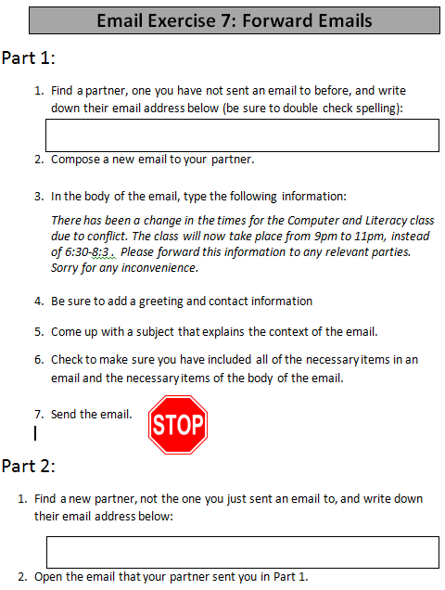
They will then write a new email to their partner that includes the information listed on the handout
One student should pair up with the teacher email address

Step 2: Model Activity
Learners should have their EYES FORWARD AND HANDS OFF OF THEIR COMPUTERS
Ask two learners for their email addresses; write on in Partner A and the other in the space for Partner B
Ask learners how you would create a new email: compose
Ask learners where Partner A’s email address goes: “to” box
Ask learners what all needs to be included in emails: recipient email address, subject, body
Ask learners what goes into the body: greeting, text, closing, contact information
Type the email and send it

Step 3: Learners complete activity
Students should complete Part 1
Circulate to assist and answer questions
Any questions that many students ask should be addressed to the whole class

Step 4: Part 2-Students need another email address
The first step of Part 2 requires students to retrieve another email address.
Instruct learners to find another partner that they did not use for part 1

Step 5: Model Activity
Learners should have their EYES FORWARD AND HANDS OFF OF THEIR COMPUTERS
Review how to get back to the inbox
Ask learners how to open a received email: click on it
Teacher should open the email that was sent to them by their student partner
Ask students if they remember how to forward an email: click on forward at the bottom of the email
Forward the email to your new partner

Step 6: Learners complete activity
Instruct learners to complete Part 2
Circulate to assist and answer questions
Any questions that many students ask should be addressed to the whole class

Teacher Directions: Activity 2: Email Etiquette

Step 1: Context
Ask students if they have ever received mail that they thought was junk or nonsense? Would they pass that mail off to a friend?
Explain that email is just like snail mail this way: You do not want to forward an email that is junk to other people
Ask if anyone has ever received an email which promised something free if you sent it to ten people?

Step 2: Go through PPT
Download Day 5 Email Etiquette and go through it with the learners

Step 3: Practice Exercise
Learners should think about what they have learned, and come up with at least three rules they would share with family and friends regarding email etiquette
Instruct them to write them down on a piece of paper and then share them with the class

Email Exercise 7: Forward Emails

Part 1:
- Find a partner, one you have not sent an email to before, and write down their email address below (be sure to double check spelling):
- Compose a new email to your partner.

- In the body of the email, type the following information:
There has been a change in the times for the Computer and Literacy class due to conflict. The class will now take place from 9pm to 11pm, instead of 6:30-8:30. Please forward this information to any relevant parties.
Sorry for any inconvenience.

- Be sure to add a greeting and contact information

- Come up with a subject that explains the context of the email.

- Check to make sure you have included all of the necessary items in an email and the necessary items of the body of the email.
- Send the email.

Part 2:
- Find a new partner, not the one you just sent an email to, and write down their email address below:
- Open the email that your partner sent you in Part 1.

- Locate the Forward button and click on it.

- Type the recipient email address in the appropriate space.

- In the body of the email, the text portion should include:
I thought you might want to know this information, in case you were not already informed.
- Be sure to include a greeting, closing and contact information.

- Check the recipient email address for any spelling mistakes. Make sure it includes @gmail.com

- Check to make sure every necessary part of emails is included.

- Send the Email.

