Email: Day 4

Objectives Learners will be able to… | Materials
Computer skill: send and reply to emails  Computer skill: decipher difference between forward and reply  Computer skill: review parts of an email  Computer skill: determine Tone | Make Student Copies  - Email Exercise 5: Send vs. Reply (Tab 10)  - Email Exercise 6: Tone Matching (Tab 11)  Props, Technology or Other Resources  - Projector  - Computer for every student  - Download and project Tone Example from Lesson Plan  - Download and Project Day 3 Tone Practice from lesson plan
Lesson Plan |  | Vocabulary
Warm-up:  Description: review parts of an email, write the answers on the side of the board as you go: Ask learners what three things always need to be included in an email: recipient address, subject, body. Ask learners what four things always needs to be included in the body of an email: Greeting, Text, Closing, Contact information  Materials/Prep:  Activity 1: Send and Reply Practice  Description: learners will partner up and send each other an email and then reply to the email  Materials/Prep: copies of Email Exercise 5: Send vs. Reply  Activity 2: Forwarding vs. Reply  Description: depending on how many people are still taking the test/how much of the test they have left, learners will either follow a handout which instructs them how to login to Email, or, if everyone is done by 7:40, teacher will lead learners through log in process  Materials/Prep:  Activity 3: Tone Activity  Description: discuss the importance that comes with being aware of tone within an email  Materials/Prep: copies of Email Exercise 6: Tone Matching (if you run out of time to do this activity, say so in the lesson report and then attach the handouts to the clipboard, download and project Email Tone Examples and Day 3 Tone Practice from Lesson Plan |  |  | - Recipient address  - Subject  - Body  - Greeting  - Closing  - Reply  - Forward  - Tone

Teacher Directions: Activity 1: Send and Reply Practice -Email Exercise 5: Send and Reply
Step 1: Pair Students off
Students should pair off with someone across the room from themselves
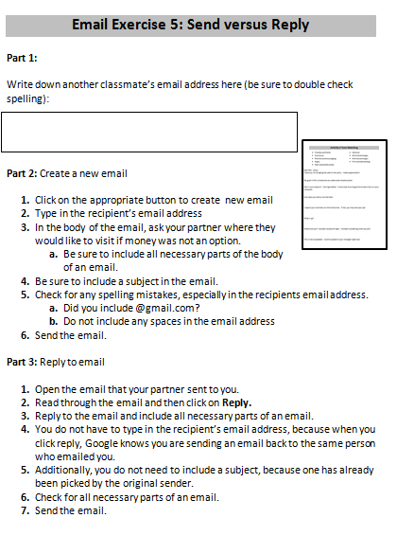
Step 2: Hand out exercise
Hand out Email Exercise 5: Send and Reply
Instruct students to write their partners email address into Part 1
Ask them if it is important to double check that you have the spelling of the email address correct: yes, always
Ask them if they have to include @gmail.com: yes, always include the email service provider

Step 3: Read assignment together
Read through the passage and directions with the class

Step 4: Demonstrative Review
Instruct learners to have their EYES FORWARD AND HANDS OFF OF THEIR COMPUTER
Teacher will demonstrate how to complete the activity- modeling is the key to success
Where to click to create a new email? Compose
Is spelling important when it comes to email addresses? Yes.
What three things must be included in an email: recipient email address, subject, body
What four things much be included in the body of an email: greeting, text, closing statement, contact information

Step 5: Learners complete activity
Instruct learners to begin their activity with part 2: composing a new email
Remind them to include all necessary parts of an email

Teacher Directions: Activity 2: Forward versus reply
Step 1: What does it mean to reply?
Take a piece of paper and write a student’s name on it. Explain to the class that this is a letter. Hand the paper to the student, what are you doing with the paper? Imagine it was an email: sending the paper
Ask what it is called if the student writes on the letter and sends it back to me: reply
Ask what it would be called if instead of sending the email back to me, the student passed it on to another member of the class: forward

Step 2: Define forward
Explain that when someone forwards an email, it means they have received an email and wish for someone else who was not originally included to see it
If they need more explanation, use the letter example again and have learners use the following phrases:
- I am sending this letter to…(hand to recipient)
- I am replying to this letter…(hand it back to original sender)
- I am forwarding this email to…(hand letter on to a different student, do this 2 or 3 times)

Step 3: Where is the forward button?
Ask learners how to get back to their inbox, no matter where they are in their email-click on inbox
Instruct learners to click on the email that was sent to them by their partner
Ask if they see the word “forward” anywhere: same area as the forward option
Step 4: Demonstrate forwarding
Learners should have their EYES FORWARD AND HANDS OFF OF THEIR COMPUTER
Demonstrate how to forward
Ask learners if they have to include a recipient email address: yes, it is being mailed to someone not previously included in the email
Ask learners if they have to include a recipient email address when replying to an email: no

Step 5: Controlled Practice
Instruct learners to forward the email that their partner sent to them to the teacher email address (comp.lit.opendoor@gmail.com)
*****Forwarding etiquette will be discussed during Day 5******

Teacher Directions: Activity 3: Introduction to Tone -Copies of Email Exercise 6
-Download and Project Email Tone Examples and Day 3 Tone Practice from lesson Plan

Step 1: Context
Open the attached Email Tone Examples: Page 6
Ask a learner to read each email
Ask them what emotion they think the sender was conveying: there is no wrong answer
Explain that it is possible to read an email and think the sender meant one thing, when they really meant another
Email #1: This email was actually sent to an MLC employee. The employee thought the sender was angry, when in actuality that is simply the way they sent emails. They did not intend to come off angry, but they did.
Email #2: The sender was being sarcastic, which came off rude and unprofessional. You might have friends that communicate this way, but in an professional setting, communication like this is never okay.

Step 2: What is Tone?
Explain that when discussing the emotion of writing, we are discussing tone
Tone is the attitude toward a subject

Step 3: How does it relate to email?
Explain that tone is important when it comes to sending emails because you do not want people to get the wrong idea.
Because email is not face to face, it can be easy to misinterpret what people are saying, so when sending an email it is important to be clear about your purpose and intentions

Step 4: Tone Practice
Write directly on the board a list of tone options:

- Friendly
- Humorous
- Positive
- Encouraging
- Worried
- Angry
- Stern
- Demanding
- Informal

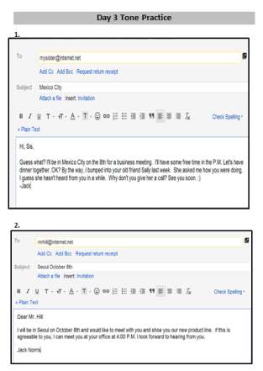
Project Day 3 Tone Practice and go through the emails and match the tone to the sentence with the class
Point out words/phrases that help to determine tone

Step 4: Pair Practice- if there is time
Only complete this activity if there is time, if not, be sure to write that in the lesson report and explain that it should be reviewed during the warm-up
Hand out Email Exercise 6: Tone Matching
Model completing the Exercise- do at least number 1, number 2 if needed
Instruct learners to find a pair and with their partner they should match the tone with the appropriate text

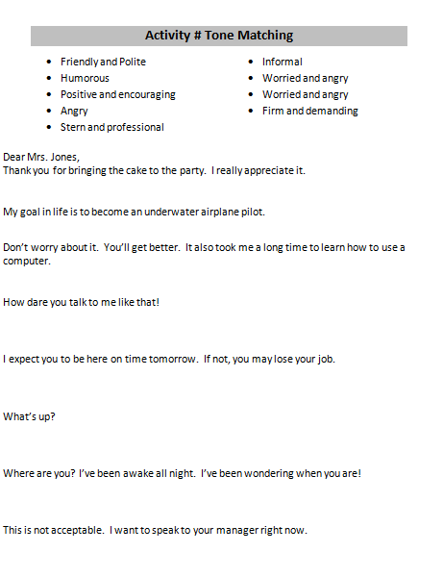
Email Exercise 5: Send versus Reply

Part 1:

Write down another classmate’s email address here (be sure to double check spelling):

Part 2: Compose a new email

- Click on the appropriate button to create new email
- Type in the recipient’s email address
- In the body of the email, ask your partner where they would like to visit if money was not an option.
  - Be sure to include all necessary parts of the body of an email.
- Be sure to include a subject in the email.
- Check for any spelling mistakes, especially in the recipients email address.
  - Did you include @gmail.com?
  - Do not include any spaces in the email address
- Send the email.

Part 3: Reply to email

- Open the email that your partner sent to you.
- Read through the email and then click on Reply.
- Reply to the email and include all necessary parts of an email.
- You do not have to type in the recipient’s email address, because when you click reply, Google knows you are sending an email back to the same person who emailed you.
- Additionally, you do not need to include a subject, because one has already been picked by the original sender.
- Check for all necessary parts of an email.
- Send the email.
Email Tone Examples
Alex,
Send me the following changes.
1) Acknowledge when people sign up on the website
2) add a Facebook link button
3) put a link to the Events section of the site in the main navigation?
Get this done ASAP.
- Liame

Steve,
Heard you really had an awesome time in that status meeting on Friday. Did you forget your morning coffee or intend to screw up as bad as you did? Hahaha
Oh well, better luck next time.
Kyle Hanson

Day 3 Tone Practice
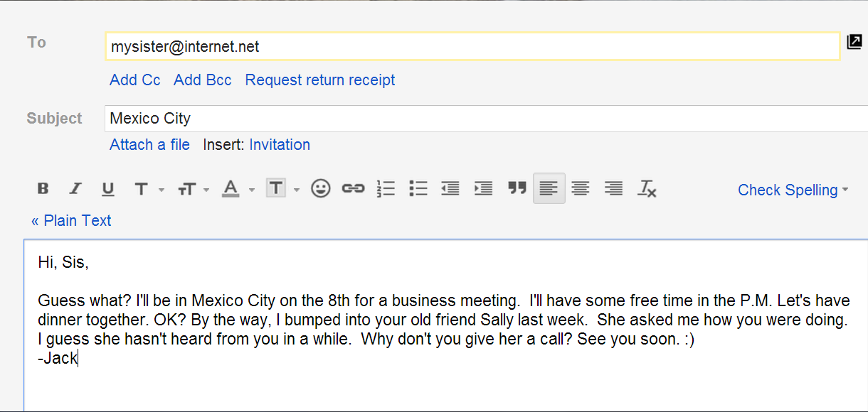
1.
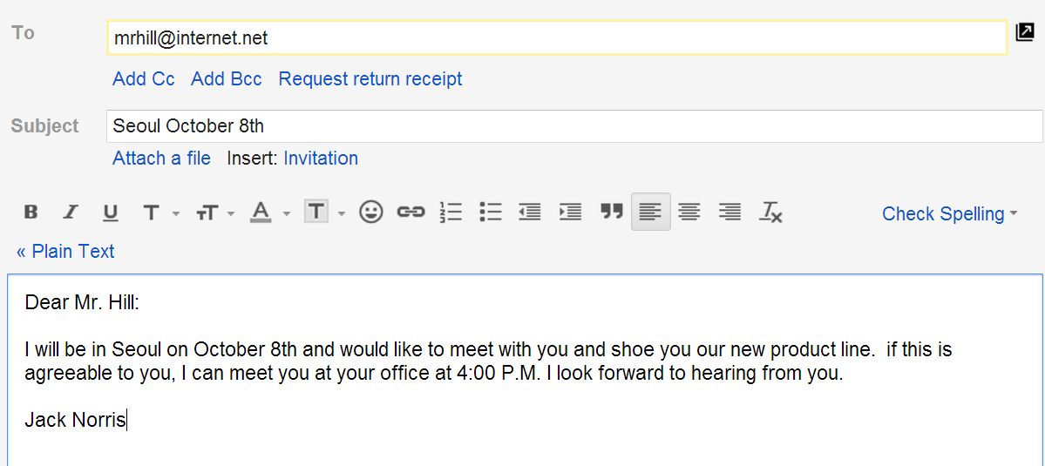
2.
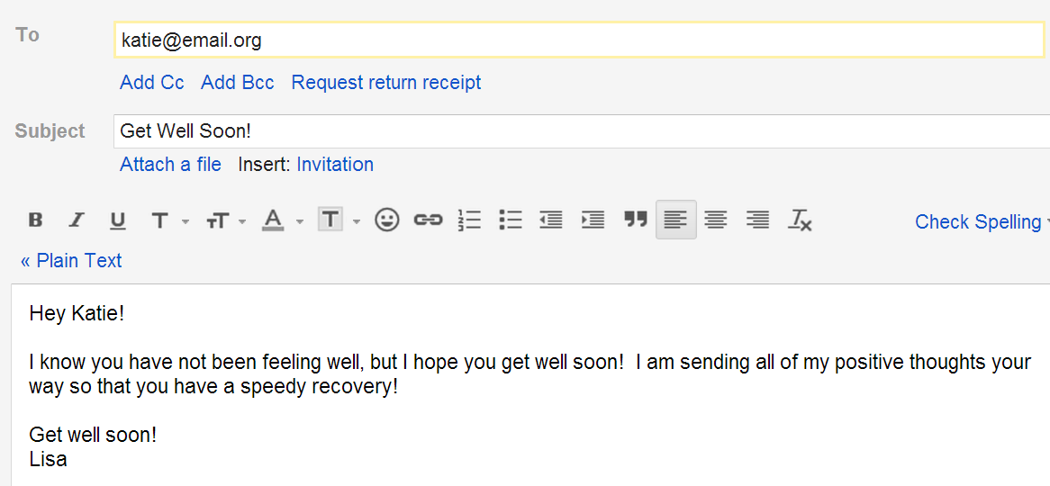
3.

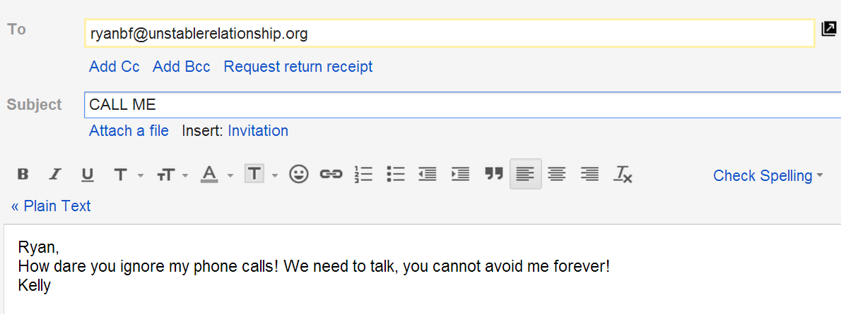
4.
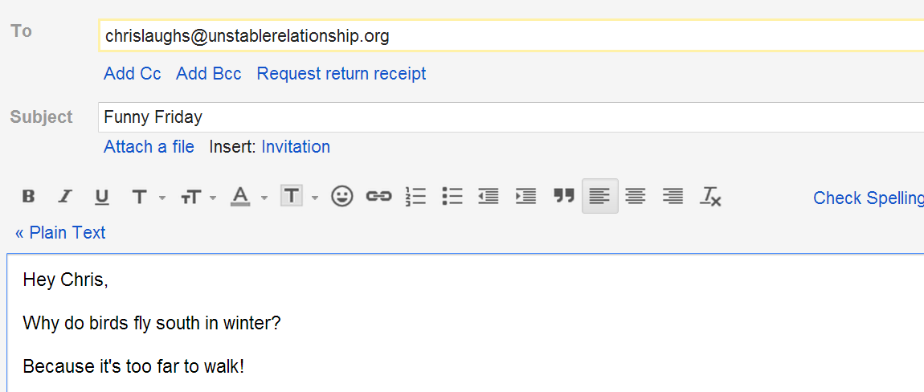
5.

Email Exercise 5 Tone Matching

- Friendly and Polite
- Humorous
- Positive and encouraging
- Angry
- Stern and professional
- Informal
- Worried and angry
- Worried and angry
- Firm and demanding

Dear Mrs. Jones,
Thank you for bringing the cake to the party. I really appreciate it.

My goal in life is to become an underwater airplane pilot.
Don’t worry about it. You’ll get better. It also took me a long time to learn how to use a computer.

How dare you talk to me like that!

I expect you to be here on time tomorrow. If not, you may lose your job.

What’s up?

Where are you? I’ve been awake all night. I’ve been wondering when you are!

This is not acceptable. I want to speak to your manager right now.

