During Day 2 you will be proctoring the North Star Digital Literacy pre-assessment.
All the of the computers that learners use need to be registered (per direction on the North Star site) for the assessment,
- This can take anywhere from 20-40 minutes depending on the number of students and number of volunteers/coordinators who are setting the assessment up.
- REGISTER THE COMPUTERS BEFORE CLASS BEGINS
  - Use the computer sign-in sheet that was filled out Day 1 to determine which computers students are using and pull them out of the COW
DO NOT PRE-TEST STUDENTS IF (Use Computer Use Questionnaires to see what kind of experience learners have with computers):
- They are very uncomfortable with the computer
- You feel taking the assessment will overwhelm them (happens with brand new computer users)
Learners who do not take the pre-assessment can:
- Log in to Mavis Beacon and practice typing
  - If they seem to need help with the mouse, help them get to http://www.skyways.org/central/mouse/page1.html , which is a mouse usage practice site (mouserobics)
Students who come in late: Determining whether or they have time to take the assessment without cutting too much into class time depends on a few things:
DO pre-test them if:
- You feel you have time to register their computer
- They have a basic knowledge of the computer
- They took the previous unit
Do NOT pre-test them if:
- They come more than 10 minutes into the testing period
- They are not familiar with the computer
- They come in late and you are busy setting up learners who showed up on time and are not taking the assessment
*****One way to ensure you get to the tests quickly is by having all of the computers registered before class begins. This takes prep time, but saves important class time. ********
Email: Day 2

Objectives Learners will be able to… | Materials
Computer skill: North Star Assessment  Computer skill: log into email address | Make Student Copies  - Day 2 Warm-up-2 per page, print 1 for every 2 students (Tab 5)  - Email Activity 1: Login to Email (Tab 6)  Props, Technology or Other Resources  - Projector  - Computer for every student  - Download Day 1 Introduction PPT  - North Star How-To
Lesson Plan | Vocabulary
Warm-up:  Description: learners will complete the warm-up activity  Materials/Prep: copies of Day 2 Warm-up  Activity 1: North Star Digital Literacy Pre-Assessment  Description: learners will take a pre-assessment of their Email knowledge  Materials/Prep: each computer must be registered to take the test BEFORE CLASS BEGINS, use North Star How-to to complete the steps for registration  Activity 2: Log in to Email  Description: depending on how many people are still taking the test/how much of the test they have left, learners will either follow a handout which instructs them how to login to Email, or, if everyone is done by 7:40, teacher will lead learners through log in process  Materials/Prep: copies of Email Activity 1 if needed | - Desktop  - Internet Browser  - Address Bar  - Email Service Provider  - Gmail  - Username  - Password  - Email  - Web address/URL  - Log in  - Inbox

Teacher Directions: Activity 1: North Star Digital Literacy Assessment
Step 1:
Take this time to explain the Email North Star Digital Literacy Assessment and its purpose:
This can be read verbatim to the students: The North Star Digital Literacy Assessment has set the standards of what it means to be knowledgeable about different aspects of the computer. The purpose of this assessment is to provide learners with a standard with which everyone learns the computer to ensure that they will be successful outside of the classroom. The pre-assessment is meant to inform the teacher of what you know already and then we can see how you improve at the end of the class. If you pass the assessment with an 85% or higher, you will receive a certificate that proves your competency at the unit you were tested on. These certificates can also be presented to employers as proof of your computer skills when you apply for a job.
With this pre-assessment it is okay if you do not know anything. If you do not know the answer to a question, you are given the option to simply answer “I do not know” or you can take a guess. You are encouraged to guess on this assessment.

Step 2: How the assessment works
This can be read verbatim to the students: When it is time to begin, students will open the assessment titled Email. The assessment begins with a test of the speakers. If you hear the piano playing, you will use your mouse to click the “Next” button.
Explain that if that student does not hear the piano playing, they can look above their keyboard at and they will see three buttons on the right. These are the volume buttons, one to turn down volume, turn it up, and turn it off.
Next, North Star will go through an orientation of how the assessment works. Each question asked in the assessment will be a function of the program, so your answer to the question will be performing that function. BE CAREFUL not to simply click when the page comes up because the assessment will read that as your answer and you cannot go back.
Teacher should pull up the Screen Shot page and review it with the students.

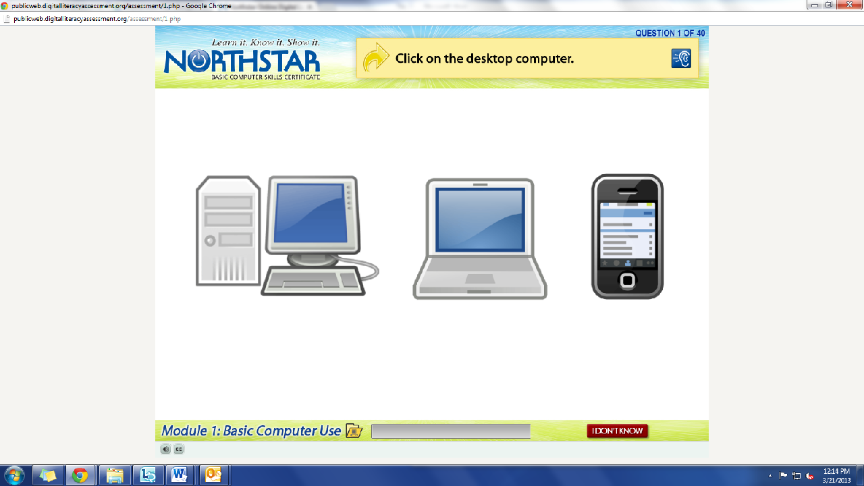
What is the question begin asked?
How do we answer it? We click on the answer.
You must listen carefully to the question being asked so that you know how to answer it.
If you miss the question when it is read, you can either read it on the top of the page, or click the on the blue ear and it will read the question again.
If you do not know and do not want to guess, but once you click it, it will ask you if you are sure you want to skip the question, you have to answer “Yes” to move on. You are, however, encouraged to guess.

Step 3: Learner Code of Conduct
Read the Learner Code of Conduct to the students:
- Learner must listen carefully to all instructions given by proctor
- Learner must treat others with courtesy and respect during assessment process
  - This means no talking to each other during the assessment, if you have a question ask the proctor. If a learner finishes early, they must remain quiet until everyone is finished
- Learner should ask questions prior to the assessment if they are uncertain about the certification process
- Learner is responsible for his or her certificate: if the certificate is lost, s/he will have to retake the assessment
- Learner should inform the proctor if he or she believes that assessment conditions affected his or her results
Ask if there are any questions
Explain that the questions will be read aloud to them, so students need to be sure they are listening carefully. If they miss the question, is it also written at the top of the page.

Step 4: Take Email Assessment
If there are no questions, learners should scroll down the testing page and click on the Email Assessment
If students are frazzled during the test because they missed the reading of the question, there is a blue square in the top right corner with an ear in it. When it is clicked the question is read again

Step 5: After the assessment
Instruct learners to go to Mavis Beacon and practice typing
To begin at 7:40
Teacher Directions: Activity 2: Log in practice -Email Activity 1: Login to Email
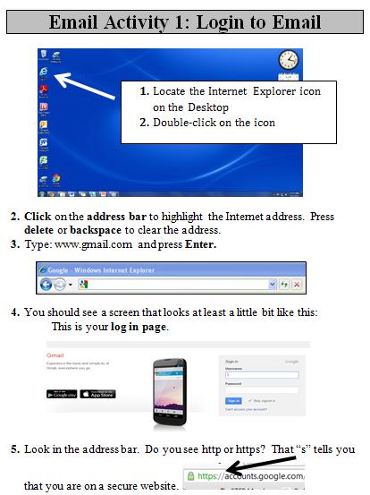
If some students still have a lot left in their assessment, go ahead and give learners the log-in handout and have them follow it. (There is a bar on the test screen which shows how many questions have been completed out of the total questions)
If students are done by 7:45, go through the steps together, focusing on the bolded vocabulary words.

ALL TOGETHER OPTION
Step 1: Open Internet Browser
Ask learners what the first screen they see when they turn their computer on is called: desktop
Ask learners what type of software provides access to the internet: internet browser
Ask learners for an example of an internet browser: internet explorer, firefox or chrome
Instruct learners to open the browser they prefer, explain that Internet Explorer is what will be used by the teacher

Step 2: Where does the URL go versus email address
Write the following on the board, and leave them on the board for Step 3
- www.gmail.com
- mnliteracy@gmail.com
- www.mnliteracy@gmail.com
Ask learners to hold up 1 finger if one is the right answer, 2 if 2 is and 3 if the third option is correct
Explain that students should not call out answers, they simply need to hold up 1,2 or 3 fingers
Ask which one is an email address? Which one is a web addres?
Ask how they know
Ask where the URL goes? Address bar
Ask learners what URL they should plug in to get to their Email address? What is their email service provider? Gmail.com
Instruct learners to go to Gmail.com

Step 3: Username and password
Point out the email address that was written on the board in step 2
Ask learners which part of the email address is the username-mnliteracy
Ask learners where the username needs to be typed
Ask learners what else is needed to log into their email address- password
Instruct learners to log into their email using their Username and Password

Step 4: Inbox
Ask learners where they are now? Inbox
Explain that when users log into their email, the first place they will go is their inbox
What is in the inbox? Received emails, read and unread

****If you have to simply give students the worksheet and there is extra time at the end of class, go through the steps again and really focus on the vocabulary words for today.
North Star How-To
Teacher A- Generating Codes:
- Go to https://www.digitalliteracyassessment.org/admin
- Login information:
- PLEASE SEE YOUR SITE COORDINATOR FOR NORTH STAR LOGIN INFORMATION!
- Select your name from the drop-down menu
- Click Submit
- Click on Generate User Codes
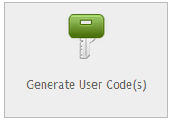
- Simply type in students’ names and a click enter
- The code next to their name will be used to register their computer
Teacher B- Registering each computer:
- Turn on student computers
- Go to digitaliteracyassessment.org/assessment/proctored
- Username: SEE YOUR SITE COORDINATOR
- PIN: SEE YOUR SITE COORDINATOR
- Type in student’s name and then enter the code you got from Part 1
- Click Confirm and Start
- Minimize the page
- Instruct students not to close out of any programs you have opened on their computer
Note: As you spend more time in the classroom you get to know the students who show up early and who show up late. Register the students who usually show up early as soon as you arrive, that way they can begin typing as soon as they get to class.

Day 2 Warm Up
- What is your e-mail address?
Be sure to include your username, the @ sign, and the e-mail service. Example: joe55@gmail.com
- What is your user name?
The username is the first part of your e-mail address (the part before the @ sign). Example: joe55
- What is your password?
This is the secret code that gives you access to your e-mails. It’s similar to a PIN number for an ATM. Example: hockey2323
- What is the web address of your e-mail service?
This is the place where you access your e-mails online.

Day 2 Warm Up
- What is your e-mail address?
Be sure to include your username, the @ sign, and the e-mail service. Example: joe55@gmail.com
- What is your user name?
The username is the first part of your e-mail address (the part before the @ sign). Example: joe55
- What is your password?
This is the secret code that gives you access to your e-mails. It’s similar to a PIN number for an ATM. Example: hockey2323
- What is the web address of your e-mail service?
This is the place where you access your e-mails online.

Email Activity 1: Login to Email

- Locate the Internet Explorer icon on the Desktop
- Double-click on the icon

- Click on the address bar to highlight the Internet address. Press delete or backspace to clear the address.
- Type: www.gmail.com and press Enter.
- You should see a screen that looks at least a little bit like this:
This is your log in page.
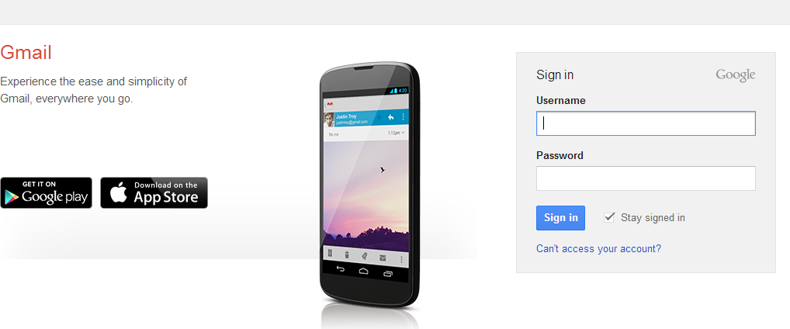

- Look in the address bar. Do you see http or https? That “s” tells you that you are on a secure website. 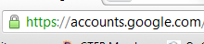
- Enter your username into the appropriate box.
- Enter your password into its appropriate box. Do you ever tell people your password? No. Never.

- Once you have typed in your username and password correctly and accurately click signin.

- If you have put all of your information in correctly, you should see this screen:

- This is called your inbox. It is where you see all of yor received emails, both read and unread.

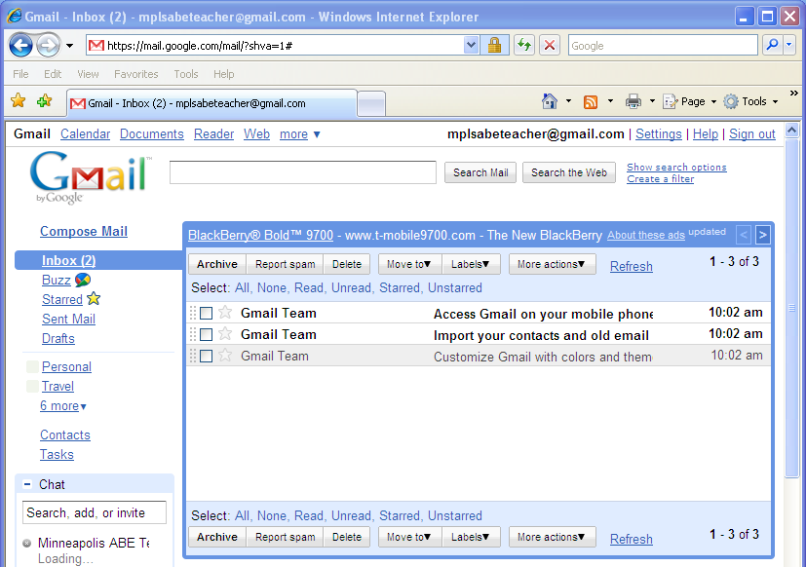
BOLD emails=unread

Emails that have been read use regular text.

- New messages are listed in bold.
- Click on the bold messages (unread messages) to open them.
- When you are done looking at an email, click on Inbox. This will take you back to the screen we started at.

- Now we need to sign out. Always sign out of email when you are done. Look in the upper right corner for your email address.

- Click on your email address
- Click on Sign out

