**Computer Instructor Training Optional Outline**

This outline is meant to be used after a volunteer has been interviewed and is now joining the classroom. It is assumed that the coordinator already provided the following information: how to find curriculum online, how to write lesson reports, and a tour of the facilities.

**Day 1: Observe**

*Before Class:*

1. Locate the **Computer Curriculum Binder**
2. Pull out and Read through **Curriculum FAQ’s**
3. Take out **Volunteer Manual** and look through **Basic Class Info and Teaching Tips**

*First hour:*

1. Observe instructors, fill out **Observation Form**

*Second hour:*

1. Locate a pair of headphones and grab a computer
2. Go to digitalliteracyassessment.org/admin

Ask your coordinator for log in information

1. Look for "Click here to launch the training"

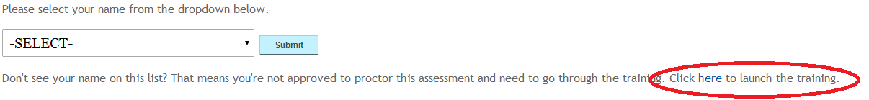

1. Go through training.  There is a quiz at the end, so you do need to pay close attention
2. When finished with training, go to digitalliteracyassessment.org
3. Take an assessment or two, they provide insight into what students will be learning and why
   * **Note:** It is best if you take the assessment that relates to the class being taught. Doing so before each unit is a great tool for preparation.

**Day 2: Assist**

*Before Class:*

1. Locate the Computer Volunteer Manual (inside there is a plethora of information)
2. Look over Daily Volunteer Checklist
3. Trained in on how to use copier/how to determine what needs to be copied for lesson
4. Look over lesson plan with co-teacher, if there is an activity you feel confident instructing, GO FOR IT! Make sure to discuss it with your co-teacher

*During Class:*

1. Circulate the room while co-teacher is instructing
2. Assist students who are falling behind
   1. Instead of doing tasks for them, ask them leading questions “What are we trying to do” “Where are we trying to go”

**Day 3: Teach**

**Note:** If you are feeling nervous about taking over, go ahead and take another week to assist in the classroom if possible. But by week 4 you should take over at least half of class instruction, unless otherwise discussed with coordinator and co-teacher.

*Before Class:*

1. Locate the Computer Volunteer Manual-inside there is a plethora of information
2. Look over Daily Volunteer Checklist
3. Discuss roles with co-teacher and determine who will teach what, as new instructor be sure to pick activities you feel most comfortable with
4. Make necessary copies

*During Class, Teaching Tip:*

1. Be sure to remember to explain context of why you are teaching a specific skill, demonstrate that skill a couple of times with students watching, do the skill as a class and then let students practice in their own. The more modeling you do, the more successful the learners will be when they work independently.