**Ellii Orientation for Learners**

*The Digital Learning Team is here to help!* [*support@mnabedistancelearning.zendesk.com*](mailto:support@mnabedistancelearning.zendesk.com)

Here are some skills that learners will need to master in order to **successfully use Ellii for distance learning** and **to fully benefit from the platform’s built-in tools**:

* Open an **internet browser** (there is no Ellii app).
  + On iPhones and iPads, **Safari** is recommended (not Chrome).
* Navigate to [**ellii.com/students/login**](https://ellii.com/students/login)and [make a bookmark](https://digitalskillslibrary.org/bridges-interactive/gateway-skills/gateway-skills-skills/ef-3/), favorite, and/or add a shortcut on the home screen.
* Know and remember your **Username + Password** for Ellii, and differentiate between login details for Ellii and those for other platforms.
  + If learners have Gmail/Google accounts: Use “Log in with Google.”
  + Reset your password if you forget it (only for learners with email).
* Select **Ellii** (for teacher/class assignments) or **Ellii Solo** (self-selected content).
* Navigate to the correct **Ellii Class** and find assignments (current vs. past).
* Navigate **Ellii Solo** to find, select, and continue self-study materials.
* Complete different types of activities:
  + Find and read **Instructions**
  + Basic navigation - access the **menu**, use **arrows** to advance or go back
  + Flashcards and picture dictionaries
  + **Matching** words with images or definitions - Example handout for learners
  + **Play** audio
  + **Record** yourself speaking
  + **Type** words in a text field
  + Choose **“Review answers”** and/or **“Try again”** to see feedback or make corrections
  + Start/stop video, rewind/fast-forward, make fullscreen/exit fullscreen
  + Use Ellii’s immersive reader
* Understand digital tasks vs. PDF-only activities (PDF-only activities are not interactive. Teachers will not be able to see learners’ work. ***Time-on-task is NOT recorded***.)
* **Log out** when finished, especially if using a public or shared device.

Page 4 of this document is an example handout for intermediate-level learners. It shows how to join a class, create an account with your email address, and how to do a matching activity. Feel free to make a copy and modify it for your context. Obviously, please change anything highlighted in yellow to fit your own class!

# 💡 Tips for Beginning Learners 🪜

Beginning-level learners will likely need a lot of **individual coaching and support** to successfully use Ellii independently.

* **Don’t do it alone.** As much as possible, collaborate with colleagues and volunteers to make a plan for onboarding learners across your program or site. Get lots of “helpers” involved! Consider how you might leverage the multilingual skills of support staff, volunteers, or more experienced learners who can provide support in learners’ home languages.
* **Prioritize!** Create a learner account for yourself and explore various Ellii assignments and/or Ellii Solo activities. Select just one or two things to teach first. Let learners build confidence with one type of activity at a time. Add additional activities one by one.
* **Practice, practice, practice.** To avoid overloading learners, work 1:1 to teach and practice the steps to “log in” and “log out” (you can substitute “start/end,” “begin/finish,” or other familiar phrases if helpful). Expect to review the steps multiple times. Rome wasn’t built in a day! Be patient and remember to celebrate all the small successes.
* **Colors and icons**: Pre-beginning learners can learn colors instead of words like “log in” or “next.” Teach learners to recognize the **yellow** log-in rectangle, or the **blue** Ellii Solo tab.
  + Other examples: Ellii content (teacher assignments) and the "next" button are both **yellow**. Lesson previews tend to have a primary color scheme.
  + Teach learners to attend to **common icons**, including arrows, buttons for playing and recording audio, the question mark for instructions, and the “magic wand” to submit your answers.



* **Key vocabulary**: Consider which additional vocabulary terms you will need to teach for learners to navigate the site and complete tasks. Examples: *materials, lesson, start, click, read, listen, type, record*
  + The [Digital Skills Glossary](https://digitalskillslibrary.org/glossary/) may be a useful resource, particularly the [Mouse & Keyboard](https://docs.google.com/presentation/d/1gxmw5o0jr3WHn9iSXDxmsQcBiwYMfM-O39St5qXDW5E/edit?slide=id.g2132892b06c_1_121#slide=id.g2132892b06c_1_121) and [Navigation](https://docs.google.com/presentation/d/1gxmw5o0jr3WHn9iSXDxmsQcBiwYMfM-O39St5qXDW5E/edit?slide=id.g2132892b06c_1_139#slide=id.g2132892b06c_1_139) categories.
* **Peer support**: High-beginning or experienced students who share a language group can act as classroom aides, grounding new students into the routines. Make sure to REINFORCE the routine. Consistency and repetition build confidence!
* **Translation tools**: It’s perfectly fine to access instructions in a language other than English! The login page is available in several languages:



These built-in translations are only available for logging in and creating a new account. However, do learners have other tools or apps that they can use? Encourage them to use these resources as needed to access and navigate the Ellii platform.

* Consider having learners take the **Ellii Solo Placement Test in person**, with support from staff or volunteers. This will help learners become familiar with the platform and common types of tasks. When the test is completed, the platform will “suggest” activities at the learner’s level.
  + If you do this during class time, be sure to take attendance as if learners “left early” to avoid double-counting time in SID. Also be aware that the test includes audio, so learners will need to use headphones or work individually.

Perhaps most importantly, **cultivate and model curiosity and a growth mindset**. If one approach isn’t working, what else could you try?

It might feel as though you are “wasting time” teaching learners how to use a website, but try to shift your thinking. Consider how many logins to various platforms, portals, and apps you must manage in your own personal and professional activities. By taking the time to support learners with Ellii, you are empowering them to access additional learning outside of class time. You are also building transferable digital skills and resilience, which will serve learners well both in and out of school.

**Sample Learner Handout**

**You can do homework on ellii.com**

**You must create a student account.**

1. Use your phone’s **camera** to scan the code and go to the website.

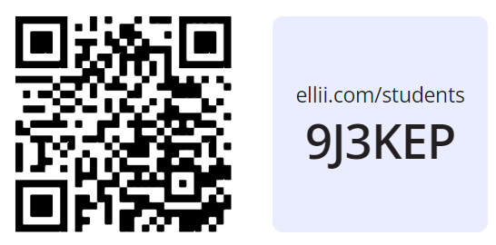

1. Choose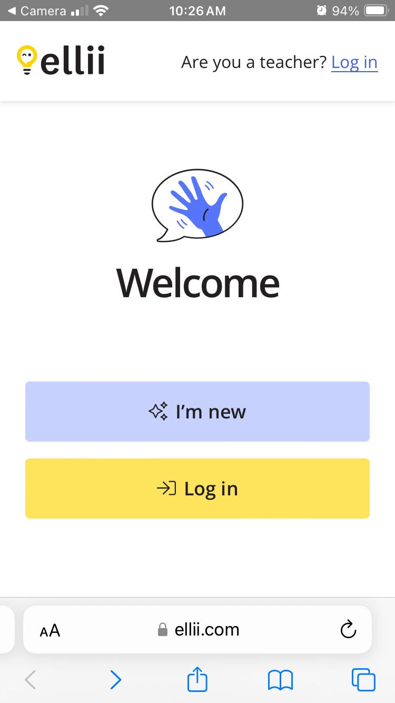
2. Choose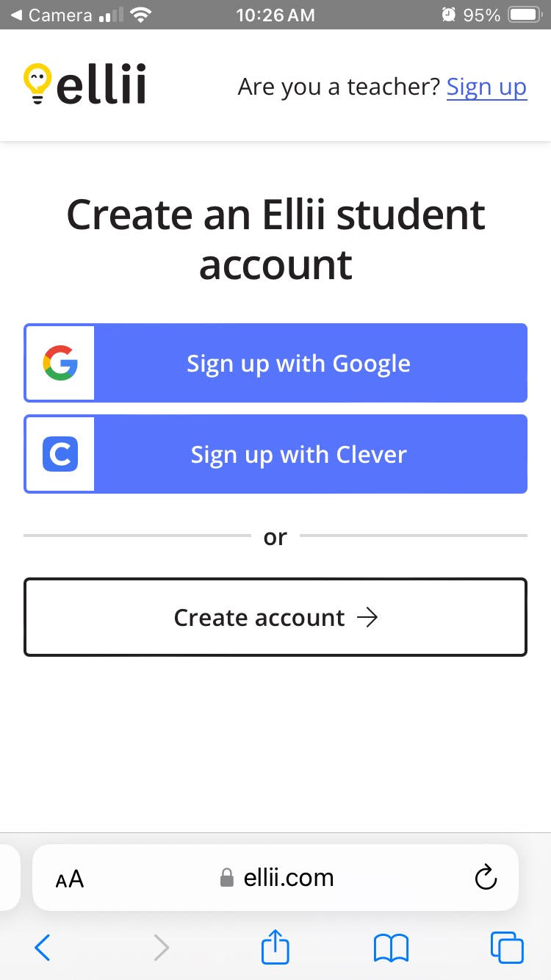
3. Type your **first name** and **last name**.
4. Use your **school email** (@isd191.org).
5. Use the same **password** that you use for **MobyMax**. Talk to Elizabeth if it does not work.
6. Put a **checkmark ☑️**  in the box. Choose **Join class**.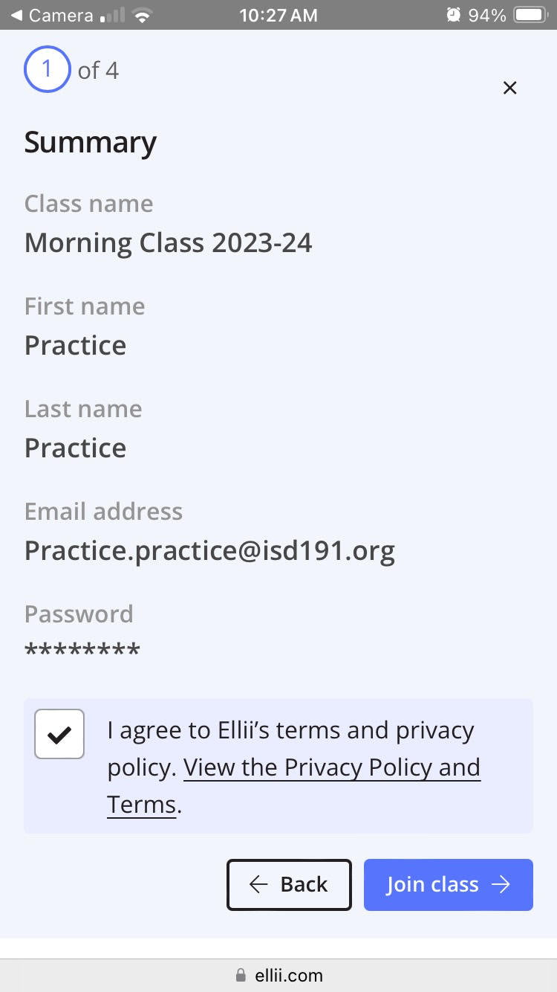

**How to Do Activities in Ellii**

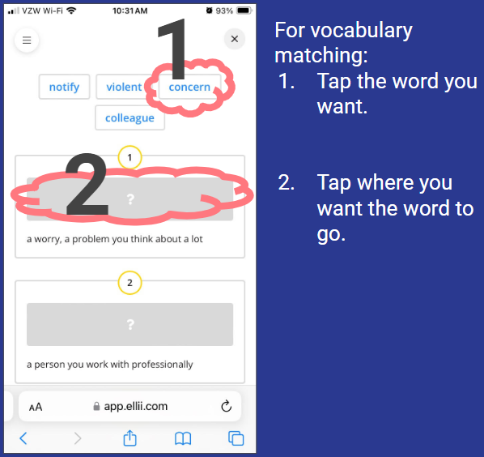

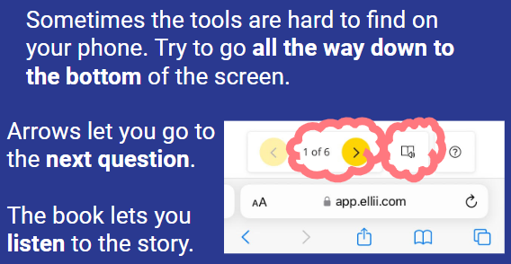

**Additional Ellii Resources**

# Getting Started

* [Take a tour of Ellii](https://youtu.be/ENQK5YaCyiY?si=v399H3gKAnK3cc1D) (3-minute video)
* [How to join an organization account](https://youtu.be/z8UiyK-whEw?si=lzwh2fHAit35hbcu) (90-second video)
* [How to Use Ellii: Teacher Training Module](https://help.ellii.com/article/212-how-to-use-ellii-teacher-training-module) - series of videos with links to related tutorials
* Ellii Bot (AI-assisted scoring for writing and speaking tasks) - [6-minute video](https://youtu.be/rtLIzmA29Xw?si=CMNooKx8WNdf0o2O) and [blog post](https://ellii.com/blog/ellii-bot-just-got-smarter)
* [Teaching with Ellii](https://ellii.com/blog/categories/teaching-with-ellii) blog posts, [Weekly Newsletter archive](https://ellii.com/blog/ellii-weekly-newsletter) (What to Teach This Week), and [Lesson Plan Calendar](https://help.ellii.com/article/54-how-to-use-lesson-calendar)

# Ellii Solo

* [For Teachers](https://help.ellii.com/article/295-how-to-use-ellii-solo-teachers) - tutorial
* [For Students](https://help.ellii.com/article/294-how-to-use-ellii-solo-students) - tutorial

# Additional Videos

* [Playlist](https://youtube.com/playlist?list=PLP0N5nuiA3aM_OP18M7G9XSYjXigIuunA&si=4akMKb3lb4UoQTDP) of Ellii Features and Tools - 80+ short videos for learners and teachers
* [Drag, Drop, Teach webinar](https://youtu.be/1ZeOTiexGtM?si=FihJL0AfA70G2eae) (1 hour) - how to use Ellii’s lesson planner and customize assignments for your learners
* [Allied Healthcare Career Pathway content in Ellii webinar](https://youtu.be/vMlFNOxnhwg?si=LllqliKc6b00Ew3R) (1 hour)
* [How to use Ellii Dilemmas](https://youtu.be/Kte1oAeUYwE?si=7SG52DHZjSKjtUEu) (12 minutes) - new feature as of 2025
* [How to use Ellii Polls](https://youtu.be/8HylceqW6ws?si=EtdvjtNRLmx2KoQo) (8 minutes) - new feature as of 2024
* [Finding CASAS Content](https://help.ellii.com/article/177-how-to-find-filter-casas-content) - tutorial
* [All videos](https://www.youtube.com/@elliiteachers/videos) from Ellii for Teachers

# Roster Management (if using Ellii for distance learning - please consult with your manager/coordinator)

* [Making student accounts (manually)](https://youtu.be/Sfm5Qhpjk_w?si=E2V55-ycmZY5Yn--)
* [Archiving students](https://youtu.be/Han6TG4Pqts?si=Ah9LlpJP84knrABx)
* [Archiving classes](https://help.ellii.com/article/257-how-to-archive-or-delete-classes)

# Reporting

* [How to use the reports tool](https://youtu.be/MpFdjE8nsv0?si=xPtWvBgoMVr2xXB8) for assignment scores and time-on-task (2-minute video)
* [Step-by-Step Guide to Ellii Reports](https://drive.google.com/file/d/1YQtPUvIBvXYJpLfHp94k_V_pQLLnU49f/view?usp=drive_link) for DL Proxy Hours