Proxy Hour Reporting Guidance for

Edmentum Courseware and Exact Path

July 2025

* The new Learner Daily Usage Reports are less than ideal for adult education. The Contact Hour Summary Report is no longer available. The Statewide DL Team is working with Edmentum, and we hope that the proxy hour reporting process can be simplified in the future.
* For now, there are three different reports you may need to run:
  + **Courseware Learner Daily Usage Report PDF file** – This report provides time on task in Courseware courses, but not in Flex Assignments or Exact Path.
  + **Exact Path Learning Path Progress Report PDF file** – This report provides time on task in Exact Path, but not in Courseware courses or Flex Assignments. (The CSV file is also acceptable if you prefer this format.)
  + **Courseware Learner Daily Usage Report CSV file** – This report provides time on task in Courseware courses, Flex Assignments, and Exact Path. *This report is not recommended unless learners are using Flex Assignments*.

# **Courseware Learner Daily Usage Report PDF file**

[**Follow these steps**](https://scribehow.com/shared/Edmentum_Courseware_Learner_Daily_Usage_Report_PDF_steps__L8Y1P5XyTUK5UOOr-kppSQ) to access this report **via your Courseware tab**, not the new Account Management tab.

Use the Total Time on Activities from the top of each learner’s page. Round to the nearest whole minute. Enter this time in the [Time-on-Task Platform Spreadsheet](https://www.literacymn.org/sites/default/files/2021-01/mn_abe_dl_proxy_hour_formula_revised_5.2019.xlsx) to calculate the additional 25% time to enter in SID.

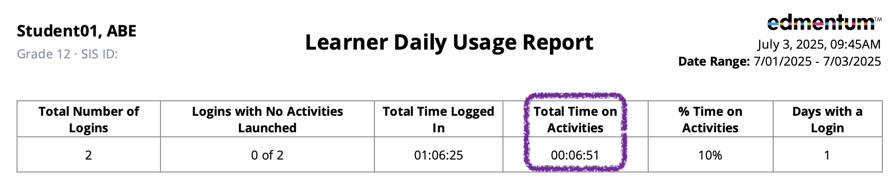

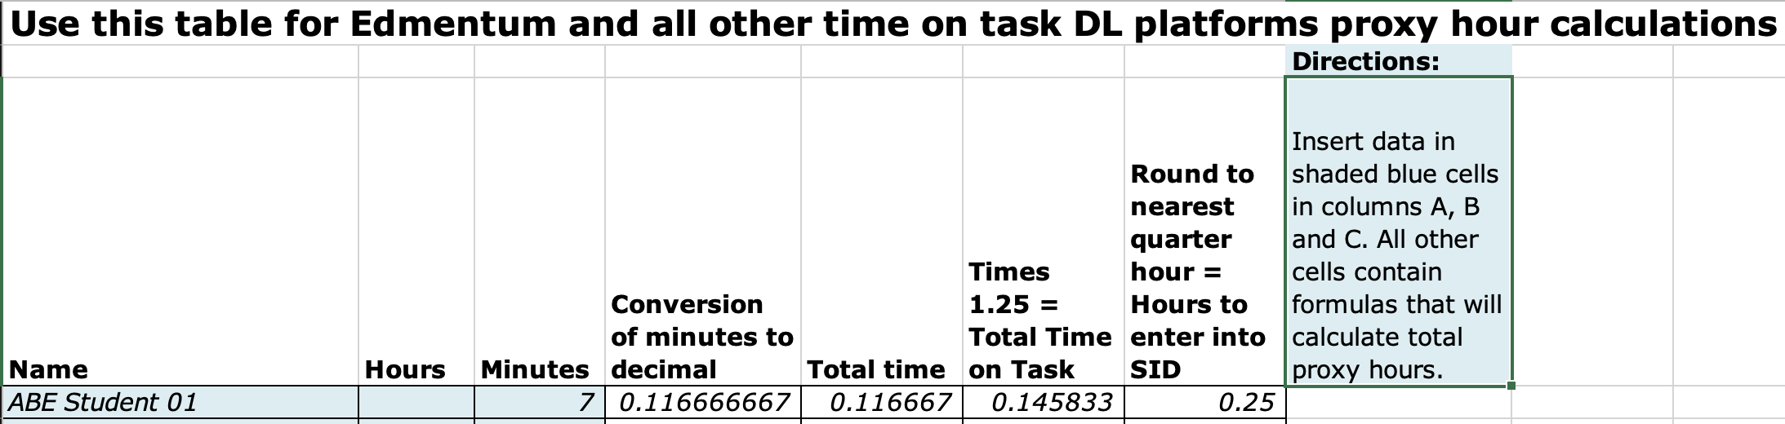

# **Exact Path Learning Path Progress Report PDF file**

This report **has not changed** significantly.

[**Follow these steps**](https://scribehow.com/shared/Edmentum_Exact_Path_Learning_Path_Progress_Report_PDF_steps__Brzh0nqDQvWlegyZ9ub21g) to access this report **via your Exact Path tab**, not the new Account Management tab.

In most cases, you should use the time from the "Time on Task - Learning Path" column. Round to the nearest whole minute. Enter this time in the [Time-on-Task Platform Spreadsheet](https://www.literacymn.org/sites/default/files/2021-01/mn_abe_dl_proxy_hour_formula_revised_5.2019.xlsx) to calculate the additional 25% time to enter in SID, as shown above.

If you can verify that learners completed one or more **diagnostic assessments** in Exact Path during the date range for the report, it is acceptable to use the "Total Time On System" column. However, if learners are also using Courseware, you must SUBTRACT any time that learners spent working on Courseware activities.

Please check with the learners' teacher(s) and/or the learners themselves if you are unsure. The diagnostic assessments can be very time-consuming, but this time is not captured in the "Learning Path" column of the report. The goal is to allow ABE programs to count the time that learners spend on these assessments without double-counting time spent on Courseware activities or counting excess time logged in to the platform with no activity.

When learners use both Courseware and Exact Path, you may choose to combine the time in both areas and enter it in a single day in SID. You may also choose to enter the Courseware time on one day and the Exact Path time on a different day.

# **Courseware Learner Daily Usage Report CSV file**

This report is only recommended if learners are working on **Flex Assignments** in Courseware. All time spent on Edmentum (Courseware courses, Flex Assignments, and Exact Path) is included, but additional data manipulation is required.

[**Follow these steps**](https://scribehow.com/shared/Edmentum_Courseware_Learner_Daily_Usage_Report_PDF_steps__L8Y1P5XyTUK5UOOr-kppSQ) to access this report, except **in step 17 you will select CSV** instead of PDF.

When you open the CSV file, it will look something like this:

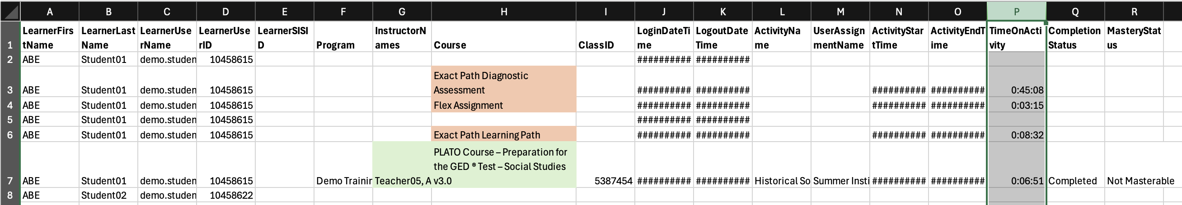

Each login and activity for each learner appears as a new row. One learner may have many rows. Each row shows only the time spent on that login and activity (column P). **The total time on task for each learner is not included**. Also note that the course and activity information (columns G-I and L-M) will only be included for Courseware course activities. The orange highlighted information shown in Column H was manually added and did not appear in the original file.

Now the real fun begins!

1. Download [**this spreadsheet template**](https://docs.google.com/spreadsheets/d/1TZVw9oaQNGmIet-Ap6MG8J73abOKNtzT/edit?usp=sharing&ouid=108175558245748788804&rtpof=true&sd=true). You will probably want to download it as a Microsoft Excel file instead of using it as a Google Sheets file.
2. Copy and paste your learners’ data, **columns A-R**, into the “EdmentumJuly2025” tab.
3. If you have more than 600 rows of data, you will need to copy and paste the **formulas from columns S and T** into the additional rows.
4. Click in any cell of your learners’ data.
5. In your Excel ribbon, go to the Insert tab.
6. Click **Pivot Table**.
7. Choose **From Table/Range.**
8. Select **New Worksheet** (will create a new tab in your spreadsheet) or **Existing Worksheet.**
9. 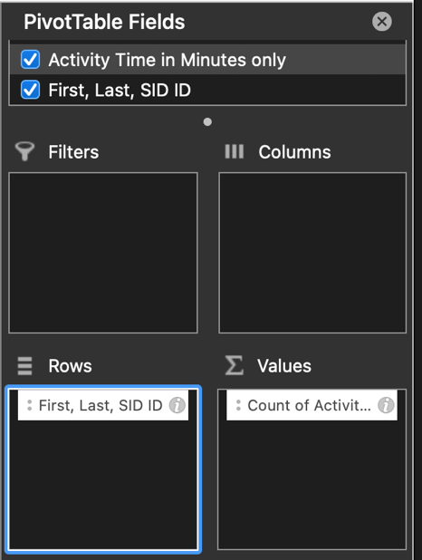Click **OK.**
10. For the Pivot Table Fields, choose **“First, Last, SID ID” (column T) for the Rows** and **“Activity Time in Minutes only” (column S) for the Values**.
11. The pivot table is probably wrong! Don’t worry, you can fix it. Select the cells in the Activity Time column, then right click (PC) or Control+click (Mac). Go to **“Summarize Values By” and select Sum**. 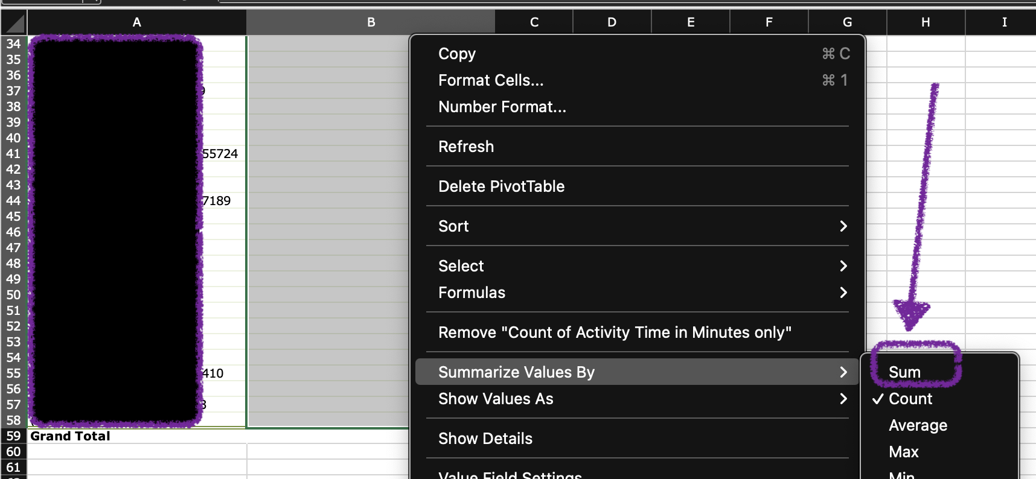
12. Your pivot table should now show one row for each learner and their total time on activities. Copy and paste the learner names/SID ID numbers and total minutes from your pivot table into columns A and B on the **SID Hours tab**.
13. Enter the hours shown in column E in SID. A screenshot of a calculator

    AI-generated content may be incorrect.