1. usalearns.org
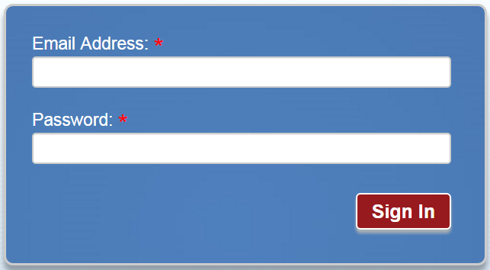
2. 

3.

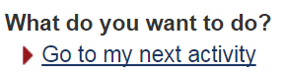
4.

1. usalearns.org
2.

3.

4.

