USA Learns Examples: Completing Every Activity
This page is NOT COMPLETE. The student did not finish #5. They will not get credit for this page. You must complete every activity on the page.

This page is COMPLETE. The student will get credit for it. Good work!
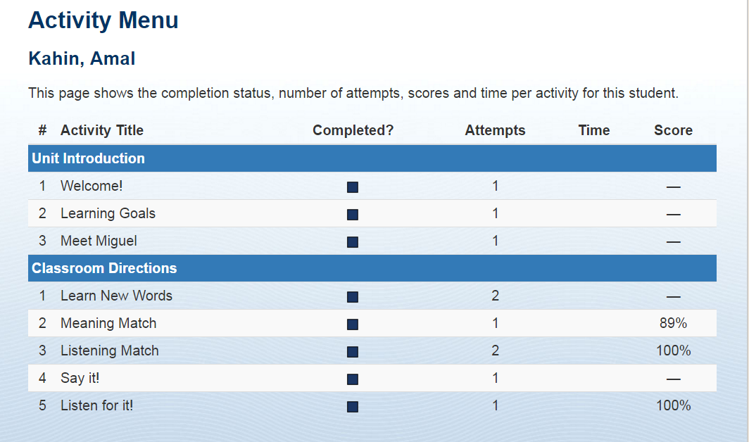

USA Learns Examples: Earning Proxy Hours
In USA Learns Course 1 students receive 3 proxy hours for every completed unit.
(Course 1)
3 hours
3 hours
3 hours
3 hours
3 hours
NO CREDIT
3 hours
3 hours
3 hours
3 hours
3 hours
3 hours
NO CREDIT
3 hours
3 hours
NO CREDIT
NO CREDIT
NO CREDIT
NO CREDIT
NO CREDIT

In

In USA Learns Courses 2 and 3, students receive proxy hours for every completed lesson. Course 2: 5 hours per lesson, Course 3: 2 hours per lesson.
(Courses 2 and 3)
NO CREDIT
2 or 5 hours
2 or 5 hours
2 or 5 hours
2 or 5 hours

