

Start Date: ______________

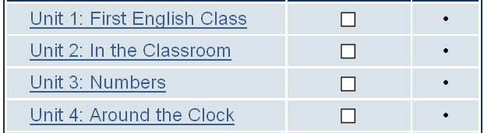 Date to be finished: ____________
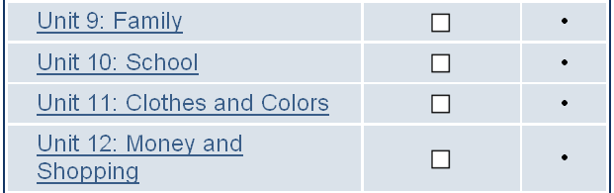
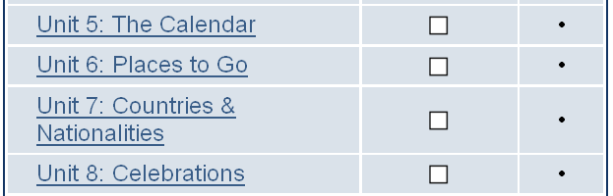Date to be finished: ____________

Date to be finished: ____________

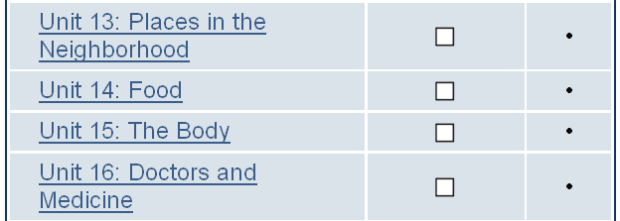 Date to be finished: ____________

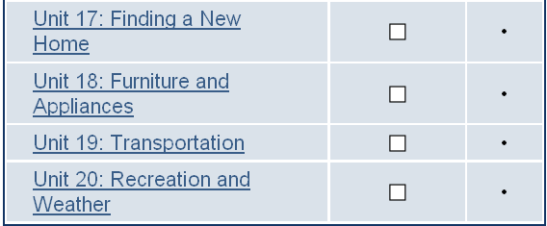 Date to be finished: ____________

