Pulling a Student’s Individual Score Report
- Go to www.accuplacer.org. Login with your Site Score Reporter credentials.
- Click the “Reports” tab.
- As with locating an open test session, there are many options here for locating the student’s score report. However, if any information you enter does not match exactly with what the student entered when they took the test, their results will be excluded. For this reason, using only a date range is the most effective way to find the correct report. The default is to search during the past 30 days, and you may just leave it at that.
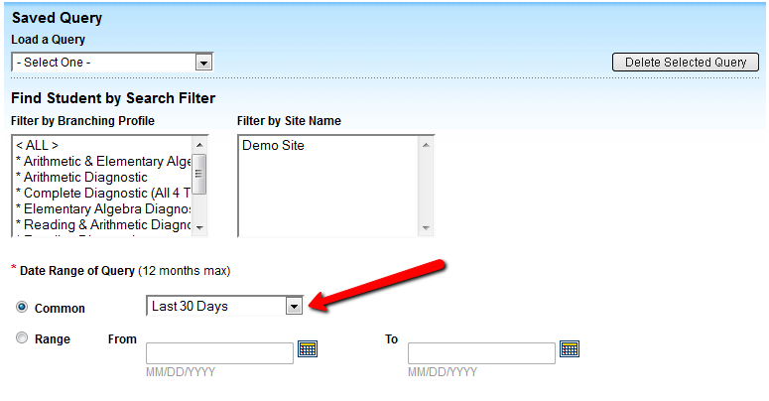
- Choose which information you want to print on the student’s score report. Possible items are listed on the left; items you have chosen are listed on the right. Click an item in the left column and then click the right arrow to add it; click an item in the right column and then click the left arrow to remove it.
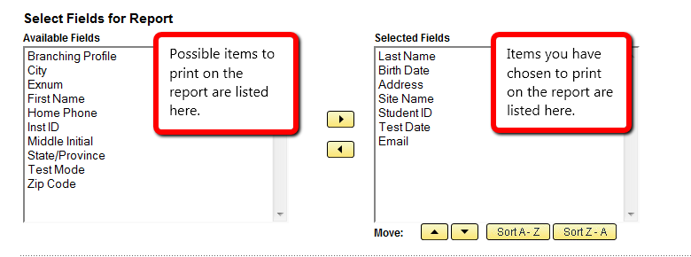
- The “Score Report Settings” can be left at their default values. Skip this section and scroll down to the bottom of the screen.
- For this type of report, saving the query isn’t necessary. So you can also leave this box blank.
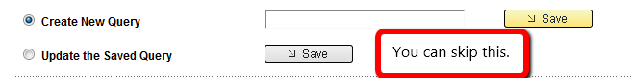
- Click “Submit.”
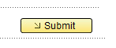
- Results that match your search criteria display on the page. Scroll and/or page through these to find the one you are looking for.
- When you’ve located it, click “View.”
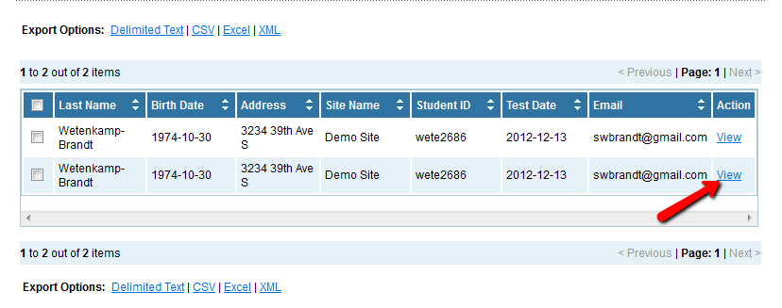
- The report will display on-screen just as it did when the student first finished his/her test. You can print it or use the Learning Path information at the bottom of the report to register the student for My Foundations Lab.

