Accuplacer Diagnostics
Diagnostic Testing Process
1. Sit down with the student at the computer where he/she will take the test. Go to www.accuplacer.org and login with your Proctor credentials. Close the pop-up “announcements” window if necessary.
2. Click “Administer Test” on the left side bar.
3. Click “Administer New Test Session.” (Or, if you are working with a student who started a test previously, but was unable to finish and saved his/her progress, choose “Manage Test Sessions.” See page 6 for information on how to restart an open test.) You will see a screen like this: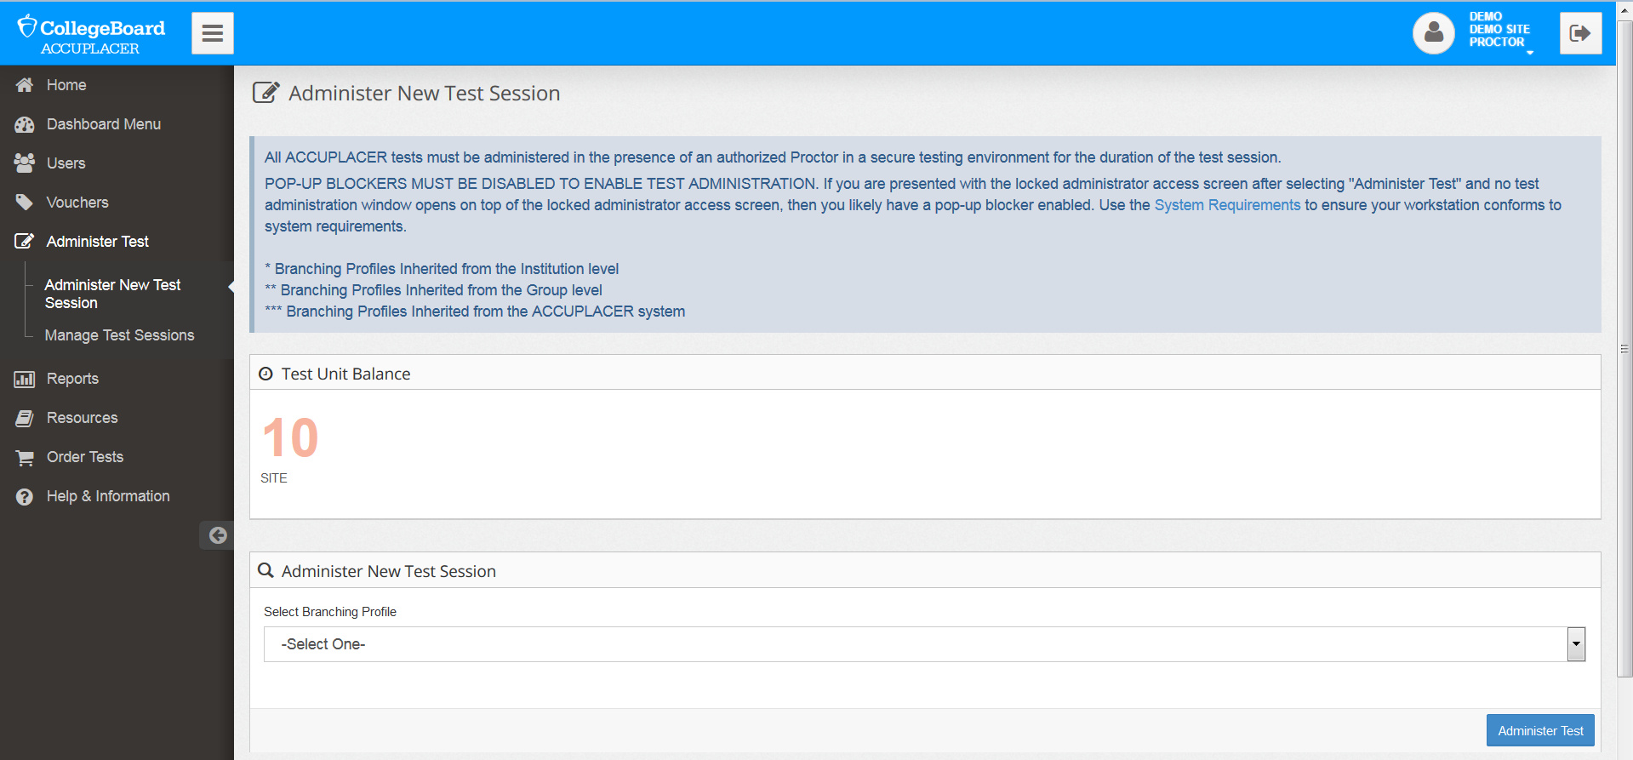
4. Under “Test Unit Balance” check to see that you have sufficient test units to administer the test(s) for this student.
5. From the list of “branching profiles,” choose the test or set of tests that you will administer. As an ABE practitioner, you only have access to Diagnostic tests, not to Placement tests that are used on college campuses.
6. Click the “Administer Test” button. The test opens in a new window. If you have a pop-up blocker operating, it will block this window. You’ll need to set the browser to allow pop-ups from accuplacer.org or disable the pop-up blocker entirely.
7. Turn the computer over to the test-taker. He/she will need to accept Accuplacer’s privacy policy by clicking the “Accept” button.
8. “Student Instructions” opens in another pop-up window. Close this window after reading it.
9. The test-taker then completes a student information form. If your program does not use a Student ID, you can design an ID system or use the ID number generated by MABE/MARCs.
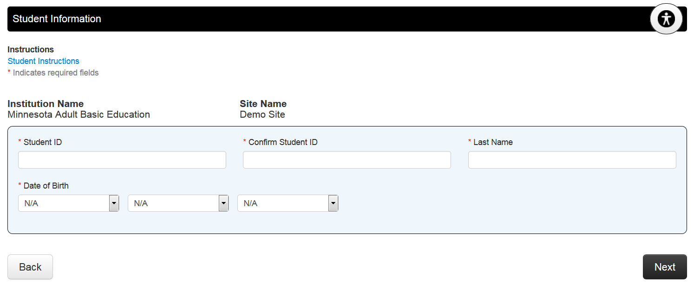
If this person has taken or started an Accuplacer test with your program previously, and the last name, student ID, and date of birth were entered identically both times, his/her identifying information will be displayed. Otherwise, this needs to be completed. Note the checkbox at the bottom of the page that allows the student to opt out of email messages from the College Board/Accuplacer.
10. A “Welcome” message displays with information about the Accuplacer and directions for taking the test. After reading this, the test-taker should click “Next” to begin. A set of directions for answering questions displays. When you are sure the student understands them, instruct the student to click “Start Test Session.”
11. The test begins with two sample questions. After the sample questions, the test proper begins. Each Diagnostic test has 40 questions. Questions are answered in three steps: choose an answer, click “submit,” click to “confirm” the choice. Here is an example:
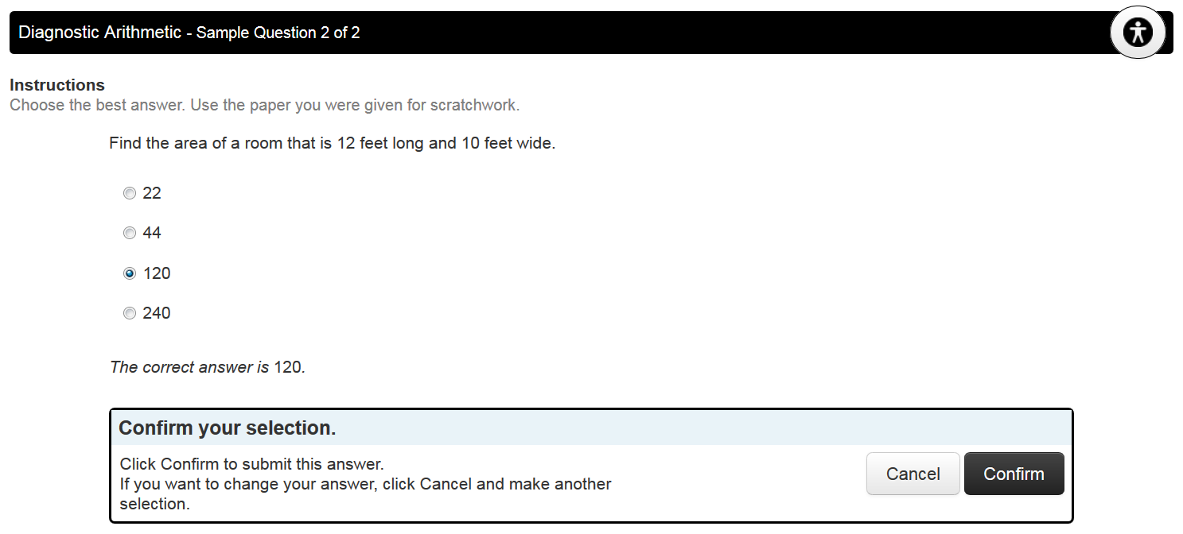
Test-takers should not navigate away from the test window while testing (to open another browser window or a different program). Doing so may lock the test out or prevent answers from being saved. This rule is to prevent test-takers from looking test answers up online.
On some math problems, an on-screen calculator is available for test-takers to use. You’ll see a calculator icon on the black bar above the question when a calculator is available:
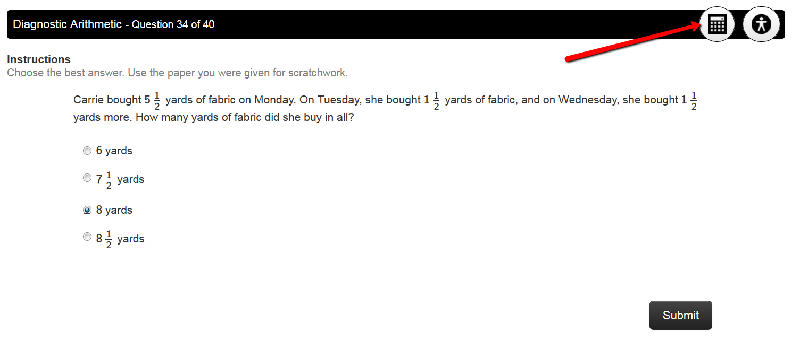
12. If you have chosen a “branching profile” that included more than one test, the second test will begin automatically after the test-taker has completed the first one. The second (and subsequent) test(s) begin with sample questions.
13. When the test-taker finishes all tests that were assigned, the student will receive a set of 6 background questions about his/her experience with Accuplacer, educational background, first language, employment status, and planned course of study. These questions are standardized across all of MN ABE and will be used to document which students we are serving.

14. When all tests and background questions are complete, the Proctor login window displays like this:
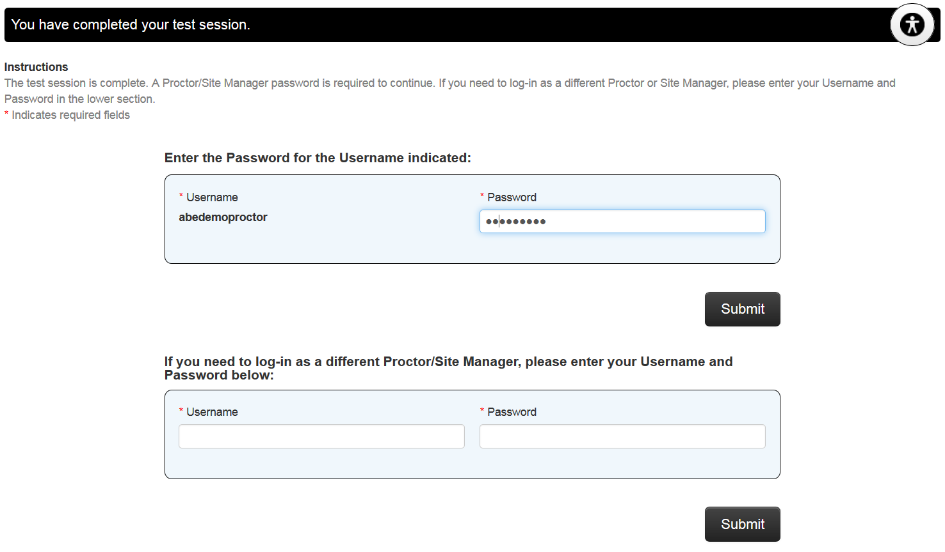
You (or another proctor) must enter your password to view the test results.

Test results will look something like this:
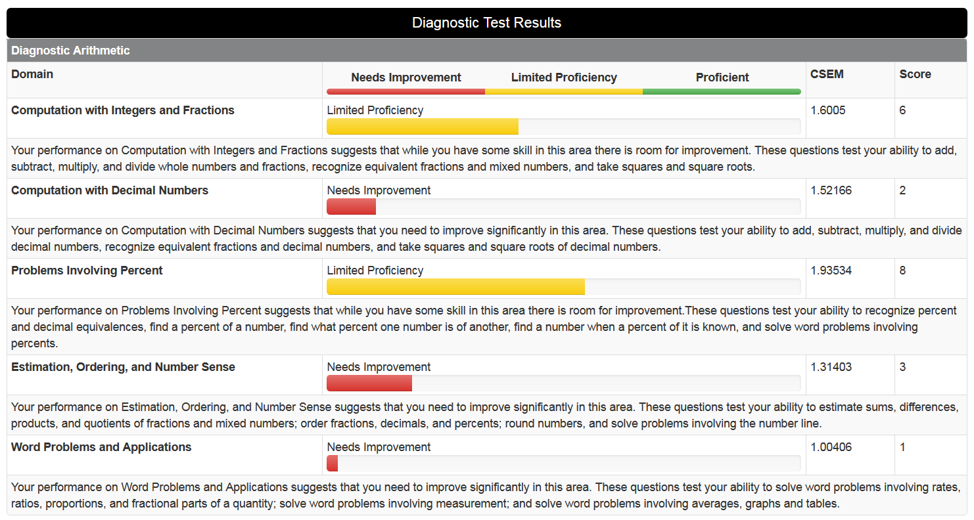
At the bottom of the results screen, you will see “Learning Path” information. This is necessary for creating an account on My Foundations Lab if you are using that online learning platform. You’ll need three different numbers: Access Code, Course ID, and Locator Code. Two are located on this report. The Access Code is NOT found here. Instead, you should have been provided a single Access Code by My Foundations Lab staff at Pearson. This Access Code can be used to enroll all your students.
The Access Code allows the student to set up an MFL account without purchasing a subscription (it accesses one of the subscriptions already paid for through ABE funding). The Course ID places the student in the correct site “grade book,” and the Locator Code accesses the student’s test results to create a personalized learning path in MFL.
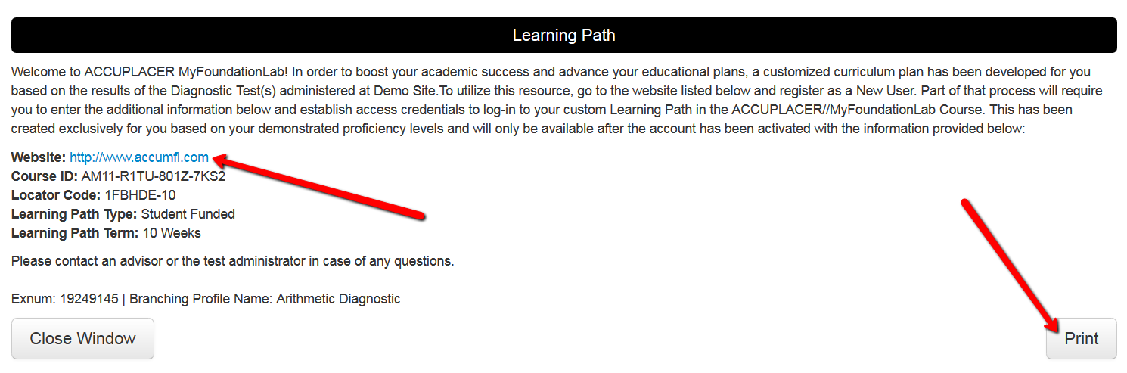
What to do when the test-taker needs to leave before the test is complete:
If the test-taker cannot finish the test during the time allotted, it is possible to save his/her progress and resume the test at a later date or time. To do this, the student MUST click the “Save and Finish Later” link in the upper right of the screen.
When the test-taker clicks this button, he/she will be asked to confirm.
Clicking “OK” returns the test-taker to the Proctor login screen. You (or another proctor) must return to the computer and enter your proctor password to save the test. Doing so places the test into the “Open Test Sessions” list. You can restart the test from this list when the student returns.

Restarting a Saved Test
When you need to resume a test that was incomplete and saved, begin by logging in as usual. From the “Administer Test” section on the left side bar, click “Manage Test Sessions.”
You will need to search to find the appropriate test session.
While there are many fields on this search page, completing more information is not better. If there is any discrepancy in the spelling of the student’s name, the ID number, the exact branching profile used, etc. the search results will exclude the test session you are looking for.
The best option is to search using only a date range. Choose a date several days before you think the student started, and leave the end date at the current date. This will display many results (if there have been many students saving tests) but you will be unlikely to miss the one you want.
Click the “Search” button and wait for the results to display. When you locate the one you need, click the “resume” link to re-open the test.
On occasion, teachers have experienced problems with saved tests not resuming where the student left off. This may happen if the student opened another browser window or another program (invalidating those test answers).

Registering a Student for My Foundations Lab
- Go to www.accumfl.com
- Under “Register Now,” click “Student.”
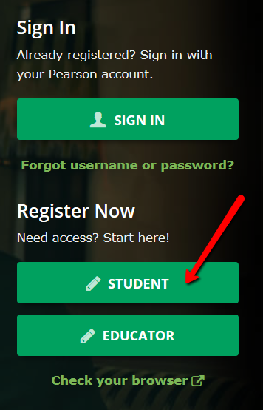
- Verify that you have all the necessary information to register the student.
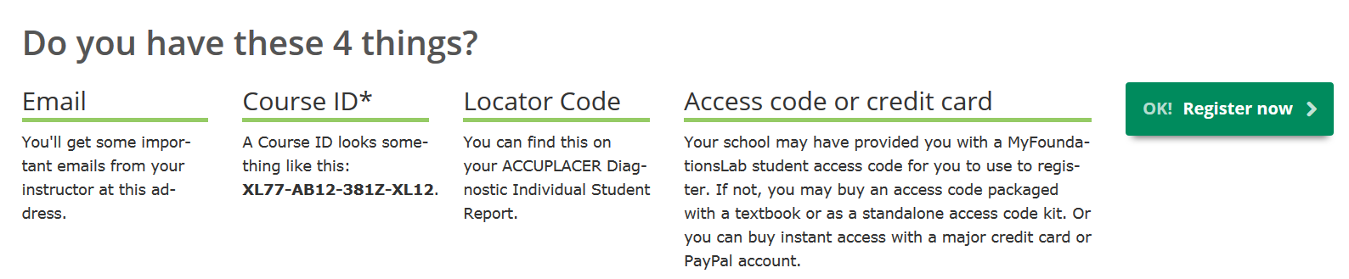
- If so, click “OK! Register Now.”
- Choose “Yes, I have an Access Code.” Click Next.
- Accept the privacy and license agreement.
- It’s unlikely that students will have an existing Pearson account unless they have used MFL previously. If the student is unsure, click the “Not Sure” option and enter the student’s email address to check whether an account already exists under that email address. Otherwise, click “No” and create a login name and password.
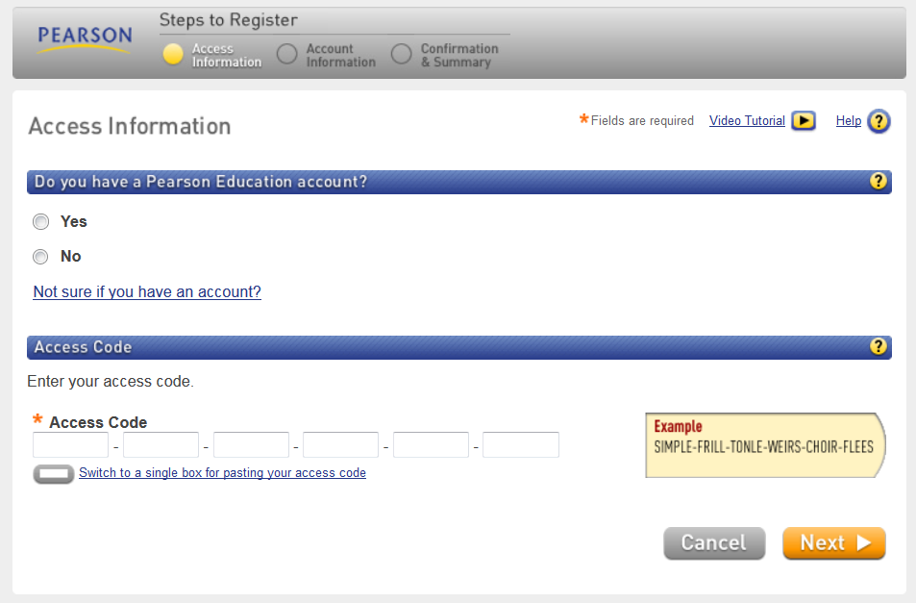

- Enter the Access Code you were given for My Foundations Lab and click “Next.”
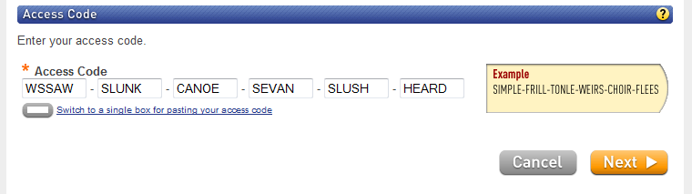

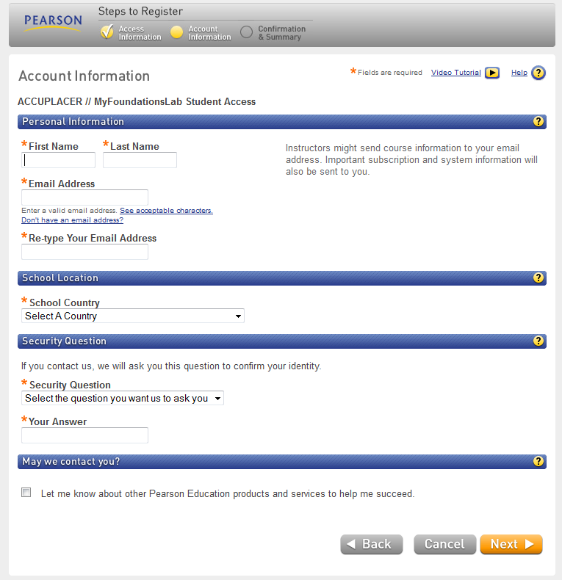
- Complete the Student’s profile and click “Next.”

- Print this page!
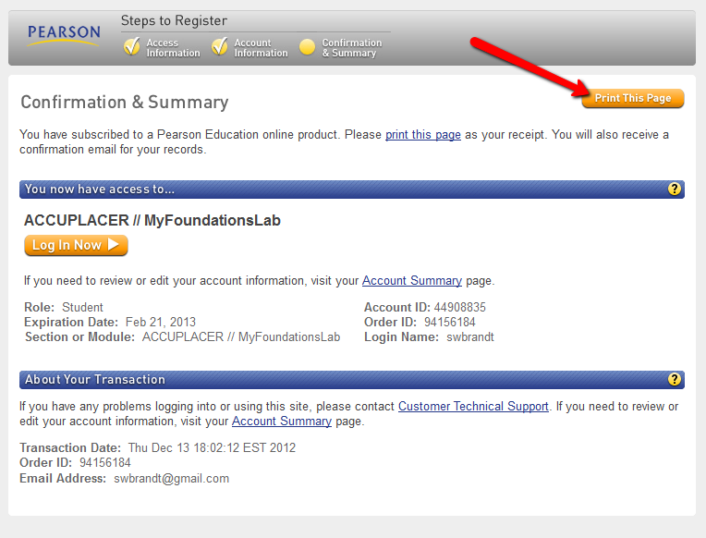
Click “Log in Now.” You’ll be redirected back to the first page. Click “Sign in” and enter the Login Name and Password you set up.
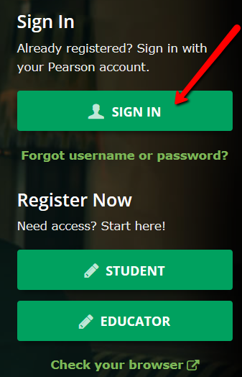
- Click “Enter ACCUPLACER/MyFoundationsLab.”
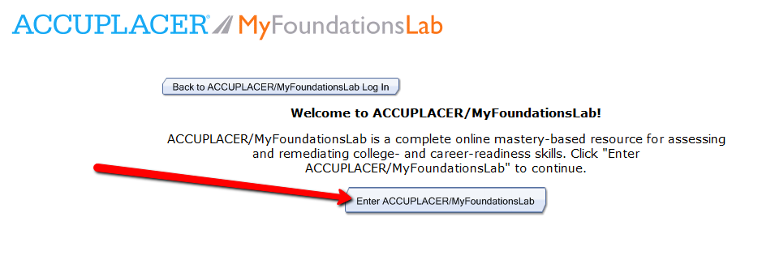
- Enter the Course ID from the student’s score report. (If you still have the score report window open, you can copy and paste this here by using the “switch to single box…” link.)
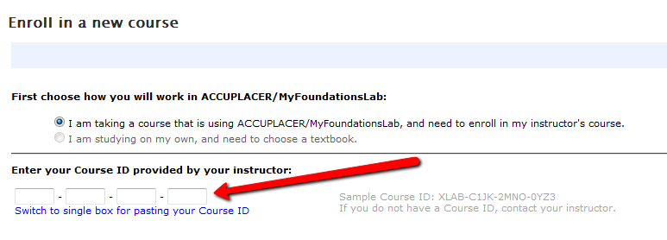
- Click “Enroll.”
- Enter (or copy and paste) the Locator Code from the student’s score report and click “OK.”
- Click “OK” one more time.

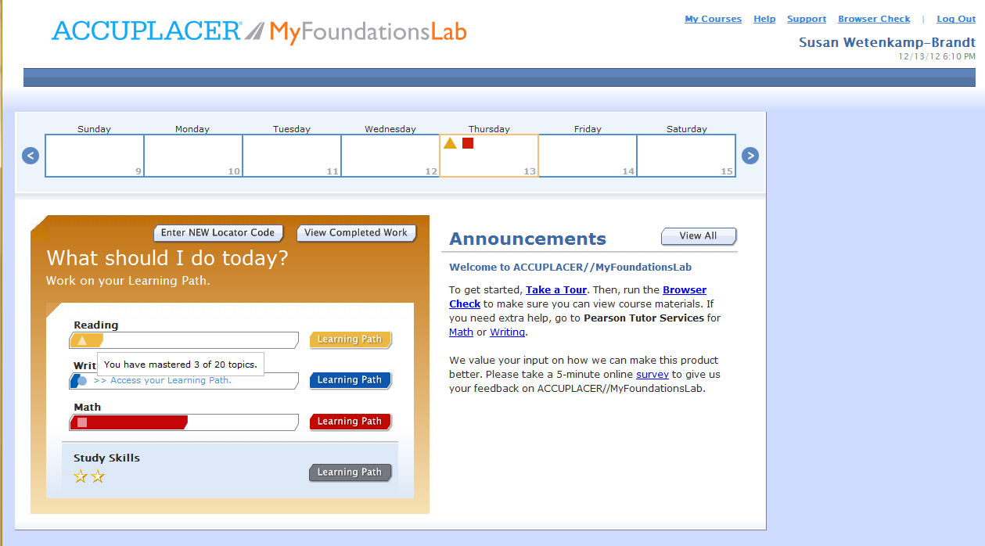
- You’re in! Click a learning path to get started.
- To get back into MFL in the future, simply go to www.accumfl.com, click “Sign in,” enter the Login Name and Password, and click “Enter.”

