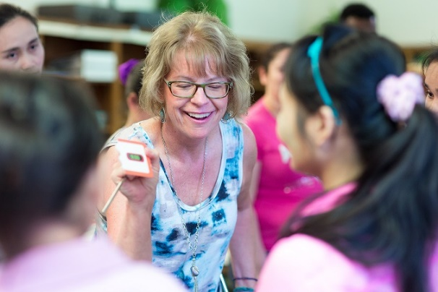
Classroom Video Observation
Observations are a powerful professional development tool for both novice and experienced teachers. Observers 1) get new activity ideas for their teaching toolkits, 2) see classroom management techniques in action, and 3) can reflect on their own teaching practices based on what they witness.

Name: Click here to enter text. Date: Click here to enter text.
Classroom Activity: Click here to enter text.
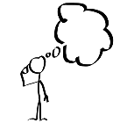
Pre-Viewing Questions:

- After reading the activity instructions, which parts of the activity are unclear to you?
Click here to enter text.

- Which parts of the activity will be the most challenging for students?
Click here to enter text.

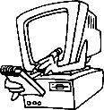
Video Observations:

- How does the teacher prepare the students to participate in the activity? (overview of the activity, review of vocabulary, clarifying questions, pre-teaching language, etc.)
Click here to enter text.

- How does the teacher model the activity for the students? What visuals were used to support the activity instructions?
Click here to enter text.

- How does the teacher check the students’ comprehension throughout the activity?
Click here to enter text.

Post-Viewing Reflection:

- How does your teaching situation differ from the one in the video? What adaptations will you need to make to the activity for your class level, size, or set-up? (additional modeling, technology, grouping, etc.)
Click here to enter text.

- What would you like to “steal” from the teacher to incorporate into your own teaching? (e.g. personal qualities, classroom management techniques, the way the teacher creates a good classroom atmosphere, etc.)
Click here to enter text.

